Distributed by INDICAN PICTURES
A ZOOR Films Production

Written & Directed by: Jaime Zevallos

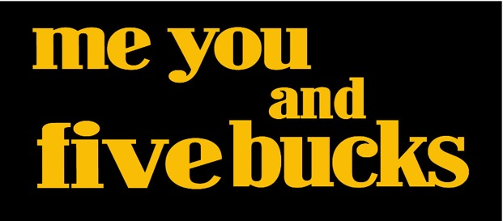
Produced by: Sean Nateghi

Music by: Shai Shaashua

94 minutes / HD / Color / USA / Stereo

Contact: Indican Pictures / 323.850.2667 / Shaun@IndicanPictures.com

TAGLINE

Whatʼs not to love about New York? Itʼs got everything... except for Pam.

SYNOPSIS

The lives of several very different individuals converge in modern day New York City as they meet at a crossroads in this colorful Woody Allen-esque romantic comedy. Charlie, a waiter and womanizing lovable loser, dreams of selling his book “The 7 Steps of Healing the Male Broken Heart,” but finds himself still working in restaurants in order to survive in the Big Apple. Low on cash, he's left with no other choice but to look for a roommate to share his tiny studio.

Surprisingly, the first person to answer the ad is his Ex and only love of his life Pam; the reason behind his book. As he reluctantly allows Pam to move in, Charlie learns his book finally sold to a big publisher and that his life is about to change. As things seem to be on the up and up, Charlie quits his thankless job as a waiter but must come to terms about his feelings for Pam, and the building jealousy from his best friend Louie.

Angela Sarafyan
Plays Pam, a mysterious wallflower and Charlie’s ex who comes back into his life as his roommate. Known for The Immigrant, Twilight Breaking Dawn, the new film 1915 and HBO’s new show, Westworld.

Jaime Zevallos
Award winning writer, director and actor. Plays Charlie, a womanizing waiter who longs to find love after his ex Pam left him, whom he wrote the book about. Known for numerous television appearances including House M.D., Leverage and The Bridge.

Sean Nateghi
Award winning producer and actor. Plays Louie, Charlie’s cocky and competitive best friend who’s a writer for The Manhattan Times. Known for Van Wilder: Freshman Year and his work in the theater.

Michelle Gracie
Plays Jenny, a sexy gold digger that is right up Louie’s alley. Former martial arts fighter and was a lead on E! Entertainment’s new show The Drama Queen.

Daniel C.
An accomplished theater actor playing Rick, the flamboyant best friend and glue to Charlie and Louie that won the lotto.

Tobi Gadison
Plays Frank, Charlie’s loyal book agent that has been with him and believed in him for years. Known for his work in the film Ray and The Dukes of Hazzard.

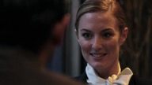
Emerald Robinson
Plays “The other Pam.” Charlie’s sexy and flirtatious book agent.

Michael Elian
Plays Dan, Charlie’s friend and long time co-worker at the restaurant. His credits include

PRODUCTION STILLS

