INTERSECTION
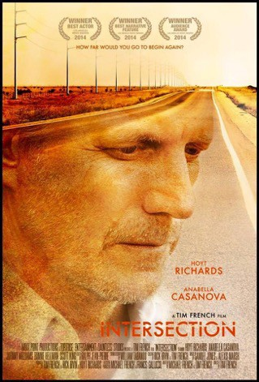

“How Far would You Go TO Begin Again?”

 | contents
- Credits |  | 3
- Synopsis |  | 4
- Press/festival |  | 5
- cast |  | 6
- Director |  | 10
- Director’s view |  | 11
- writer/producer |  | 13
- composers |  | 14
- sound designer |  | 15

- production information 16
- screenshots 17

CREDITS
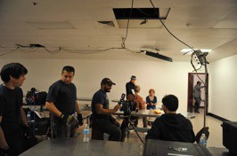
Director Tim French

Executive Producers
Michael French & Francis Galluccio

Writers
Michael French & Tim French

Producers
Tim French, Rick Irvin, Hoyt Richards

Director of Photography Ayan Pratap

Editors
Ralph Jean-Pierre & Neal Thibedeau

Composers
Samuel Jones & Alexis Marsh

Cobb
Hoyt Richards

Nash
Anabella Casanova

Lou
Johnny Williams

Jake
Scott King

synopsis

GENRE
Crime/Drama/Mystery

Tagline
“How Far Would You Go To Begin Again?”

Short synopsis
A guilt-ridden man who blames himself for the accidental death of his only child meets a mysterious beautiful woman in the same remote town where the fateful car crash occurred. There is a spark between them. But she carries a dark past.
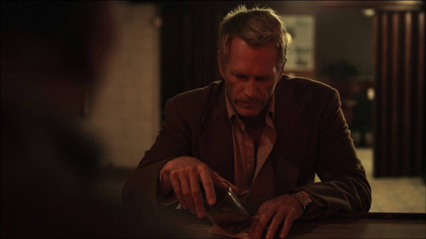

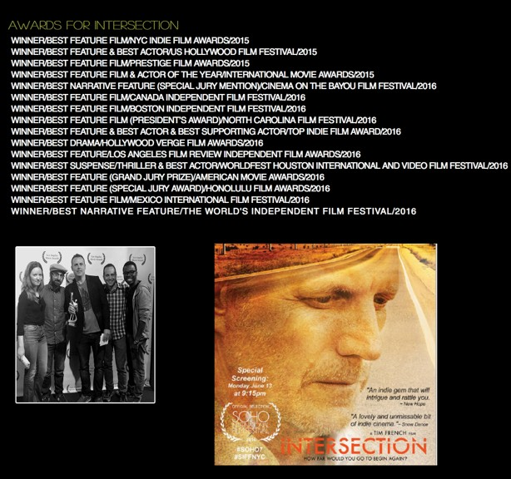
Press/festival

CAST

Hoyt Richards as Cobb

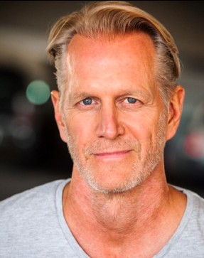

Hoyt Richards is an award winning actor, writer and producer who was born in Syracuse, New York. He grew up in the Main Line area outside of Philadelphia, PA. He is is the fourth of six children. A high school scholar-athlete, who excelled at football and track, Hoyt graduated from Princeton University with an Economics Degree. A football injury led to him led him to New York to see a shoulder specialist -- where he was discovered as a fashion model. Hoyt had a long successful modeling career before turning his efforts to acting, writing and producing. He is considered by many in the fashion industry to be the world's first male supermodel. Hoyt moved to Los Angeles in 2000 to pursue his growing interest in the entertainment industry. In 2010, he created a
production company, Tortoise

Entertainment. Tortoise has released two films to date, "Dumbbells" and "Intersection." Together these films have won well over a hundred and seventy (175) awards on the film festival circuit. "Dumbbells" has won over thirty-five (35) Best Picture awards and Hoyt has won multiple awards for Best Actor and Best Screenplay. "Intersection" has won over fifty (50+) Best Picture awards and Hoyt has won thirty (30) Best Actor awards for his role as Cobb Mills.

SELECTED FILMOGRAPHY

2014 - Dumbbells
1998 - Six days seven nights

CAST

Anabella Casanova as Nash
Anabella Casanova was born on June 19, 1984 in Claremont, California, USA as Anabelle Grace Casanova. She is an actress and producer, known for Intersection (2016), and Mask Maker (2011).

SELECTED FILMOGRAPHY

2015 - I married a method actor 2011 - mask maker

CAST

Johnny Williams as Lou
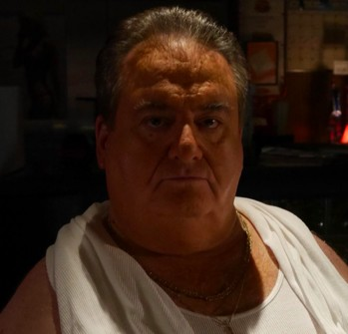
Martin Scorsese discovered Johnny “Roastbeef” in Rao’s Restaurant in East Harlem.
Scorsese immediately cast Johnny in the eventual classic “GOODFELLAS”
alongside Robert DeNiro. In fact, Scorcese was so impressed by Johnny’s handling of the role he renamed the character “ROASTBEEF”, in
his honor. With such initial success Johnny landed a role in the Orion Pictures “STATE OF GRACE” where he
got to share his acting chops with such greats as Sean Penn and Gary Oldman. Johnny’s comedic magic was recognized by Andrew Bergman, who cast Johnny as fourth banana in the Castle Rock comedy classic “HONEYMOON IN VEGAS” opposite James Caan, Nicolas Cage, and Sarah Jessica Parker. Since then Johnny has proven his versatility as a feature film actor by playing a variety of roles, from gangster to auto mechanic with such talents as Billy Crystal, Jim Carrey, and Whoopi Goldberg.

SELECTED FILMOGRAPHY

2016 - RULES don’t apply 1990 - state of grace 1990 - goodfellas

CAST

Scott King as Jake

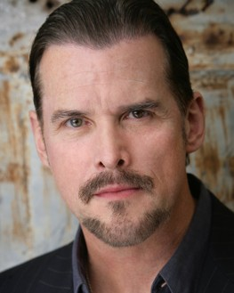
Scott King is an award winning actor, screenwriter and producer who was born in Chattanooga, Tennessee and raised on Lookout Mountain, Tennessee by two very theatrical parents. The youngest of two boys, his parents divorced at an early age then remarried in his late teens. His mother was June King and his father Bill King fought in Patton's 3rd Army in WWII retiring with the rank of Major. Scott had an older brother Brent King who was a critically acclaimed jazz tenor saxophone musician.

Attending Lookout Mountain Christian School, this sensitive, deeply religious youngster
known as the class clown often acted out characters once impersonating his absent British Latin teacher over a multi-school radio network so convincingly that he called roll for ten minutes until the real teacher arrived. Scott spent his childhood filming movies with friends around Lookout Mountain National Park using his father's camera.

SELECTED FILMOGRAPHY

2012 - Puppet master x: Axis Rising 2008 - Still me
2007 - marked

director

tim french
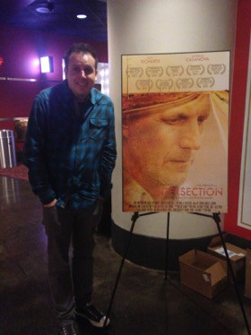
Born in NYC, Tim moved from Brooklyn to Santa Fe New Mexico at the age of two. He developed a passion for storytelling starting in elementary school and his favorite subject was always English. While writing was Tim's true love, reading wasn't. When Tim was in the third grade he was diagnosed with dyslexia and sent to the resource room at his public elementary school each day. There he would sit with a tutor who would try to help him with his reading skills. Being taken out of class in front of his peers and sent to the resource room caused Tim to feel a bit like an outsider. He felt even more this way when he turned thirteen and his parents sent him to a boarding school in New England for kids who were dyslexic. Tim's writing would mirror his current situation with him telling stories of those who were ostracized and how such
adversity could make one stronger. It wasn't until his freshman year in college, when Tim found he is true calling... screenwriting. Finally, he had found a way to take his two loves (films and writing) and merge them together. What really got Tim excited about screenwriting was when he saw Pulp Fiction for the first time. The way the characters in the film conversed and interacted with each other got his adrenaline pumping. He left the film with a new appreciation and outlook towards dialogue and the art of storytelling. Tim had developed such a passion for screenwriting that after his second year in college he changed his major from broadcast journalism to screenwriting. His thesis was a feature script tilted Grannies. Grannies tells the story of three elderly women who escape from their nursing home and hi-jack an RV for Mexico. Tim describes the script as Thelma & Louise meets The Golden Girls.

director’s view

The film
Intersection was a story that came to fruition through brainstorming with my my co-writer. We both wanted to tell a story about a man who had lost everything and would do anything to make things whole again. The questions that came with that were… What did he lose, and what situation would present itself where he felt it was the right opportunity for redemption? It was in answering those two key questions that we came up the story and eventually the script. As a director, I like to be involved with the creation of the story because it makes it that much easier to get in the mindset of each character that’s created. To know how each character acts and reacts to something is a key element for my directing process. More importantly, why a character reacts to something the way they do. Another big part in helping shape the story was the small town we filmed in called Taft. Seeing the town and getting a feel for its energy really helped me in creating the type of look I wanted for the film. Because the town of Taft is really in the middle of nowhere and has that desolate feel, it became a character within the film and added that underlining feeling of isolation that the main character goes through.

The text
The screenplay was a bit of a challenge. Sure, collaborating with another writer can be a challenge in itself, but the real one came with the genre of the story. This was my first time writing a script that wasn't a comedy. At first I wondered if I was capable of writing any other genre. When I expressed my concern to my co-writer, he said that it’s not really about the genre but the story. That as long as you have a good story to tell, it can be shaped into pretty much any genre you want. Hearing his advice really helped in building the script and assuring me that I can in fact write outside of comedy. Luckily, there was room in the script for some jokes and humor, which I took full advantage of.

style & cinematography

As I stated earlier, the style and look of the film was greatly influenced by the town we filmed in. Since the architecture in Taft is for the most part straight out of the fifties/thirties, I found myself using such films as Chinatown and On The Waterfront as cinematic references. At the same time, it was important to maintain a contemporary style as well since the story is not a period piece. In order to do that, I had to go back and watch films that successfully pulled off what I was looking to do. Films like Gran Torino and No Country For Old Men really helped me

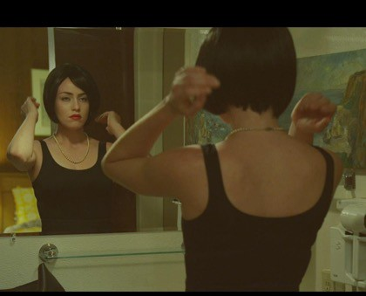
in achieving the balance/look I was going for. I wanted the film to look like it was a throwback to the fifties/thirties, but still existed in a contemporary world. I think we pulled that off.
12| P

characters & acting

The characters in Intersection were created by myself and my co-writer, Michael French. It was very important for us to create characters that the audience could relate to. We felt we effectively did this, especially with the main character, Cobb. Cobb has experienced a great deal of pain and loss. A loss he blames himself for and has to live with the guilt that comes with such an ordeal. Most people have experienced some kind of personal loss and the guilt that may come as a result. It wan’t just creating a relatable that was so important for us, as much as having a character you could root for and want to see win. Sure, Cobb has messed things up in his life but doesn’t make him unlikeable. He acknowledges he’s messed things up and is trying to find a way to redeem himself. That is why the audience roots for him. They see themselves in Cobb. This can also be said for the character, Nash. Nash has also had a rough life and that’s what draws Cobb closer to her. He can relate to Nash, just like the audience can.

When directing I always encourage my actors to collaborate with me. To voice their opinions about anything they might find relevant to their characters or even the story. Sometimes it can be something as small as how they deliver one of their lines. But soon those small things begin to add up, and in turn, end up making the film that much stronger and cohesive. That’s not to say that there weren’t times when an actor would have an idea that I didn’t agree with and therefore didn’t execute. Of course there were. But, they were minimal compared to the ideas they had which were home runs.

Writer/producer

Michael french
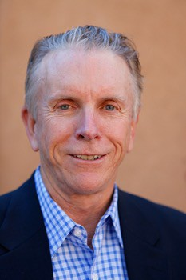

National best selling novelist Michael French, a native of Los Angeles, is a graduate of Stanford University and Northwestern University. He is a businessman and author who divides his time between Santa Barbara, California, and Santa Fe, New Mexico. Over four decades, he has published 23 books including fiction, young adult fiction, biographies, art criticism and gender studies. His most recent work, the adult novel Once Upon a Lie, a dramatic lens on the racial conflicts of Eighties America, has received critical praise from both white and black reviewers and readers. He has also co-written two screenplays with Timothy French--"Intersection' and "The Reunion." The former garnered 49 indie film festival awards and will be released later this year. The later is currently in post production.

composers

Samuel jones & alexis marsh
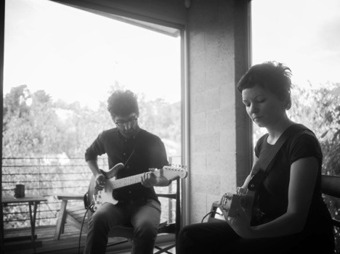

Alexis & Sam's film work has been heard at major festivals around the world including Sundance, SXSW, Tribeca, Slamdance, Edinburgh Film Festival, Los Angeles Film Festival, AFI Fest, and the Champs Ellysees Film Festival. As collaborators with Los Angeles visual artists such as Alex Israel and Morrisa Maltz, their music has been featured in gallery exhibitions worldwide, including the Museum of Contemporary Art in Santa Barbara, Peres Projects in Berlin, and Reena Spaulings Fine Art in New York City. In the television realm, Alexis & Sam's credits include commissions by Sesame Street and Nickelodeon. Alexis & Sam's studio has since relocated to Silverlake, where they house a collection of instruments and continue to produce songs and film scores.

sound designer

William Tabanou

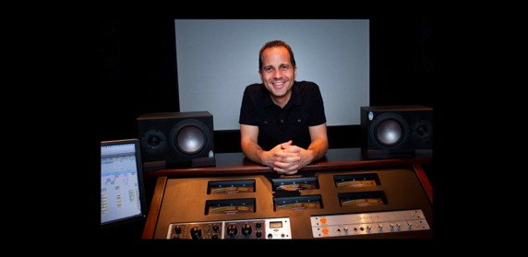

William Tabanou is a Los Angeles based sound designer and re-recording
mixer for Tab Sound Design with 18 years of experience in the post sound world. Tabanou has worked on over 100 features and shorts (Showtime, AFI, HBO, Sony Pictures, Lakeshore Entertainment, Gravitas Ventures and many more), countless commercials (Skyzone, Gerber). As a post re-recording mixer, his goal is to stir up the listener's emotions by creating dynamic and clear mixes.

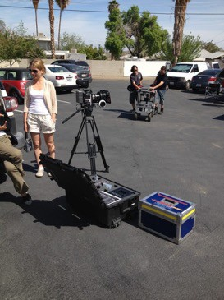
production information

produced by moot point pictures
1911 talmadge street los ángeles, ca 90027

ph: 505.577.5105
email: mootpointpictures@gmail.com

distributed by indican pictures
1041 North Formosa Avenue Formosa Building, Suite 221A West Hollywood, CA 90046

ph: 323.850.2667
email: contact@indicanpictures.com

screen shots
