Press Kit



A feature film directed by Russ Emanuel
Starring Robert Picardo, John Heard, Theresa Russell, Jeremiah Sayys,
Julie Michaels, Laura Covelli, Jilon Ghai, and introducing Jared Young

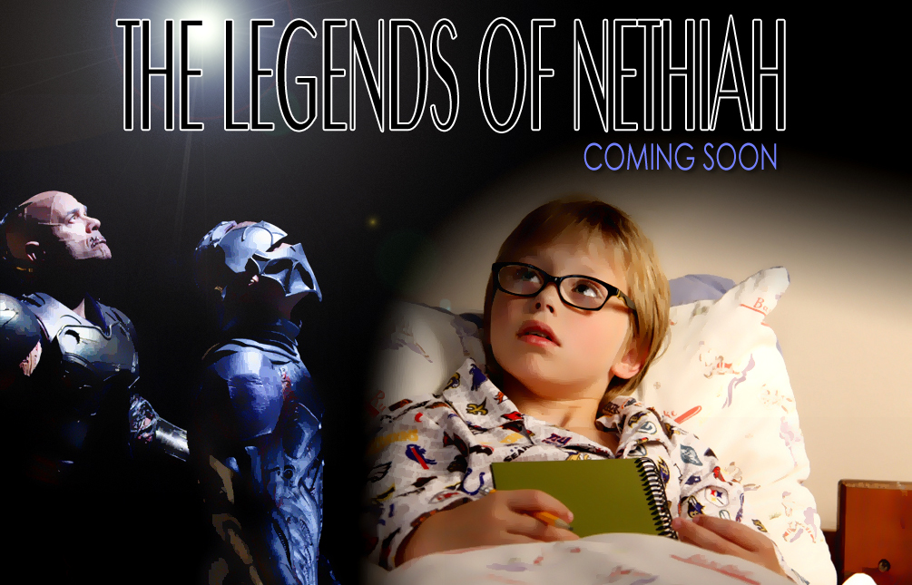

USA: 2011: HD Digital / 35MM: Color: 93 mins
http: //www.legendsofnethiah.com

For further information, contact:
Shaun Hill – Indican Pictures

SYNOPSIS – 1 Line
Through his eyes see a world you’ll never forget

SYNOPSIS – Short
This endearing film looks at the world through the eyes of a young boy (Gabriel) coping with his parent’s bitter divorce. Helping him through this challenge are the stories created by his grandfather that ultimately lead him into a world of Aliens and Fantasy where his alter ego – a hero named Nethiah, vanquishes his foes, saves the world ultimately helping - Gabriel conquer his life at home and find hope again!

SYNOPSIS – Long (150 Word)
'The Legends of Nethiah' - Where fantasy meets reality. A young boy whose parents are going through a bitter divorce, is given hope and courage through the powerful stories embellished by his grandfather (played by Robert Picardo). The stories, about an unlikely hero named Nethiah, give the boy the inner strength and resolve to confront the inevitable challenges which lie ahead. These challenges include reconciling lost friendships, accepting a gift, and ultimately choosing which parent he wants to live with- choices that will pit his own desires against the emotional needs of those closest to him.

Directed by Russ Emanuel

Starring: Robert Picardo, John Heard, Theresa Russell, Jeremiah Sayys,
Julie Michaels, Laura Covelli, Jilon Ghai, and introducing Jared Young

STATEMENT FROM THE DIRECTOR – Russ Emanuel

What can I say except that I am extremely grateful to have met my producer and friend, Howard Nash. This is our third feature film together. Pooling both our creative and technical resources, we were able to produce "P.J."(2008), a feature film starring
John Heard, Vincent Pastore and Robert Picardo. In 2009 we completed "Chasing the Green" starring Jeremy London, Robert Picardo, Ryan Hurst and William Devane; and today, in 2010, we’ve completed "The Legends of Nethiah" which now puts Robert into a leading role, something we were unable to do the first two times around.

They say that a "third time's a charm", but I would insist that, for me, each time had its own set of charms. Because every film is a miracle, a creation that requires both love and patience to put together- and which also brings together a milieu of people who help make it truly special.

For "The Legends of Nethiah", that pool of talent included the aforementioned Robert Picardo, John Heard (who plays a cameo), and newcomer Jared Young, who plays Robert's 10 year old grandson, Gabriel. Actors Laura Covelli, Jilon Ghai, Bryce Clyde Jenkins, Theresa Russell, Julie Michaels, Richard Sandrak and Jeremiah Sayys (co-creator of the "Nethiah" story), all made this a dream-come-true for this director. As for crew, this film wouldn't have been possible without Producer Howard Nash, Screenwriter Emilio Iasiello, Director of Photography Benji Bakshi (who skillfully used the RED camera we employed), Production Designer Gladys Rodriguez, Editor Emile Haris, and Composer Neil Argo, to mention but a few.

All in all, I had a lot of fun with this film, for it challenged me in a variety of new and different ways. And I very much enjoyed these challenges. That said, I hope you enjoy this film as much as I did in making it.

-- Russ Emanuel

BIOGRAPHIES

Russ Emanuel
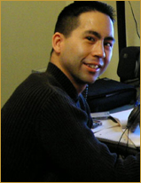
director

Originally from San Francisco, Russ grew up in both Japan and the United States, garnering an international viewpoint of the world throughout his childhood. After graduating from the University of Southern California to study Cinema-Television, International Relations and Japanese, and gaining more production experience at the UCLA Extension Program, he founded Russem Productions in 2002 to promote his shorts films including HER KNIGHT (2003) and the award-winning GIRL WITH GUN (2005). He also produced several shorts including MAVET (2004), the zombie-flick THE DIARY (2004), and most recently vampire film PERFECT RED (2006). Presently, P.J., CHASING THE GREEN, and THE LEGENDS OF NETHIAH mark Emanuel's first foray into feature filmmaking.

Howard Nash
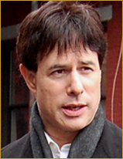
producer

Acting since the late 1970s, Howard Nash starred in numerous independent films, notably THE MEETING in 2004. However, he is best known as an independent filmmaker, having co-produced the cult film CHILDREN OF THE NIGHT for Columbia Tri-Star in 1991. He also produced SLEEPLESS NIGHTS (MTI, 2002), which is available in most video stores throughout the US and Canada. In 2005, he completed TRACKS (where he appears in a cameo alongside CHASING THE GREEN actor Chris Gunn), which also starred John Heard, along with Ice-T. He also produced the television special FELLICIANO, THE LEGEND (for PBS) starring the legendary singer, Jose Feliciano, and has produced promotional videos for the Beijing Circus, Cirque du Soleil, and the original members of the Electric Light Orchestra (ELO II). Most recently, he produced/starred in Russ Emanuel's P.J. and CHASING THE GREEN.

Richard Spitaleri
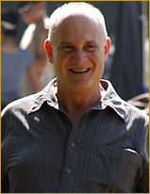
executive producer

Residing in New York, THE LEGENDS OF NETHIAH (2010) marks Richard Spitaleri's third venture with producer Howard Nash and director Russ Emanuel. Richard previously worked with Howard Nash on the early stages of CHASING THE GREEN (2008) thereby making it possible to be filmed. He also worked with Howard Nash on Russ Emanuel's P.J. (2008). Richard also has a cameo in THE LEGENDS OF NETHIAH as the voice of Gabriel’s Principal.

BIOGRAPHIES

Robert Kwartler

executive producer

From Bergen County, New Jersey, Robert A. Kwartler makes THE LEGENDS OF NETHIAH his third venture with producer Howard Nash. Robert previously worked with Howard Nash on SLEEPLESS NIGHTS (2002); and with Howard Nash, Russ Emanuel and Richard Spitaleri on P.J. (2008). Robert graduated with honors from Emerson College in 1974 earning a double BA in English Literature and Creative Writing. He has published various articles and poetry, produced packaging and provided marketing for major studios including RCA and NBC, and a few joke batches to Rodney Dangerfield and Johnny Carson. His performance resume includes stand-up comedy, puppet showcases, trade shows, and street performance. Robert's current executive production funding capability stems from thirty years of institutional commercial real estate activity and private commodity transactions (visit www.kwartler.com).

Emilio Iasiello
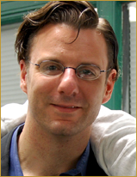
screenplay

Currently residing in Washington D.C., Emilio Iasiello is originally a political speechwriter. He recently turned to screenwriting, writing the script for the feature film SAINT CHRISTOPHER (2002). Due to this success, Howard Nash approached him about writing the screenplays for both P.J., CHASING THE GREEN, and THE LEGENDS OF NETHIAH.

Jeremiah Sayys
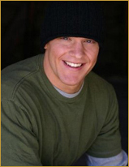
producer/original story/actor – “tully/nethiah”

A native of Alabama, Jeremiah Sayys has been residing in Los Angeles since 2004. THE LEGENDS OF NETHIAH represents Jeremiah's acting and producing debut. He also marked his directorial debut with the film, OF SILENCE, in which he also co-stars with Masiela Lusha. The film is in post-production and is set to be released in 2010. He is also Producing/Writing the feature film OPIOUS, currently being filmed and set for a 2011 release, as well as creating and starring in a new feature DEADLANDS CRY currently in pre-production.

BIOGRAPHIES (CONT.)

Kenhalo Bernet-Millan
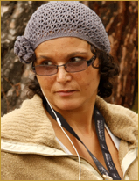
line producer/upm/1st assistant director

Originally from France and an accomplished filmmaker of all talents, Kenhalo Bernet-Millan has been managing productions in both in France and the United States. She began working with the French television show THE WHY WHY? FAMILY, in 1996. She then moved to Los Angeles and formed her own production company, Volcano Smoke. Her credits, as producer, unit production manager, line producer, first assistant director, and/or costume designer include DIE ABRAFAXE - UNTER SCHWARZER FLAGGE (2001), DINNER AT EIGHT (2007), MY HOMEWORK ATE MY DOG (2009), and more recently, THE LEGENDS OF NETHIAH.

Benji Bakshi
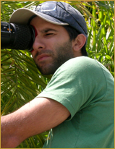
director of photography

Benji Bakshi is a highly versatile director of photography. With an eye for composition and lighting, he developed his professional experience by working first as an electrician on EXIST (2004), as assistant camera on NEO NED (2005), and as a camera operator and director of photography (second unit) on the film, CUTOUT (2006). His cinematography credits began with, and include the television series DIRK BIKE TELEVISION (2006), and the films ROAD TO PECUMSECAH (2008), INITIATION (2009), and more recently THE LEGENDS OF NETHIAH. Originally from Pennsylvania, Benji is now a resident of Los Angeles, and a 2009 graduate of the American Film Institute.

Gladys Rodriguez
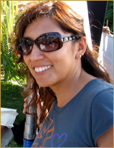
production designer

Gladys Rodriguez was born and educated in Lima, Peru, having studied Interior Design at the Toulouse Lautrec Art School. After graduating, she worked for several years as an interior designer in Peru before going to Madrid, where she received her Masters and graduated with honors in Production Design and Theatre at the TAI Fine Arts School. Having finally discovered her fascination for film, she used her knowledge of design to help bring unique colors to two short films in Spain. It was at this point that she decided to try her luck in Hollywood, moving to Los Angeles to pursue her professional film career. Since moving, she has worked on many films including the feature film FATE (2003), HOLLYWOOD FAMILIA (2006), CHRYSALIS (2008), and three of Russ Emanuel’s films: HER KNIGHT (2003), GIRL WITH GUN (2005), and now THE LEGENDS OF NETHIAH.

BIOGRAPHIES (CONT.)

Mark Rappaport
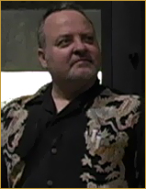
special makeup effects artist

Founder of his own company, "Creature Effects", Mark Rappaport is an acclaimed talent in the field of special effects. He is best known for supervising such films as 300 (2006) and I AM LEGEND (2008). He began as a puppeteer and sculptor on THE RUNNING MAN (1987), and quickly moved up the ranks by working steadily on such films as TREMORS (1990) and PREDATOR 2 (1992), before supervising later films such as PET SHOP (1995), WAKING UP HORTON (1998) and THE LEGENDS OF NETHIAH (2010). He has also worked in television, on such shows as FRASIER, ER, and STAR TREK: VOYAGER (which starred THE LEGENDS OF NETHIAH actor Robert Picardo).

Jim Vickers
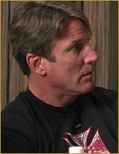
stunt coordinator

An acclaimed and award-winning stunt actor/coordinator, Jim Vickers began his illustrious career as a stunt double on the 1991 film OFF AND RUNNING. He became a stunt coordinator on the 1996 film CURDLED, and coordinated other films such as INSTINCT (1999), NOMAD (2005), and THE LEGENDS OF NETHIAH (2010). He is also a full-time stunt coordinator on such hit shows as CALIFORNICATION and HOUSE M.D. He has won 2 prime time Emmys, both for Outstanding Stunt Coordination for the 2005 episode of NUMB3RS ("Harvest Episode") and the 2007 episode of CSI: MIAMI entitled "Rush".

Wayne Beauchamp
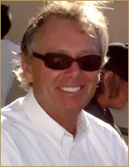
physical special effects supervisor

Through his independent production company SPFX, Inc., Wayne Beauchamp is an experienced special effects veteran. He began as a pryotechnician on the 1972 film EMERGENCY!, quickly climbing up the ladder to work on various films like HEROES (1977) as a special effects assistant, before becoming his own special effects coordinator in the 1981 film BACK ROADS. He has since coordinated and supervised such films as CHILDREN OF THE CORN (1984), TIMESCAPE (1992), FREDDY VS. JASON (2003), and more recently THE LEGENDS OF NETHIAH (2010). He has also worked on numerous television shows including THE PHONE and DEADLIEST WARRIOR.

BIOGRAPHIES (CONT.)

Christann Chanell

costume designer

Christann Chanell, a Los Angeles native, began accepting small positions as an assistant on such short films as HORROR 102: ENDGAME (2004) and music videos like YUKMOUTH & KLUMP "NECK STRAIGHT" (2006). She also worked on national television commercials, and honed her skills on her own, personal productions. As her knowledge of the fashion/wardrobe industry began to grow, she eventually founded Christann Chanell Designs. Her hard work and dedication quickly paid off: shortly after, she began working in the wardrobe departments for such projects as DEAL OR NO DEAL, ROCKY BALBOA and THE LATE SHOW with Craig Kilborn. She assumed the position of Costume Designer on other high-profile films and TV projects including LAST RITES (2006), DON'T GO (2007), and REVENGE OF THE MUMMY (2005).

Emile Haris
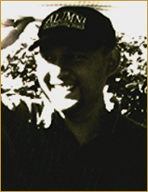
editor

A graduate in both Writing and Film from Long Beach State, Emile Haris, together with fellow filmmaker Yos Park, produced the sci-fi short FRAKIE DIED (2000), which they produced under their own banner, Atomicgum Productions, Inc. He next teamed up with USC graduate Russ Emanuel for the film HER KNIGHT (2003), a contemporary romance with fantastical elements as well as historical ones. His editing/post-production credits include MAVET (2004) which he also wrote and directed, GIRL WITH GUN (2005), PERFECT RED (2006), and more recently P.J. (2008), CHASING THE GREEN (2009), and THE LEGENDS OF NETHIAH.

Neil Argo
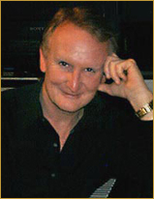
composer
Classically trained, Neil Argo's dramatic and provocative scores have been heard all over the world. From the television series WILD AMERICA, THE NEW MISSION: IMPOSSIBLE, and BEVERLY HILLS 90210 among others, he has composed for many noteworthy projects. Most recently, he teamed up with director Russ Emanuel, composing scores for his films HER KNIGHT, GIRL WITH GUN, P.J., CHASING THE GREEN and most recently THE LEGENDS OF NETHIAH. He also composed scores for two Emmy winning television shows, THE SURVIVORS OF THE SKELETON COAST, a National Geographic Television Special, and A COMMUNITY OF CARING for the Directors Guild of America, - Los Angeles and the City of Santa Monica.

BIOGRAPHIES (CONT.)

Robert Picardo
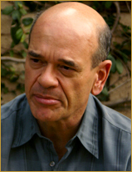
actor - "grandpa/sir hanif"

A graduate of Yale University, Robert Picardo made his Broadway debut in the comedy hit GEMINI in 1977 with Danny Aiello. He also appeared in Bernard Slade's TRIBUTE, and THE NORMAL HEART for which he won a Drama-Logue Award. He then began his long and successful association with television, where in 1988 he was nominated for an Emmy Award for his role as Mr. Cutlip on the series THE WONDER YEARS. In 1995, he won a starring role as "The Doctor" on the STAR TREK: VOYAGER series. He directed two shows, and appeared in more than 170 episodes throughout the 1990s. He also starred in 62 episodes of CHINA BEACH (for ABC Television), and more than 30 episodes of the hit series, STARGATE ATLANTIS. In the summer of 2009, he completed filming THE LEGENDS OF NETHIAH for director Russ Emanuel. Bob is presently appearing in a new television movie based on STARGATE (2009), where he is reprising his starring role of Richard Woolsey.

Jared Young
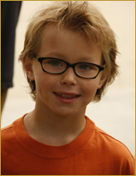
actor - "gabriel"

A Resident of Los Angeles, THE LEGENDS OF NETHIAH marks Jared Young's cinematic debut. He attends the UCLA Lab School, and will be entering the fifth grade in September, 2010.

Laura Covelli
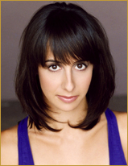
actor - "susan"

Laura Covelli, a native New Yorker, got the bulk of her acting training at The Actors Center, a prestigious institute in NYC. After completing her training, she began writing and performing original works in her favorite style ~ a combination of clown and physical comedy. Before moving to Los Angeles to pursue a film and television career, she starred in the title role of Edward Allen Baker’s dark play, DOLORES, at NY’s Gene Frankel Theatre. Now in Los Angeles, she works with the LA Womens’ Shakespeare Company, which allows this diehard theater lover an opportunity to pursue her passion, hone her skills, and wield a sword!

John Heard
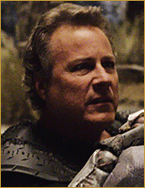
actor - "nethiah's father"

John Heard is a veteran of more than 125 television and motion picture projects. He first came on the scene as an Award-winning stage actor during the early 1970’s, and made his screen debut in a Hallmark production of VALLEY FORGE in 1975. Further projects included starring roles in CUTTER'S WAY (with Jeff Bridges), ONE EIGHT SEVEN (with Samuel Jackson), BIG (with Tom Hanks), and the hugely successful HOME ALONE, as Macaulay Culkin’s father (he also starred in the 1992 sequel version, HOME ALONE 2). In 1999, John was nominated for a Prime Time Emmy Award for his role as Vin Makazian in the HBO hit series, THE SOPRANOS. In THE LEGENDS OF NETHIAH, he is featured as Nethiah's warrior father.

Theresa Russell
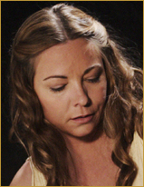
actor - "nethiah's mother"

A prolific actress living in Los Angeles, Theresa Russell made her debut in Elia Kazan's THE LAST TYCOON in 1976. She would later become a familiar face in numerous independent films including BAD TIMING: A SENSUAL OBSESSION, EUREKA, INSIGNIFICANCE, ARIA, and IMPULSE. She has also starred in larger studio films such as BLACK WIDOW (1987) opposite Debra Winger, WILD THINGS (1998) playing Denise Richard's promiscuous mother, and recently starring opposite Thomas Hayden Church in SPIDERMAN 3 (2007).

Jilon Ghai
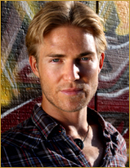
actor - "stan"

Living in Los Angeles and represented by Sovereign Talent Group, Jilon Ghai has been in numerous films including DEATH TUNNEL (2005), DEATH BY ENGAGEMENT (2005), MARCO POLO (2009), and most recently THE LEGENDS OF NETHIAH. He also has been in several television series, including guest-starring in PSYCH and COLD CASE, as well as being a series regular in HARRY NASH and THOR'S HAMMER.

BIOGRAPHIES (CONT.)

Julie Michaels

actor - "naran anie"

Born in the Northwest, Julie Michaels attended the University of Washington, and is best known for her cinematic debut opposite Patrick Swayze in ROAD HOUSE (1989). Since then, Julie has been in numerous films and television shows including JASON GOES TO HELL: THE FINAL FRIDAY (1993) as Sgt. Elizabeth Marcus, a 2006 episode of HOUSE M.D. and most recently, THE LEGENDS OF NETHIAH (2010). She has also worked as a stunt player in such films as BATMAN FOREVER (1995), TITANIC (1997), THE SCORPION KING (2002), and DOMINO (2005), and coincidentally did her own stunts on THE LEGENDS OF NETHIAH.

Richard Sandrak
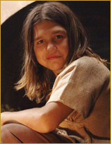
actor - "young nethiah"

Richard Sandrak was born in a small village in the Ukraine, in the former Soviet Union. At the age of 2, he immigrated with his parents to Pennsylvania. Only a year later, he began to train in both the martial arts and bodybuilding, while using small lightweight dumbbells to help strengthen his developing body. In 1999, he moved with his family to California in the hopes of a better life. Shortly after, the media began to take a notice of Richard's training, his remarkable young age, and his incredible progress. During this time, Richard met his first manager, who named him Little Hercules, "The Strongest Boy", which became an appropriate title due to his starring role in LITTLE HERCULES, IN 3-D (2009).

Bryce Clyde Jenkins
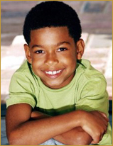
actor - "doug"

Residing in Los Angeles, Bryce Clyde Jenkins has already starred in numerous films including MY HOMEWORK ATE MY DOG (2009), and more recently EASY A (2010) as Chip Penderghast, and THE LEGENDS OF NETHIAH.

CREW LIST

Russ Emanuel  Howard Nash  Jeremiah Sayys  Emilio Iasiello  Robert Kwartler & Richard Spitaleri  Christine M. Torres  Tomax Aponte  Kenhalo Bernet-Millan  Benji Bakshi  Gladys Rodriguez & Bryce Holtshousen  Emile Haris  Neil Argo  Christann Chanell  Sharon Lynn Epstein & Jennifer Nudelman  Wayne Beauchamp  Mark Rappaport  Jim Vickers & Felipe Savahge  A. Tad Chamberlain & Sara Glaser  Russ Emanuel  Keith Selin  John Paul Ouvrier  Sandra Salas & Blu Van Zandt  Jeff Bierman & David Irwin  Amos James & Kosta Rigopoulos  Salvador Vega  Nick Smirnoff  Erik Totman | Director  Producer  Producer/Original Story  Screenplay  Executive Producers  Associate Producer  Co-Director  Line Producer/UPM/1st Assistant Director  Director of Photography  Production Designers  Editor  Composer  Costume Designer  Key Makeup Artists  Physical Special effects Supervisor  Special Makeup Effects Supervisor  Stunt Coordinators  Production Sound Mixers  Post-VFX Supervisor  Production Coordinator  Location Manager  Script Supervisors  Key Gaffers  Key Grips  1st Assistant Camera  Still Photographer  Documentarian

CAST LIST

Robert Picardo  Jared Young  John Heard  Theresa Russell  Jeremiah Sayys  Julie Michaels  Laura Covelli  Jilon Ghai  Richard Sandrak  Bryce Clyde Jenkins  Lavinia Dowdell  April Littlejohn  Mer Anthony  Kevin Fry-Bowers | Grandpa/Sir Hanif  Gabriel  Nethiah's Father  Nethiah's Mother  Tully/Nethiah  Naran Anie  Susan  Stan  Young Nethiah  Doug  Doug's Mother  Thoran  Serviceman  Principal

PRODUCTION NOTES/ANECDOTES

“PETERSON”

The character "Mary Peterson" continues director Russ Emanuel's tradition of using the Peterson name – also mentioned in his award-winning short film Girl With Gun (2006), as a business associate of character Dan Winters, and in his award-winning feature films P.J. (2008), as Dr. Peterson and CHASING THE GREEN (2009) as Ted Peterson.

HD vs. 35mm

In “Nethiah”, the present day footage was shot in HD while the fantasy sequences were shot in 35mm. This was a conscious decision so as to contrast the present and fantasy sequences as much as possible - sort of like one battling the other. By the same token, while the present day footage looks slightly de-saturated to show the pale realities of Gabriel's life, the fantasy footage is super-saturated to provide a rich and vibrant dream-like environment.

