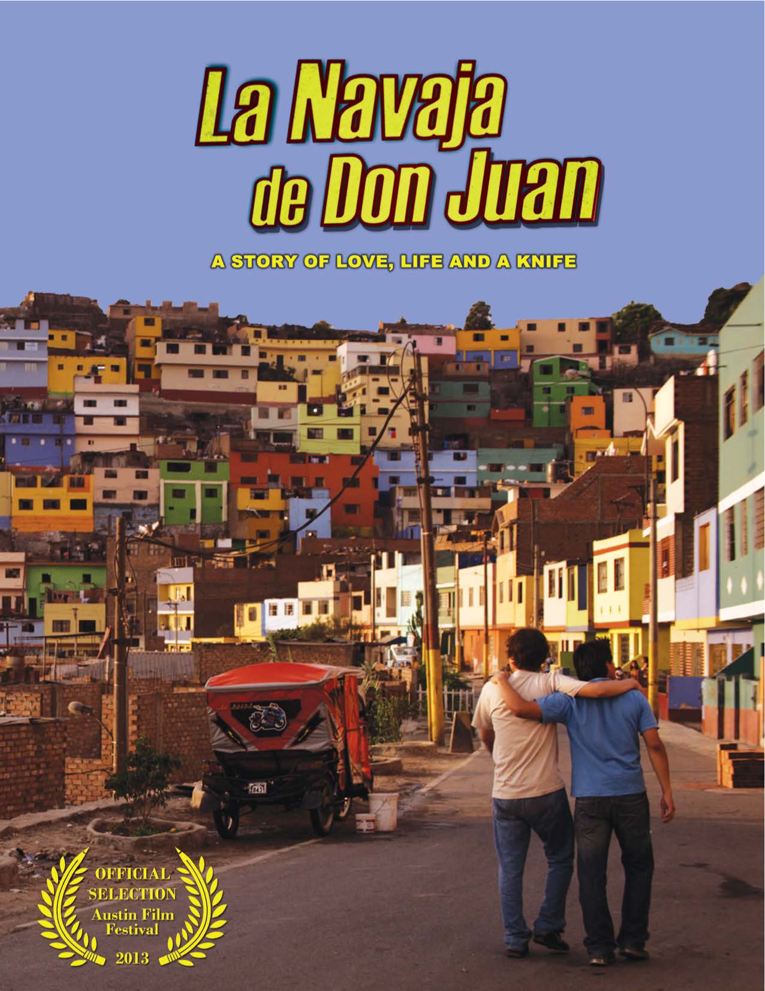

LA NAVAJA DE DON JUAN
Directed by
Tom Sanchez

Written by
Tom Sanchez

Producers
Tom Sanchez
Benjamin Wilkins
Julie Sifuentes Etheridge

Executive Producer
Cielo Garrido

Website: www.navajafilm.com
Facebook: www.facebook.com/navajafilm
Twitter: @navajafilm
Email: info@navajafilm.com

Press Contact
Jennifer Sinski, lookthinkmake
jennifer@lookthinkmake.com | 512.402.6861

OFFICIAL SELECTION FOR THE 2013 AUSTIN FILM FESTIVAL

LOGLINE
The fate of an arm wrestling match leads two rivaling brothers from the barrio across the tracks to a house party where the younger one hopes to lose his virginity.

SYNOPSIS
La Navaja de Don Juan, a Superbad-meets-Y Tu Mamá También, coming-of-age story set in Lima, Peru follows two rivaling brothers who attempt to outwit their melding Grandmother and several other obstacles in order to attend a house party, where the younger brother hopes the night will end with the loss of his virginity.

After his womanizing older brother, MARIO (Rodrigo Viaggio, Jarjacha 3, 2007) wins the right to dance with the girl that younger brother WALTER (J.C. Montoya) hopes to lose his virginity to, Walter

challenges his brother to another arm-wrestling battle, where he wins the coveted pocket knife of their deceased father. Together, the brothers set out across the barrios of Lima to reach an upper-class neighborhood to attend a house party. Unfortunately, the two must convince their GRANDMA (Irma Maury, La Mar Estaba Serena, 2001 and Motor y Motivo, 2009) to let them go to the party, which requires a white lie about a quinceañera and change of costume to leisure suits. Broke and targets for every thug, pimp and troublemaker that stands between them and the promise of a great night, the boys’ adventure contains fights with each other and with wealthy party-attendees, resulting in the best laid plans of the evening to quickly spiral out of control.

Inspired by the family stories the film’s writer and director Tom Sanchez overheard from his father and uncle while growing up in Lima, La Navaja de Don Juan stars an all-Peruvian cast including J.C. Montoya, Rodrigo Viaggio, Nataniel Sánchez, Irma Maury and Antonio Arrué. The film explores themes of sibling rivalry, brotherhood and masculinity, as well as relationships between young Latino men and women, and marks Tom Sanchez’s directorial debut.

DIRECTOR’S MESSAGE
Inspired by many crazy stories I’ve heard about my father and uncle growing up in Lima, Peru, La Navaja
de Don Juan, is both a very personal; yet, universal story about sibling rivalry, maturity and family. My goal was to make a film that was both very Peruvian while also accessible to audiences worldwide. I made it a point to hire an all Peruvian cast and shoot on location as much as possible in order to keep an authentic feel. I also made an effort to place the score and songs in the film with a certain Peruvian
sound.

I hope that Peruvian audiences will enjoy a story that takes place in a familiar world; and I hope that the rest of the world will enjoy seeing a not-to-often shown side of Peru. Ultimately, I want audiences to enjoy themselves and be moved emotionally for an hour and half.

DIRECTOR BIOGRAPHY
TOM SANCHEZ
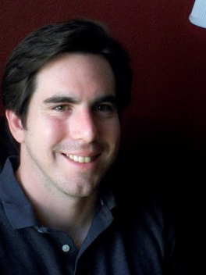
Tom Sanchez was born in Lima, Peru. By the time he moved to the United States at age eight, Sanchez was already fixated on making movies. He jumpstarted his motion picture career by borrowing his Uncle’s camcorder to make a prequel to Gremlins and a number of comedy skits with his neighborhood friends. Sanchez won the James Bridges Scholarship Award for directing while working on his MFA in film production at the University of Southern California. Tom has directed music videos including: "Irresistible" for reggae jazz artist Nigel Williams and "Liar in Texas" for Team Love Records’ Cap Gun Coup, as well as several shorts. He is also a working television video editor. La Navaja de Don Juan is Sanchez’s feature film directorial debut and is a winner of the 2012 Peruvian Ministry of Culture Post-Production Grant.

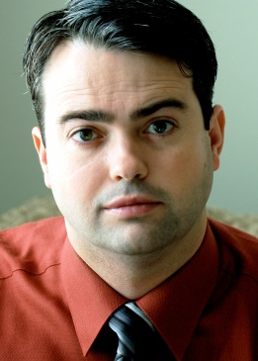
PRODUCER BIOGRAPHIES
BENJAMIN WILKINS
Planning to produce his first film from scratch as a contingency plan if he didn't get into film school, Benjamin Wilkins spent the months between submitting his applications and

learning if he’d been accepted, reading every book on independent film production he could get his hands on. In 2003, he was accepted into the University of Southern California’s master program in Cinematic Arts. Craving real world application of his education, Ben worked with the head of the production program at USC to create a new thesis option whereby students prepare a feature film for financing and production. This thesis option is now a permanent part of the MFA curriculum. Ben’s producing credits include award winning short films and nationally broadcast music videos and commercials, as well as web content for the Lexus sponsored site L-Studio. He was the first assistant director for the low-budget independent film Mr. Sadman in addition to several short films. He also currently made his directorial debut with zombie film Pretty Dead. Ben won the Entertainment Partners Producing Award in 2006.

JULIE SIFUENTES ETHERIDGE
Born and raised in Anaheim, California, Julie Sifuentes Etheridge graduated Summa Cum Laude from California State University, Long Beach with a degree in Communication Studies. She continued her studies at the University of Southern California's School of Cinematic Arts where she produced a number of award winning short films including, a Gold Medal Student Academy Award Winner (A Day’s Work, 2007) and a film that debuted at the prestigious Cannes Short Film Market (Lucky, 2005). Upon graduating, Julie worked her way through every crew role possible on a number of commercials and feature films. Never losing sight of her true passion, producing – Julie learned the logistics of feature film producing as an assistant to a notable Hollywood Blockbuster Writer / Producer as well as the inner workings of television as an assistant in the literary department at the William Morris Agency before its merger with Endeavor.

Julie comes to La Navaja de Don Juan with a background in independent filmmaking, television, commercials and blockbuster studio films with credits including ABC’s television series, “Detroit 1-8-7”, Disney’s “Oz: The Great and Powerful”, a 2013 Cannes Film Festival favorite Jimmy P (Psychotherapy of a Plains Indian) and most recently, AMC’s “Low Winter Sun.” Growing up as a first generation Mexican- American, Julie is very excited to contribute to the new wave of Latin American Cinema.

EXECUTIVE PRODUCER BIOGRAPHY
CIELO GARRIDO
Born and raised in Peru, Cielo has produced short films, features, television programs, commercials, and educational programs in the twenty plus years of her producing career. She is the Director of Production for the production company, 1405 Comunicaciones, which she co-owns with her husband, Eduardo Cayo.

1405 Comunicaciones is an independent Peruvian production company well-versed in all kinds of productions including educational films, documentaries, commercials or feature films. The company offers a perfect balance of technical and production services for both national and international productions. They are responsible for such Peruvian films as: Talk Show (2006), Illary -Amanece (2007), A... Jose (2007), El Camino del Inca (2009), and 40 Años de Petroleo en el Peru (2009).

1405 Comunicaciones became the first Peruvian production company to own, operate and rent the Red One high-definition digital cinema cameras, which they provided, along with the required technical labor and support, to the production of La Navaja de Don Juan.

THE CAST
La Navaja de Don Juan proudly stars an all-Peruvian cast introducing Juan Carlos (J.C.) Montoya as
WALTER the fighter, and Rodrigo Viaggio as MARIO the lover. The film also showcases well-known Peruvian talent with telenovela star Irma Maury as GRANDMA (Motor y Motivo, Los Unos y Los Otros), Antonio Arruè as UNCLE UMBERTO (La Manzanita de Diablo) and Nataniel Sànchez (Al Fondo Hay Sitio) as ANA.
J.C. MONTOYA - WALTER ALFARO
RODRIGO VIAGGIO - MARIO ALFARO
ANTONIO ARRUÉ - UNCLE HUMBERTO
IRMA MAURY - GRANDMA
NATANIEL SÁNCHEZ – ANA
CLAUDIA SOLIS – CANDY
DEYSSI PALEZ – CARMEN ROSA
JHONNY VARGAS LAPA –POLLO (Chicken)
SEBASTIAN RUBIO- GUILLERMO

J.C. MONTOYA - WALTER ALFARO
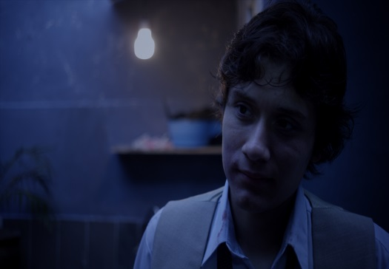
J.C. has dedicated himself to acting since 2006. A long-time friend and acting partner of co-star Rodrigo Viaggio, J.C. started out performing in short student films while studying video production in his hometown of Lima, Peru. Upon graduation, he joined the Peruvian theatre group TAIJ, which performed in several cities in Argentina, before being discovered by casting director Ceser A rroyo and brought onto La Navaja de Don Juan to play the lead Walter Alfaro. Writer/Director Tom Sanchez saw his potential in a preliminary casting season and asked for more tape on him.
RODRIGO VIAGGIO - MARIO ALFARO
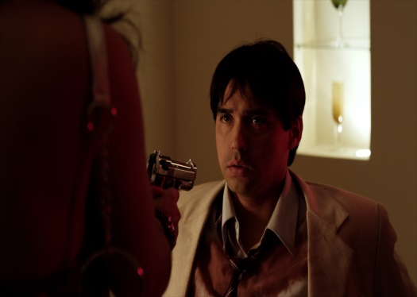
Working primarily in commercials and short films up to this point in his career, Rodrigo Viaggio has studied acting in Argentina and Spain in addition to his home country Peru. His feature film career began with an uncredited role in famed Peruvian director Francisco Lambardi's film Mariposa Negra (2006). Rodrigo played a leading role in the low-budget Peruvian horror film Jarjacha 3 (2007) before coming to the attention of Writer/Director Tom Sanchez as he was looking a t tape of co-star J.C. Montoya in the short film El Greco, which Rodrigo both directed and co- stared in. Since filming La Navaja de Don Juan Rodrigo has appeared in several films including La Casa Rosada, La Venganza Peligrosa, and Sueños de Gloria.
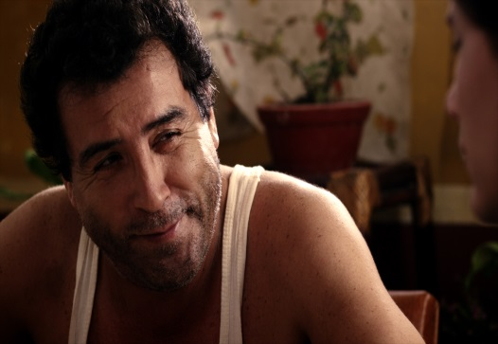
ANTONIO ARRUÉ - UNCLE HUMBERTO
Born in the region of La Libertad in northwestern Peru, Antonio Arrué grew up next door to some of Peru's most prized cultural landmarks. He can be seen in Peruvian films such as: La Manzanita de Diablo (1988), El Forastero (2002), Good bye Pachacutek (2006) and Solidad.com (2007). His Peruvian television stardom began over thirty-four years ago with series such as El Diario de Pablo Marcos and continues today on Graffiti, Ferrando

de Pura Sangre, Tormenta de Pasiones and others. In addition to being a veteran of Peruvian theatre, film and television, Antonio was worked extensively in Ecuador and Colombia.

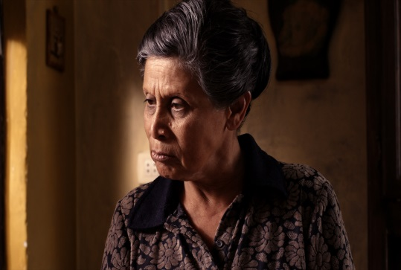
IRMA MAURY - GRANDMA
A native of Lima, Peru and raised during one of the country's most tumultuous political periods, Irma Maury has been a national favorite of Peruvian television for over 25 years. Most known for her prolific work in some of Peru's most beloved telenovelas such as Los Unos y Los Otros and Los de Arriba y Los de Abajo y Nada Mas, Irma has been branching out into the world of cinema over the last ten years and can be seen in the Peruvian films: La Chicha Esta Fermentando (1983), Te Quiero (1995), La Mar Estaba Serena (2001) and Motor y Motivo (2009).

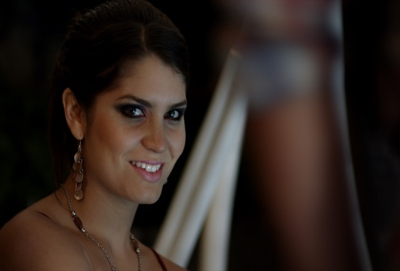
NATANIEL SÁNCHEZ - ANA
Nataniel Sánchez started working in television on María Pía y Timoteo as a dancer, and since has become one of the most popular actresses in Peru. In 2009, she joined the cast of the hit show Al Fondo Hay Sitio
from América Televisión as the role of Fernanda de las Casas. In early 2011, she co-hosted Very Verano, along with Erick Elera. She also participated in a production of West Side Story. Nataniel Sánchez is a spokesperson for Elvive Reparación Total 5, for L’Oréal París since 2012.

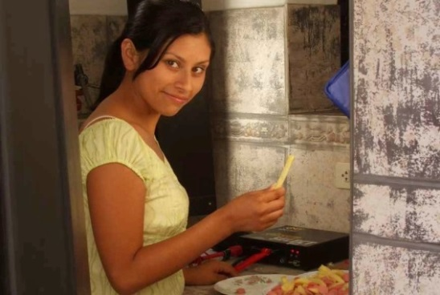
DEYSSI PALEZ – CARMEN ROSA
Deyssi Pelaez received her performing arts degree from the National Superior School of Dramatic Arts (ENSAD) as well as a bachelor’s from San Marcos University. She has appeared in several Peruvian films, including Paradise by Hector Galvez and Coliseum, by Alexander Rossi. She also performs in plays, teaches modern dance and works as a casting coordinator.

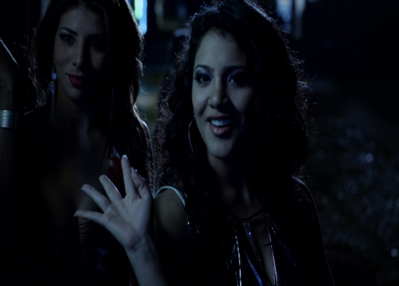
CLAUDIA SOLIS – CANDY (Caramelo)
Claudia Solis was born in Lima, and studied acting in Diez Talentos School under actor Bruno Odar. Though she had experience working in commercials, plays and voice over, La Navaja de Don Juan is the feature film debut for the eighteen year-old actress. Since the production, she has gone on to appear on Peruvian national television on the Discovery Channel series "Puertas al mas allá", which was also produced by 1405 Comunicaciones and Cielo Garrido, and national TV show "Entre Nosotras" by Frecuencia Latina. She currently works at a casting agency as an assistant.

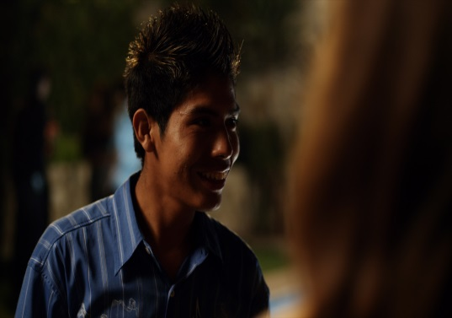
JHONNY VARGAS LAPA –POLLO (Chicken)
Originally from Ayacucho, Peru, Jhonny studied acting with actor, director and playwright Luis Enrique Cornejo, where he took on all types of roles and worked on various plays. In 2011, he joined the ENSAD (Superior National School of Dramatic Arts), where he studies acting and continues his work as an actor in theater. He currently works presenting plays in the cultural center and at Vitarte TV, a series based on the work of Ricardo Palma traditionalist "Don Dimas de la Tijereta", which is in production. He also has appeared in several short films including “Una Cita por la web@," "Fortunato” and “Ciudad Pandilla.”

SEBASTIAN RUBIO- GUILLERMO
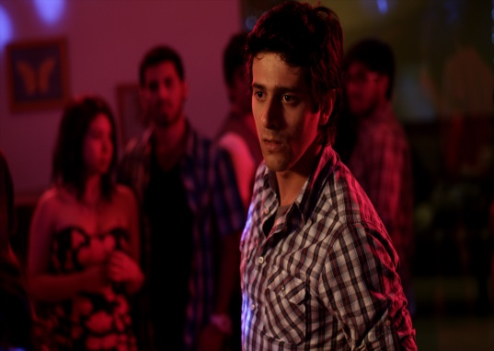
Sebastian Rubio is an actor and stage director born in Lima in 1985. Born into a theatrical family, he spent his childhood in the group Yuyachkani Years later, he attended the Pontificia Universidad Catolica del Peru (PUCP) where he studied performing arts and contemporary dance. As an actor, Sebastian has worked in productions directed by Juan Carlos
Fisher, Gisela Carde nas and Miguel Rubio Yuyachkani, among others. He was featured in the 2012 film Dark Sky, directed by Joel Calero. He also participated in the Festival de Santiago a Mil de Chile and in the FIT of Belo Horizonte. He has appeared in various Peruvian television
miniseries and cultural segments of cable and in memorable advertising campaigns. He is currently starring and directing the play 198O2OOO project, which has received several invitations to festivals in Peru and continues to generate buzz.

THE CASTING DIRECTOR
CESAR ARROYO – Casting and Associate Producer
Cesar Arroyo, a native of Lima, Peru, studied marketing and advertising in Baltimore, Maryland at the Towson Stratford Institute and worked as a freelance publicist for a number of advertising agencies before discovering his true calling as a casting director. After working a number of years in some of the largest Peruvian casting and modeling agencies around, such as Corporacion Peruana de La Moda in Lima, he took his extensive casting experience in the television, commercial and motion picture industry and founded his own company, Perucasting.Com.

THE SOUND
PAUL SERADARIAN – Supervising Sound Editor
Paul Seradarian caught the film bug in high school and quickly found himself moving to Los Angeles with dreams of making it big in Hollywood. But during film school at the University of Southern California's School of Cinematic Arts, he caught a new bug, and began to focus his studies on sound design, learning from some of the finest practitioners in the motion picture industry such as veteran Bruckheimer Films supervising sound editor Midge Costin, and Tomlinson Holman, inventor of the THX Sound System. His credits include K-town, Insidious and The Killing Room, among others.

THE LOOK & STYLE
NICOLA B. MARSH- Cinematographer
This year the feature documentary that Nicola lensed, Twenty Feet From Stardom, opened the Sundance Film Festival and was acquired by the Weinstein brothers shortly thereafter. On the narrative side, she shot the breakout horror movie Smiley, which played theatrically across the US in 2012. She has been nominated for an Emmy for her work on Troubadours – The Carol King/James Taylor Story. In addition to this, Nicola also shot two documentaries for Cameron Crowe: PearlJam20 (premiering at the Toronto Film Festival) and The Union (premiered at Tribeca). She shot the narrative feature Eye of The Hurricane, starring Melanie Lynskey and Campbell Scott.

Nicola shot the award winning documentary Burn - A year on the front lines of the Detroit Fire Department, which won the Tribeca Audience Award in 2012. Her cinematography has taken her around the world, filming in Nigeria, Argentina, Peru, Chile, England and the US. Nicola grew up in London, England. She first moved to the US to work as a news camerawoman for NBC. She holds an MFA in cinematography from The University of Southern California. At the time of leaving, two out of the three Student Academy winning shorts were lensed by her. She now lives in Los Angeles. In addition to her American passport, she holds a German passport, but has a good sense of humor. She is represented by Innovative Artists.

MANNY REVELES – Editor
Manny hails from El Paso, Texas and expected to end up as a football coach or in law enforcement like everybody else in his family, except that he couldn't stop talking about and quoting movies and television shows. That passion is what took Manny to the University of Texas in Austin for a Bachelor of Science in Radio, Television and Film, and then to the graduate Cinematic Arts program at the University of Southern California. Manny has edited a number of critically acclaimed short films, as well as promotional spots for companies such as Office Max and Heineken. He has several projects under his belt, including Comedy Central’s web series "Legend of Neil," and series such as The Originals with Emeril, as well as the Student Oscar-winning film, A Day’s Work.

THE ORIGINAL SOUNDTRACK
An essential element of La Navaja de Don Juan and the world it creates is in the music – music that
reflects the colorful Peruvian culture. Both score and songs mix traditional Peruvian rhythms and sounds with a modern twist, featuring most prevalently, Chicha, a Peuvian style of cumbia. The score includes performances by acclaimed Peruvian guitarist Victor Vento and Peruvian percussionist Gino Gamboa, as well as special feature guitar performances by director Tom Sanchez.
Songs from other artists include:
1. Live version of “El Tunche” by Fausto Orquesta of Lima
2. “Lima Congo” by Fausto Orquesta
3. “Cachetea la Caderona” by Joaquin y Los Bandidos” of Lima
4. “Te Quiero Ver” by Peruvian pop-punk band Grupo Seven
5. “Para Elisa” by Los Destellos – a “chicha” adaptation of Beethoven’s Fur Elise
6. An originally produced cover of “Lagrimas” written by Roberto Blades
7. A “Chicha” rendition of Ruben Blade’s “Pedro Navaja” with guitarist José Luis Carballo – famed Chicha guitarist from “Chacalón y la nueva crema.” Sung by Gino Gamboa
8. “Como Tu” by Vitaly Novich - Lim

THE ORIGINAL SCORE
CHANDA DANCY – Score Composer
Original Score for the film was composed by vocalist and multi-instrumentalist, Chanda Dancy, a selected fellow of the 2009 Sundance Film Composers Lab, winner of the 2002 BMI Pete Carpenter Fellowship for Aspiring Film Composers and the 2004 APM/YMF Music Business Award where she was honored alongside great film composer, John Williams. Hailed as a musical prodigy, Chanda began composing music at the age of twelve and is a graduate of the University of Southern California where she composed scores for over thirty short films. Chanda has become a sought after composer for her own signature sound and dramatic point of view. She is most noted for her collaboration with filmmaker Ted Chung on such short films A Thousand Words, Mike’s, and I.D. Music by Chanda has been heard all over the world in theatrically released feature films such as Lift to Hell by Ning Jinwu, commercials, radio and in such festivals as Cannes Film Festival, Tribecca Film Festival, Sapporo Short Film Festival, Slamdance, Sundance and Pangea Day.

Chanda’s score from La Navaja de Don Juan is available for purchase on Amazon as well as iTunes, or just about anywhere else online. The original soundtrack will be available for purchase at a later time.

THE ORIGINAL SONGS
KENNY MORAN – Music Supervisor & NuVintage Music Group
Kenny, a multi- faceted, Engineer, Producer and Writer has worked world-wide with some of the most prolific songwriters and producers in the history of modern recorded music such as Greg Phillinganes, Nathan East, Steve Lukather, David Foster and most recently GoonRock (LMFAO). Working with such talented producers and writers has allowed Kenny to approach engineering from a production view, bringing a contemporary urban and pop sensibility to his mixes. In Production, Kenny is routinely called upon for composition, arranging, programming and sound design in seemingly any genre. His specialties include Mix and Recording Engineer, Music Production and Sound Design.

NuVintage Music Group produced the soundtrack for La Navaja de Don Juan and is just what the name implies – new production that remembers its past. From vintage tones to the latest technology, NuVintage Studio at D.A.M. have created a place for signature sounds and brands of soul filled music. No matter what style of music, each production involving NuVintage Music Group continues to carry the soul of "NV".
Original selected songs produced by Kenny Moran and Nu Vintage music:
1. Dragolinas – performed by Luis Javier García
2. Dejame en Paz – by Luis Javier García
3. “Inolvidable” by Giovanna Moraga Clayton
4. “Lios Del Amor” vocals and guitar by Michael Ripoll
5. Toniando, written and performed by the Director’s sister, Susan Sánchez
6. “Sueño” written by Giovanna Moraga Clayton and performed by Tom Sanchez
7. Dónde Ésta Mi Mujer” – performed by Gino Gamboa – lyrics by Tom Sanchez

TECHNICAL SPECIFICATIONS
YEAR: 2013
RUNTIME: 1:35:25
LANGUAGE: Spanish (English Subtitles)
FILMED ON THE RED

SALES, INQUIRIES & DISTRIBUTION
Chris Sablan
Original Artists Agency
Phone: 310.275.6765, chris@original-artists.com

http://www.navajafilm.com/
http://www.facebook.com/navajafilm
Twitter: @navajafilm
Email: info@navajafilm.com

