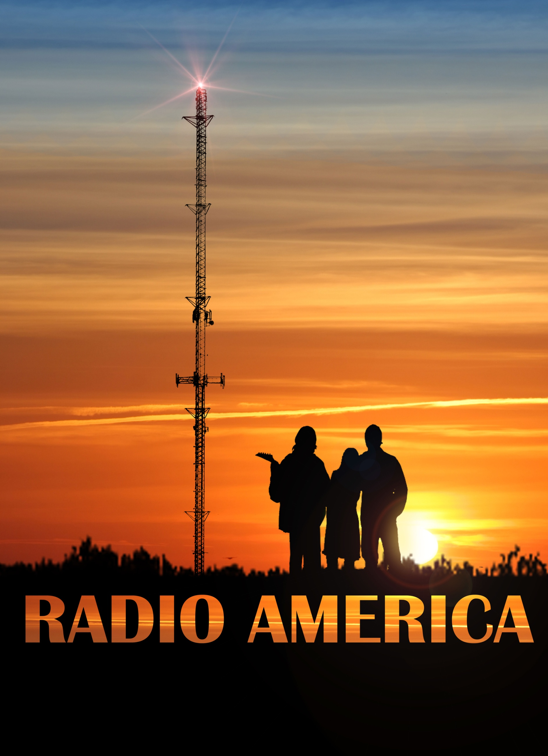

**“I LOVED Radio America... any small town musicians can easily relate to the movie. From the rise to fame to the pressures of success Radio America gives insight on the evolution of true musicians. Radio Random Network gives Radio America Two Thumbs up!”**

**- Russell Devin McLain CEO/Program Director - The Radio Random Network**

**This band's fascinating rise and demise is definitely worth the journey.**

**- Nowhere California (radio show)**

**“Beautiful story...Photography was gorgeous... Great soundtrack.”**

**- Bernadette  Brady – KTIM**

“For anyone who is interested music and bands, Radio America is worth checking out.”

**- M**eagan Meehan, The Examiner

**“Radio America gives you the VIP pass from farm**

**to fame with all the right tour stops in between.”**

**- Mireille Miskulin , The Entertainment Corner**

"We walked away touched by the incredible story told throughout the film. The movie features great music, as a film in this genre should, but the interactions between the two brothers and their friends is what makes the film so special."

- BGG After Dark

**“…Original and captivating…**  **Everyone who ever had a dream, this film will bring it back to life.”    * * * * \***

**- Mattie Peltier – Talent Monthly**

**The Story:**

Eric and Dave work on a dairy farm and play music in their off hours. Their friend Jane encourages them to play their music in public which brings the attention of a national record company. They are offered an opportunity to record some of their songs for the record company, but the material is deemed not commercial enough and the agreement is on the verge of being terminated. In a desperate attempt to prove their commercial viability to the record company, Jane takes their final recording to the local rock radio station where the DJ agrees to play the song on the radio. The overwhelming response from the listenership triggers a full blown record deal and tour as a warm-up act on a popular national tour. However, commercial success brings commercial pressures that strain their love for each other and for making music. A tragedy during the tour brings an end to their fleeting brush with fame and brings into focus what really matters most to them.

**A note from the director:**

**I love the anticipation and excitement you feel before a big show.  It doesn't matter if you're going to see the show or if you're going to perform in one, the excitement is a shared experience on both sides of the stage.  Music has that rare magic that can transcend boundaries to bring people together by expressing those universal emotions that we can't always express in any other language.**

**Radio America is a fictional tale spun from true stories woven together with a single through line.  I grew up in the Midwest and played in a bunch of rock bands at the time.  It was a magical time of my life because anything could happen and realizing dreams seemed almost inevitable.  Many of the situations in Radio America come from my time playing in rock and roll bands as well as the stories of my musician friends who have lived stranger-than-fiction lives!  Once I sat down to write this script, it exploded onto the pages in 18 consecutive hours.  Though the characters are fictitious, they are an homage to the wonderful and colorful people who passed through my life and made it richer.**

**Though recorded for this movie, the songs in Radio America were actually written during the time this story takes place - just before the collapse of the music business.  Many consider the period around the new millennium to be a turning point not only in how the music business marketed and monetized its product, but also how that music was actually created.  Before digital recording, the musicians all had to spend untold hours in a studio together, take after take, until they created something that was deemed commercially viable and hopefully artistically fulfilling as well.  And those trying times in the trenches acted both as the glue that bonded bands together in a brotherhood as well as blasted them apart in an effort to recapture their individuality.**

**I love the characters in this movie.  They're funny and tragic, selfish and selfless, childless and heroic, and ultimately fragile and human all at once.  I hope we have captured a glint of our shared humanity in this story about the magic of music, how two farmboys found it, lost it, and what it took to get it back.**

Meet The Cast:

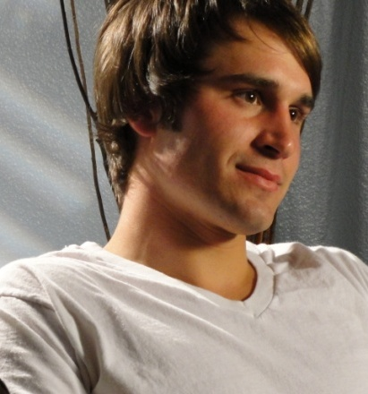

[Jacob Motsinger](http://www.imdb.com/name/nm2990560/?ref_=tt_cl_t1) (Eric Vandenberg): Born in Des Moines, Iowa, and raised in Slater, IA, Jacob excelled in academics, sports, music, and drama in High School. He later studied pre-med at Luther College in Decorah, IA while continuing to act and model. After wining several prestigious awards for acting, he moved to Los Angeles to pursue a career in acting.

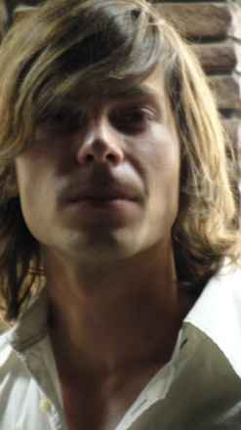

[Christopher Alice](http://www.imdb.com/name/nm3719485/?ref_=tt_cl_t2) (Dave Schultz) hails originally from Sweden. He came to the United States to pursue a career in the arts. He is an accomplished guitarist and musician. He has also won acclaim as a screenwriter.

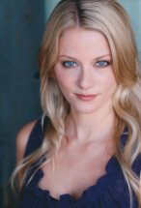

[Kristi Engelmann](http://www.imdb.com/name/nm2690914/?ref_=nv_sr_1) (Jane Taylor) is an accomplished actress from Chicago, IL with a formidable resume. She has studied at UCLA and DePaul University where she studied theater and psychology.

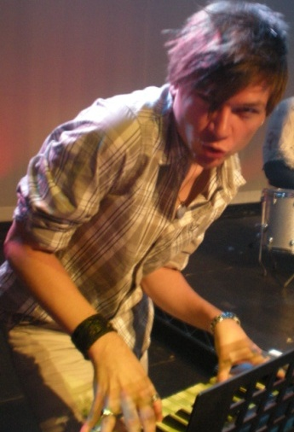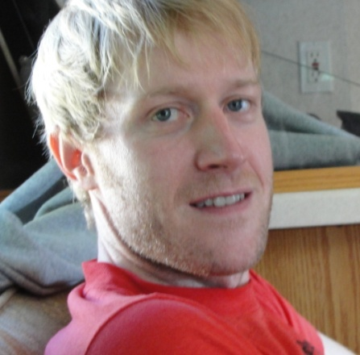

[Xander Jeanneret](http://www.imdb.com/name/nm3577853/?ref_=tt_cl_t5) (Bill) was born in Orlando, Fl, but grew up in the Midwest. He earned his Bachelor of the Arts at Luther College in Iowa. Since then he’s been around the world, living in Greece, Italy, Canada, Mexico, France, England, and Nagasaki, Japan. He is fluent in Japanese. He has gotten well known and loved as a regular on the show “King of the Nerds”.

[Wayne Bastrup](http://www.imdb.com/name/nm1955028/?ref_=tt_cl_t4) (Donny) is a talented drummer in real life as well as in Radio America. He also holds a masters degree in Architecture from the University of Washington and his work can be seen in Terminator Genisys.

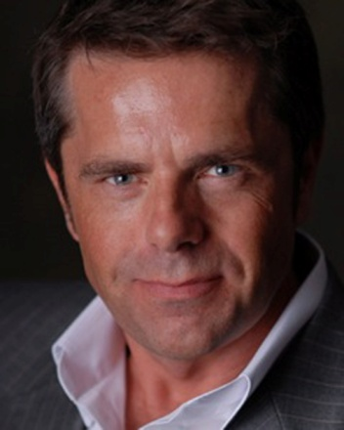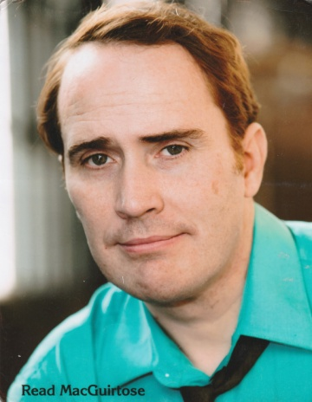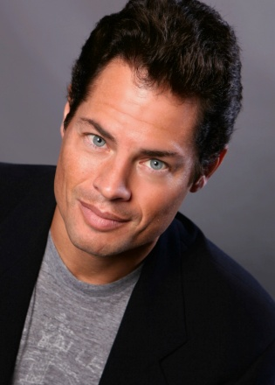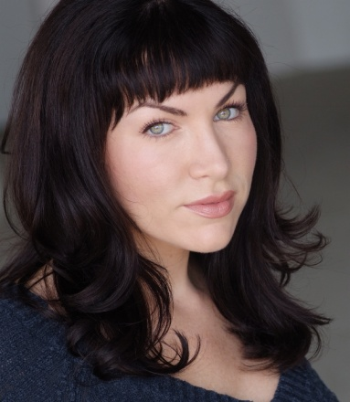

[Peter Le Bas](http://www.imdb.com/name/nm4159159/?ref_=tt_cl_t9) (McMahon) was born in Dublin Ireland to a family of entertainers. He was a regular on Irish TV during his teenage years. He has also built a successful private air charter business, which we found out after casting him as a promoter/pilot.

[Read MacGuirtose](http://www.imdb.com/name/nm2825835/?ref_=tt_cl_t6) (English Joe) is actually a singer/songwriter when he’s not acting. He also holds a masters degree in physics from the University of Southern California. He is a fine actor and improviser and always had everyone cracking up on set.

[Cheryl Rodes](http://www.imdb.com/name/nm2809010/?ref_=tt_cl_t8) (Bryce) is from Lake Forest, California and graduated from the School of Cinematic Arts at the University of Southern California. She has also written, directed and produced her own projects.

[Jeff Bold](http://www.imdb.com/name/nm4120295/?ref_=tt_cl_t7) (Tomi Sullivan) is an actor, a popular fitness trainer, and an avid outdoorsman in Los Angeles. Originally from Boulder, Colorado, Jeff has a huge heart and a giant personality that only fits in the great outdoors!

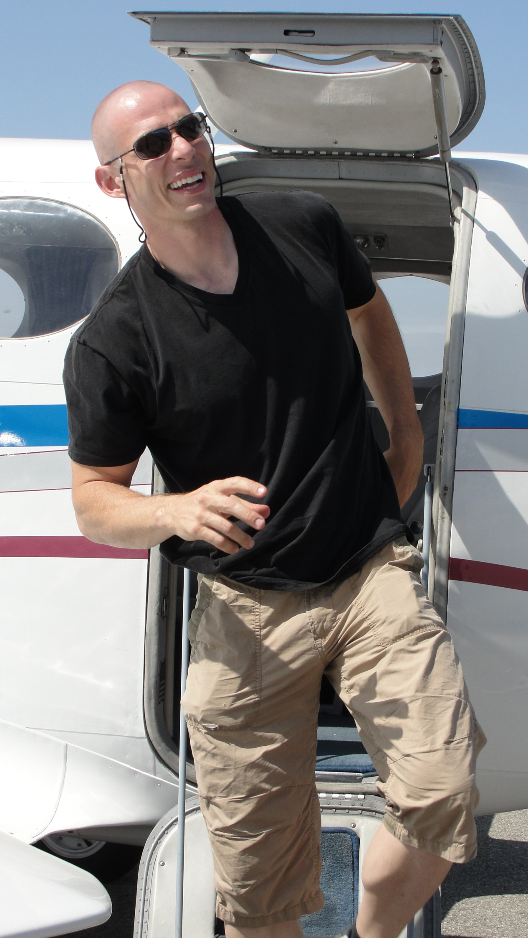

[Christopher Showerman](http://www.imdb.com/name/nm0962398/?ref_=tt_cl_t10) (Writer/Director/Simon)

Best known for his role as George in [George of the Jungle 2](http://www.imdb.com/title/tt0322389/?ref_=nm_flmg_act_30), Christopher grew up in a small farming community with a strong music background from his music teacher mom. He got a bachelors degree in Music theory and composition from Michigan State University before moving to Los Angeles to pursue a career in the entertainment industry. Around his college years, he performed various genres of music all over Michigan including rock, jazz, musical theater, and opera.

Radio America is a distillation of many of the experiences he collected during this time. The script was written in 18 hours and ready for production with a different director, but when that director fell out, Christopher was thrust into his directorial debut. Shot in over 30 locations with the generous assistance of literally hundreds of talented professionals, Radio America was a project that defied the odds time and time again.

The role of Simon also gave him the opportunity to debut his shaved head.

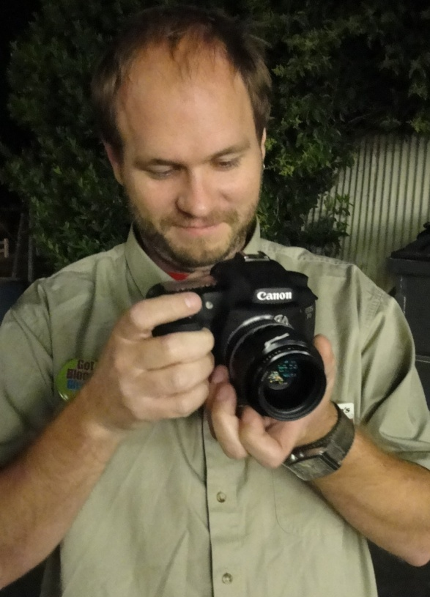

[Terrance Stewart](http://www.imdb.com/name/nm2725827/?ref_=ttfc_fc_cr9) (Director of Photography) studied psychology at Iowa State University and went on to study filmmaking at California State University, Long Beach. He's now the cinematographer for the Los Angeles Kings hockey team.

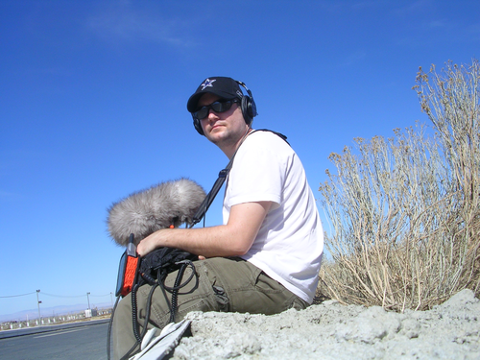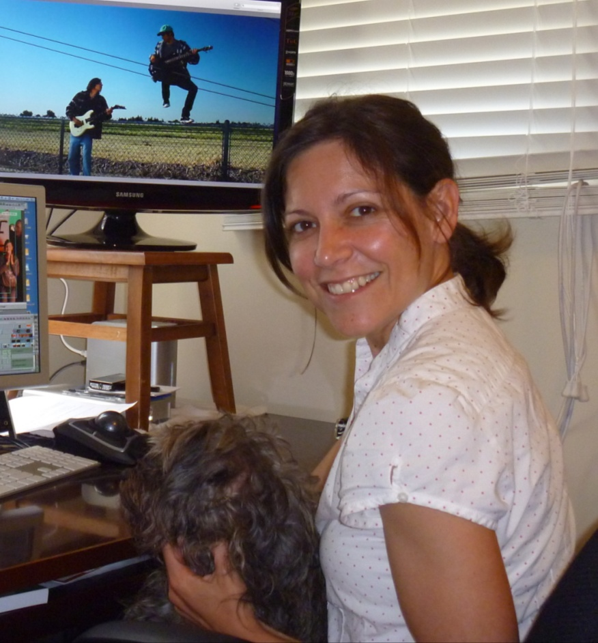

[Jason Tuttle](http://www.imdb.com/name/nm2294664/?ref_=fn_al_nm_1) (Sound Design) got his undergrad at the University of Michigan and got his MFA in Sound Design from the University of California, Los Angeles. He’s worked on films, TV shows, musicals, plays, video games, and web sites.

[Jessie Marion](http://www.imdb.com/name/nm0547983/?ref_=ttfc_fc_cr10) (Editor) grew up in Los Angeles and studied drama and

dance at the University of California in Irvine. Her impressive editing resume includes Disney and Warner Brothers Studios.

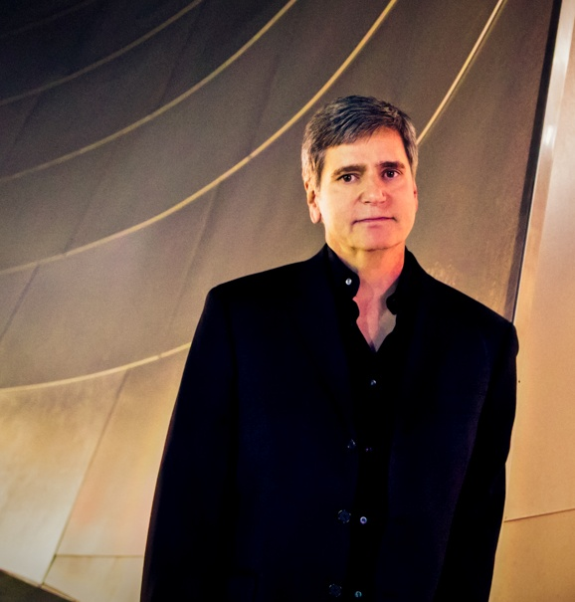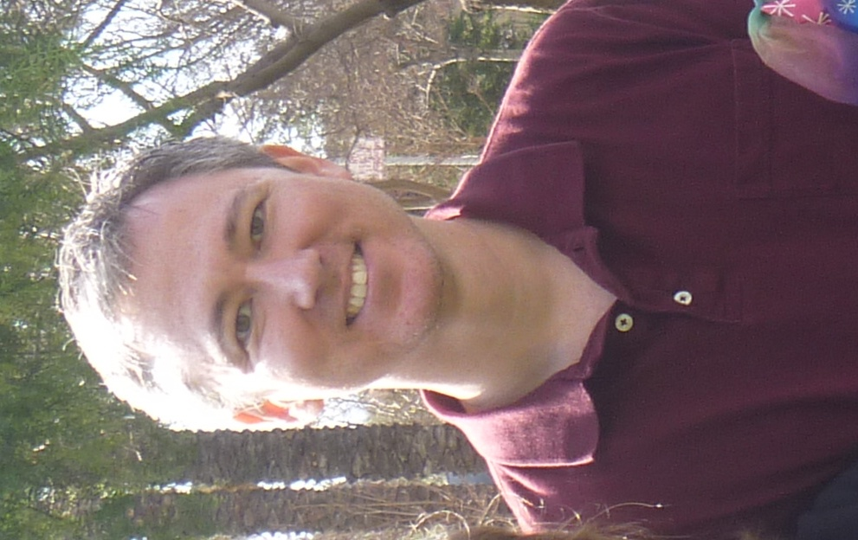

[Patrick Morganelli](http://www.imdb.com/name/nm2265179/?ref_=ttfc_fc_cr8) (Composer) comes to the entertainment industry after retiring from his previous career as an F-14 Fighter Pilot for the Navy. His remarkable musical versatility has served in a variety of cinematic genres ([Hear more here](http://www.patrickmorganelli.com/drama/)!) and most recently his multi-media opera, [Hercules Vs. Vampires](http://www.laopera.org/season/1415-Season-at-a-Glance/Hercules-vs-Vampires/), is being performed by the [LA Opera](http://www.laopera.org/).

[Thomas Moser](http://www.imdb.com/name/nm1093050/?ref_=ttfc_fc_cr28) (Visual Effects) studied film at Florida State University and Central Florida. He is one of the busiest guys in Hollywood working for Blacklist Digital and freelance on high profile projects you've definitely seen. He's also a fantastic writer and director with an impressive and varied body of work on his resume.

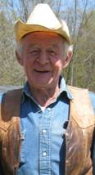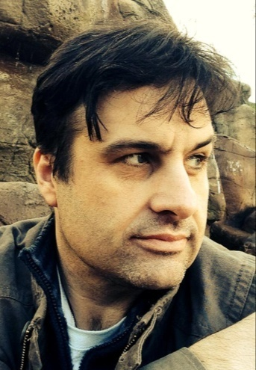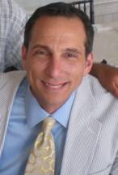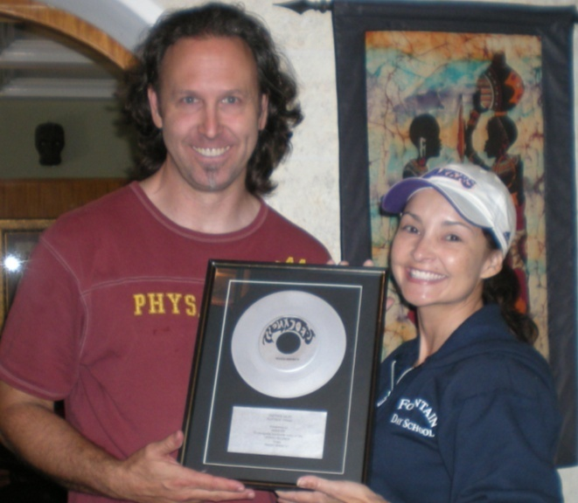O

[James C.Showerman](https://pro-labs.imdb.com/name/nm4481951/)

(Executive Producer)

[Chris](http://www.imdb.com/name/nm0243768/?ref_=ttfc_fc_cr2) & [Aliza Durand](http://www.imdb.com/name/nm0913325/?ref_=ttfc_fc_cr7)

(Producers and Art Department)

Chris is a well known Hollywood stunt man and writer. Aliza acts, writes, dances & played Laura the Trophy Secretary in Radio America.

[Greg Kappy](http://www.imdb.com/name/nm0438574/?ref_=ttfc_fc_cr3)

(Executive Producer) Check out Greg's powerful documentary [Shooting For Home](http://shootingforhome.com/).

[Clint Morris](http://www.imdb.com/name/nm2204071/?ref_=ttfc_fc_cr4)

(Producer & Publicity) runs [October Coast](http://www.octobercoastpr.com/#!) with experience in journalism, radio, print, online & TV.

**Or our official Website!**

**WWW.RadioAmericaMovie.com**