SMALL TIMERS SYNOPSIS
Directed by Jonny Cruz

Tag Line: One Treasure, Two Capers and Three Idiots!

SYNOPSIS:
Three small-time crooks with dreams of hitting a big score just can't seem to get anything right. When they attempt to steal computer parts – they end up with toys, when they try to steal a car – they end up with a junker. But when they accidentally stumble across a priceless erotic statuette known as Caesar's Phallus they think they’ve hit it big! Unfortunately instead they find themselves being pursued by a ruthless art collector, his hired hit men and their angry wives!

Rated: R

TECH SPECS:

SMALL TIMERS

Directed by Jonny Cruz

Starring: Jordan Spradley, David Conrad, Jonny Cruz, Nicole Leigh, Alcides Dias, Lela Bell and Frank Ford

Runtime: 80 minutes
Format: 1:85 Flat
Sound: Dolby SR
Country: USA
Language: English
Website: www. SmallTimersMovie.com
Genre: Action

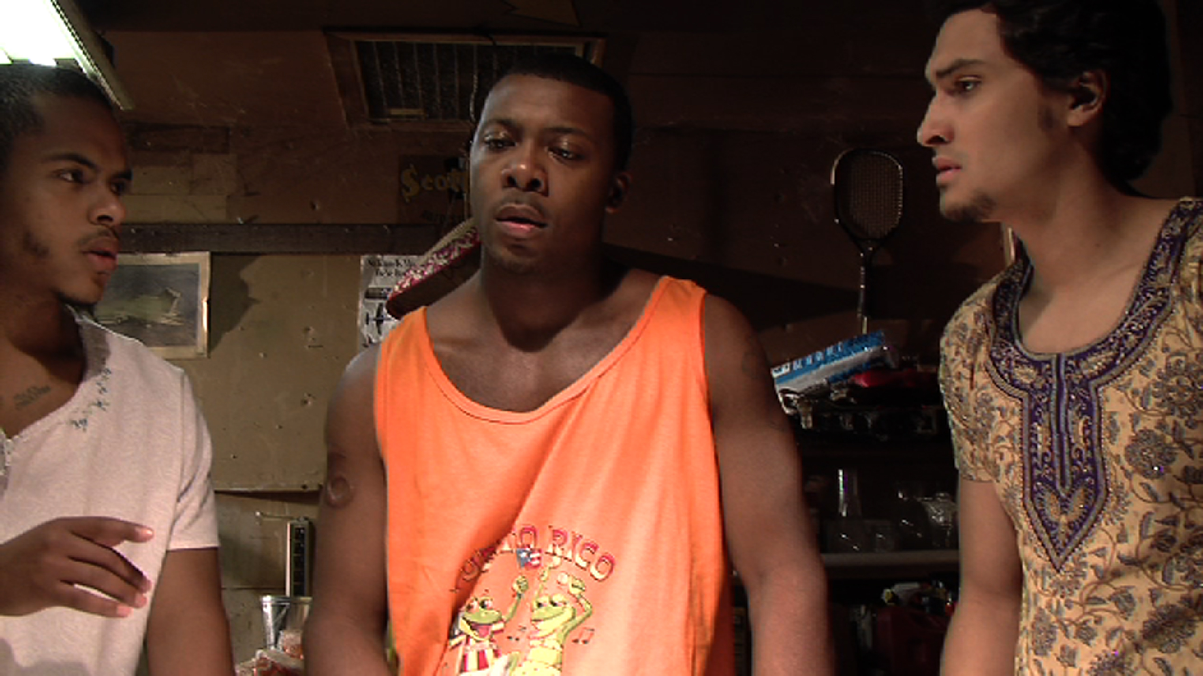
FULL SYNOPSIS

Small Timers is a fun, hilarious urban comedy revolving around the life of three amateur crooks, ANTOINE, CHRIS, and RICARDO. They aspire to make it BIG in the criminal underworld by pulling off the perfect score.
The brains of the operation, Antoine struggles with the fact that his life is mediocre. Right when he thought it couldn’t get worse, he loses his job on the same day his wife tells him she’s pregnant! Striving to make a name for himself and to bank some cheddar Antoine hatches the perfect plan to rob a bank. Now he brings in his best friend Chris who is the muscles and brawn of the group whose life has stalled out but is someone that Antoine can count on. Rounding out the trio is Ricardo, their charismatic buddy who is an adorable idiot. As a trial run the three rob a warehouse of computer parts to make some quick money and make sure the team is well oiled and ready to go. The first caper of course is full of accidents and the trio barely makes their getaway!
With one success under their belt the trio celebrates a little too quickly, until they realize they didn’t get computer parts, but instead robbed a toy factory…And to make matters worse, they get caught red handed by the Antoine’s wife! With another screw up under his belt and with everything looking like it’s hit rock bottom, an unexpected surprise lands in their lap.
Ricardo has a plan to rob a bank that seems foolproof – and this time the boys actually pull it off giving birth to three criminal masterminds! However, unbeknownst to them one of the items stolen from the bank turns out to be a Caesar’s Diamond phallus, a relic worth millions of dollars hidden within a briefcase from the bank heist. Suddenly faced with riches beyond their dreams the dynamic trio reaches out to their local fence about their score…
The fence immediately lets an erotic art collector, bank owner and criminal mastermind, Mr. Russo know about the heist immediately turning the trio into targets of entire underworld. Mr. Russo kidnaps Antoine’s wife while dispatching a ruthless hit man to kill the boys. Now Antoine, Chris and Ricardo must pull off the most important heist of their lives - Stealing back his wife.
Can they go from zeros to heroes? Or will they succumb to the mob and become buried in Giants stadium with Jimmy Hoffa! Find out in this fun, hilarious movie that is the perfect mix of old capers like The Hot Rock and the Sting with the modern humor of Dumb and Dumber and Friday!

- DIRECTORS NOTES -

Serendipity is the idea that you are always right where you need to be. You may think everything is going wrong, your life is in tailspin, and then from out of nowhere you find exactly what you’ve been looking for, all thanks to the trials and tribulations you’ve endured. I don’t know if I believe in fate or karma but it’s true that every mishap we had while working on Small Timers pointed us towards the answer we really needed.

Small Timers is the story of these three normal guys trying to be professional thieves. While trying to rob a bank they mistakenly steal a priceless treasure. These bumbling wannabes suddenly find themselves in the middle of the exact espionage they had been looking for, but it’s not really what they want, in fact the price and the danger are more than they bargained for. In the end they discover it’s the family and the friends they’ve grown with and love that is the real treasure.

Making Small timers was our own heist, instead of professional thieves, here we were trying to be professional filmmakers and just like our protagonists we found ourselves in over our heads plenty of times but we always found the answers and it was always thanks to the help of friends and family.

The idea to make the movie came from Tim Grace. I met Tim working on a horror film in college and we kept in touch after we wrapped. Some years later I was graduated from college and had been doing some steady acting work and making sketches for online on the side. I’d been throwing around the idea of making a feature, but didn’t really have the money. The amazing thing is once you put an idea out there the universe will often provide a way, because one day Tim calls me up out of the blue and says he’s going to make a feature and he wants me to shoot it. Naturally I said yes.

I was pumped, not just to be making my first film but because we already had an investor who promised to invest 90% of the budget. Before I knew it we were making a movie, we wrote up the script and started locking in dates and tying down our crew, everything was coming together like clockwork.

Of course we all know the best laid plans of mice and men often go awry. This guy who was planning to invest was an older dude, very sweet, and he said to us he really wanted to make a movie before he died. So of course right before we start making the movie, he dies. We do not get that money. My heart goes out to his loved ones, but my mind is racing at the thought of what I’m going to do. Here we are, ready to shoot and… we have no money. Tim says start shooting anyway, it’ll work out somehow. I’m less convinced than Tim, but we prepared to film anyway.

Before too long we had a couple 1000-dollar investors, then after a while a couple more. Incrementally over time more money would come in. It felt like every time we needed money it would come. I don’t even know where some of the money came from. We were hustling every day to get it. Al Dias was just a cast member and he was so happy on set with what we were doing that he decided to invest and eventually became one of our executive producers.
The investors for the film ended up being people who all cared about the film and wanted to see it made. That’s how it was every day. Whenever we ran up against an obstacle an answer would appear.

Locations were by far the biggest headache during production. The movie starts with the boys breaking into a warehouse. I wanted the film to look and feel like a legitimate caper movie before we brought in the humor. The first scene needed to have some suspense and it needed to look the part. I needed a huge warehouse, if I had my way it would have been the one at the end of Raiders, but this was Texas and those aren’t just lying around every corner. I end up driving around the warehouse district just looking into random spaces. None are ideal, most are too small or they just told me no. I’m lucky and I find one that will work, it’s not what I wanted and to make matters worse the owner wants 400 dollars down before we film. I talk to Tim, tell him our options and he says to bite the bullet and get it done.

I call the next day and tell the manager we’ll take the warehouse for 400. He says he’ll confirm with the owner and I assume that was the end of it. It’s not. I get a call back from the guy later saying the owner now wants 500. I begrudgingly go back to Tim with the new offer and he begrudgingly agrees to it. I call the manager back and now he tells me the owner wants 600. I tell the guy to go to hell and hang up the phone. I was done at this point, we needed to shoot in a couple days and I’d just given up on the human race. Why are people so greedy? What ever happened to supporting the arts? I try not to think about it and pass out anxious.

Tim calls me up a day later and says he’s found a warehouse. I almost didn’t care what it looked like; I just wanted to film the damn thing. We go see the place and it was exactly what I had envisioned. It was huge. It was perfect. And it was free! Scott free! Tim had mentioned off handedly to a woman he needed a warehouse and she just happened to own one. She respected what we were doing and because we were out there making it happen she was happy to help. Its uncanny how many times solutions appear like this. You need to always put out there what you need and it comes back to you. Always talk about your priorities; the universe wants you to succeed.

Of course sometimes the universe gives you a gift even when you don’t ask for it. There is a scene we filmed in the warehouse where we have to repel down from the roof. The day we were set to film we don’t have enough rigs for all three of us to use. I as the director decided to forgo the rig because of some stupid part of my brain that said, if anyone should get hurt it ought to be me. So I climb up this rope, we roll the camera and I shoot straight to the ground like a rocket. It was horrifying but my own damn fault. The best part is that we use the shot in the film; it’s one of my favorite parts because it’s totally real. It made the film better. We were always improvising on set and coming up with new ideas on the spot.

Frank Ford who played Mr. Russo, the main foil of the film, is a very skilled improviser. I had learned improvisation from him and so I was very comfortable going off script with him. We had a lot of fun playing around with Mr. Russo’s scenes and not just with what’s on the page, this movie showed me how selective I have to be with my shots. Mr. Russo is this very powerful man and his home needed to reflect that. Russo can’t just live in some suburban house or the dirty apartments all of our friends lived in. We needed a mansion.
Lucky for us Al Dias hooked us up with a friend who had one. Actually I take it back what I said earlier, the universe didn’t want us to make this movie, Al Dias did. This house was huge and gorgeous, it was pretty much perfect. Unfortunately, we couldn’t expect Al to pay his friends for using their house and we didn’t have enough money at the time to pay them, so as a result we wore out our welcome real quick. I had 10-pages to shoot in one day, but I made it happen and it taught me a lot.

The project was the greatest learning experience I ever had. We wanted to make a comedy movie that had heart; and of course, a golden dick. We wanted people to care about these three idiots. You look at these guys and they are all coming from a good place, they’re just doing it wrong. Our supporting characters grounded the world. The main character had a wife and baby on the way; these are good realistic stakes that we can relate to. We wanted this to be a funny movie about this silly priceless artifact, but still be believable. I think we were able to find the balance we wanted.

I still think it’s really funny that this movie is centered on a solid gold jewel encrusted dick. I know that’s crass but it just funny. I remember when we had to go buy the thing. I was with Robbie Story, my good friend and co-writer, I walked up to the counter and asked this girl behind it if we can hot glue gun jewels to this dildo. Immediately her interest piqued. When we said we were shooting a movie, laughing, we quickly had to convince her it wasn’t porn. Of course no matter how much glue we used, nothing would stick to this damn thing, but everybody wanted to play around with it. It became a joke that nobody can touch the dick! It became this real precious artifact being guarded. Talking about all this makes it seem like an outrageous movie but it’s not. It’s subtle even with its absurd parts.

The biggest beast of Small Timers was post and it almost killed me. The original cut after we finished filming was 2 1/2 hours. We sat on it for a long time because we didn’t know what to cut out. We over wrote and overshot. On set we were grabbing everything we could, we didn’t know exactly what we needed, but we wanted to make sure we didn’t have to go back because we didn’t get a shot or some idea.

We had been filming on HDV tapes. And we didn’t have a workflow to get the footage into avid; I couldn’t even get it into final cut to then transfer over to avid. I eventually had to get somebody else to transfer all the tapes onto separate hard drives. Each tape was 30 gigs, so editing tape off of these hard drives would tax them so heavily they would keep breaking down and we would lose footage. I had to recut so many times and there was all this willy nilly nonsense going on that I had no control over.

My full mental collapse came later when the cut was done and I was adding in ADR (additional dialogue recording). All the sides had been recorded and I had just finished dropping it all in place when the hard drive starts making this noise. You know that noise, a death rattle of sorts for technology. I tried so hard to save it, but the drive died right there in my arms and I just started crying. I was panicked, I was so close to being done and now I had to call all these actors back and tell them they had to come back and redo all the work they just did a few days earlier. I was sure everyone would be pissed and fed up with me and with this production, but no, they were all happy to come back. It had been two years and everyone was still so eager to help.
From then on I was through complaining, not because I wasn’t still frustrated but because of all the people that worked on this film and for the people who invested time and money and did it all with a smile. Small Timers was my film school it taught me how to cast, shoot, edit, write, do everything; by the time I was done I knew how to shoot a movie, a million dollar movie, I couldn’t do it before and now I could. Thank you all so much.

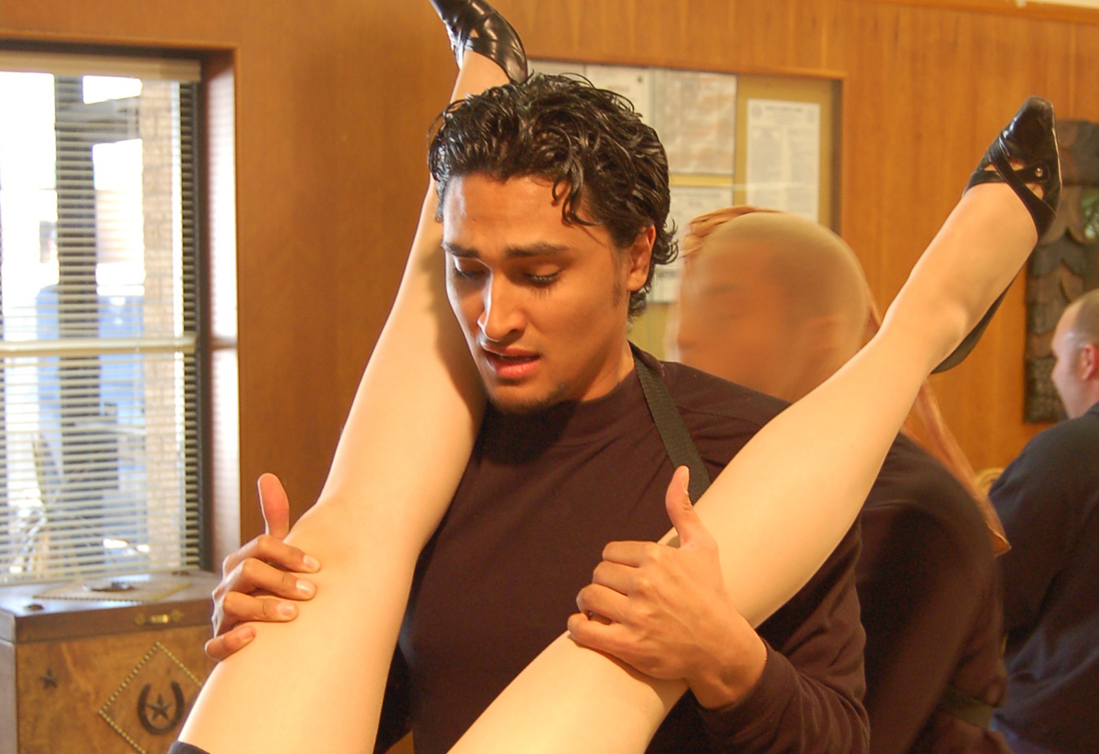
Technical Information:
Title: Small Timers
Genre: Comedy
Running Times: 89 Minutes
Media: HD MOV File
Digital Beta
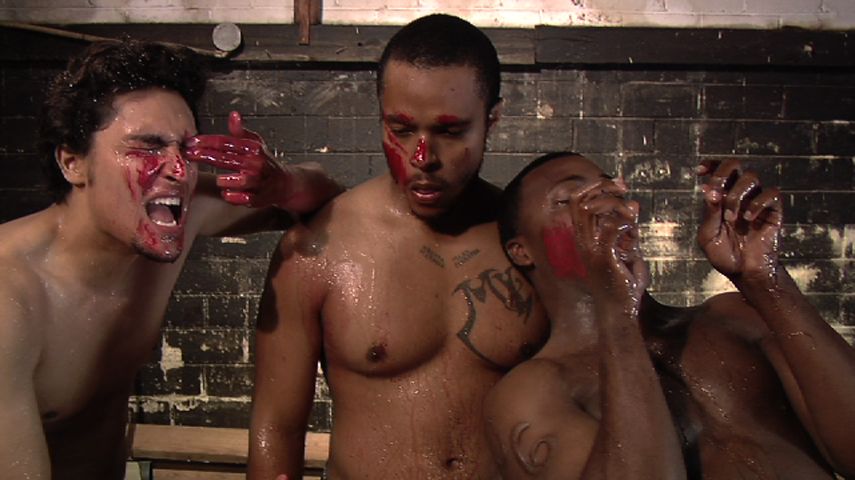
HD Cam - SR
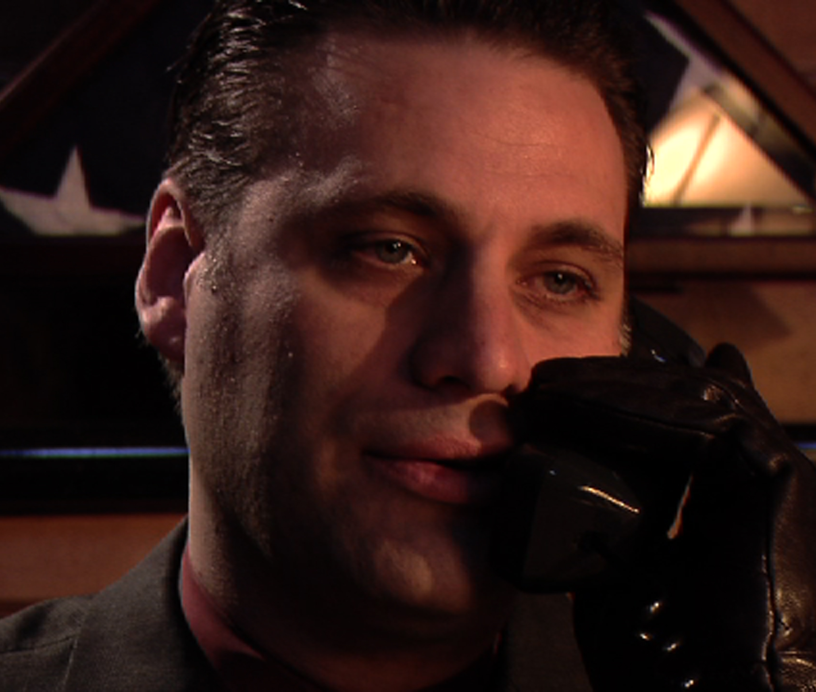

Principal Cast

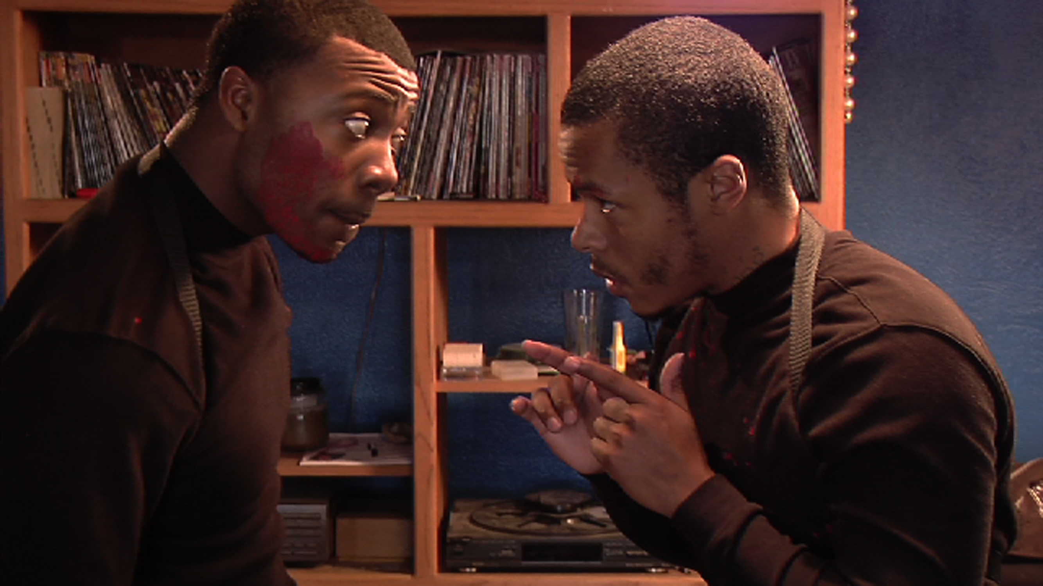
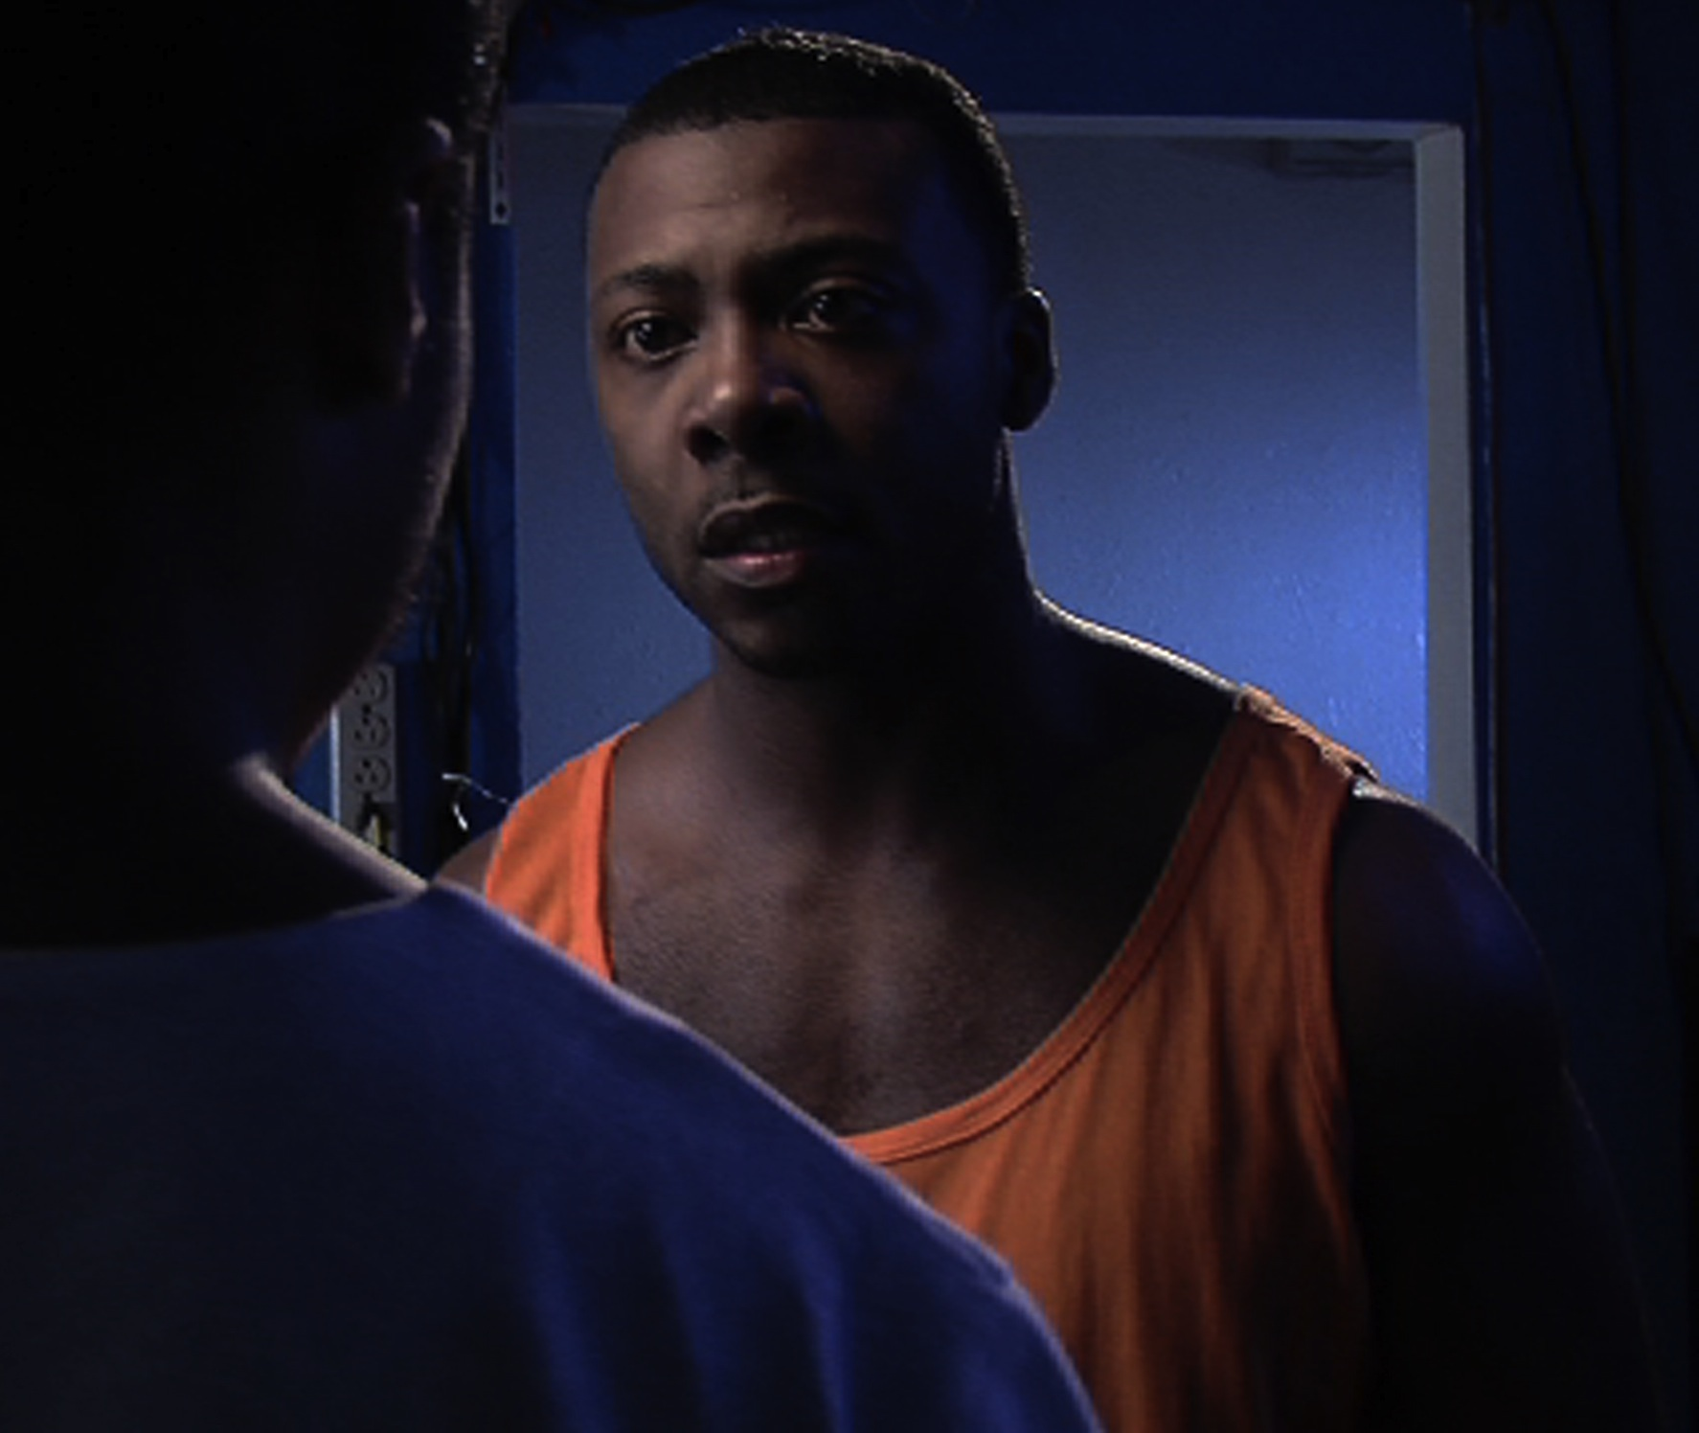
Jordan Spradley……………………………………….…Antoine

David Conard………………………………………….…….Chris

Jonny Cruz……………………………………………….Ricardo

Frank Ford………………………………………………….Russo

Lela Bell…………………………………………………....Jalissa

Nicole Leigh………………………………………………….Jade

Johanna Goldsmith………………………………….Mrs. Russo

Alcides Dias………………………………………………..Sykes

Dameon Ellis……………………………………Detective White

Robby Storey…………………………………..Detective Meeks

Brenna Demerson………………………………………..Camilla

Reese Rios………………………………………………...Jeffrey

Steven Markel……………………………………..….Mr. Simms
The Film Makers

Directed By
Jonny Cruz

Written by
Robby Storey
Jonny Cruz
Cortez Davis

Executive Producer
Ron Day
Alcides Dias
Jason Prisoc
Jeff Rodgers

Produced by
Jonny Cruz
Tim Grace

Director of Photography
Ron Gonzales

Edited by
Jonny Cruz
Ron Gonzalez
Tim Grace
Robby Storey

Original Music By
Gabe Patterson
Cody Westheimer

ABOUT THE CREW

JONNY CRUZ—DIRECTOR
Degree from the University of Texas at Arlington in Communication and Technology with a minor in Theatre, Jonny Cruz is part of the next wave of exciting film directors. Already an accomplished actor, as evident in his starring appearances in General Hospital and numerous action movies as well as “Jimmy Romero” in the upcoming action adventure Infiltrators! His comedic genius can be found in his shorts on the internet as well as the legendary improvisation appearances that he pops up in on stage and small films. Jonny is ready for the big time and Small Timers is a vehicle!

TIM GRACE - PRODUCER
Degreed in Music & Video Business, Tim’s experience in television/film includes production and promotion for such shows as "Club 104" and "Youth Quake", formally on the USA Network. Through his work on "Youth Quake" the show was nominated for a Cable ACE Award. He directed the pilot series entitled - "A Day-In the Life" as well as the Award winning show 'Kids Lives'. His recent achievements as Producer, can be found on distributed films 'Devon's Ghost: The Legend of Bloody Boy", The Imposter, The Lawn Boy, Black Angels, and Attack of the Yakuza

