STARCROSSED
Buckup Productions and Two Piano Films
Written and Directed Chase Mohseni
Produced by Ben Reed, Chase Mohseni, Chris Martens, Christian Papazian
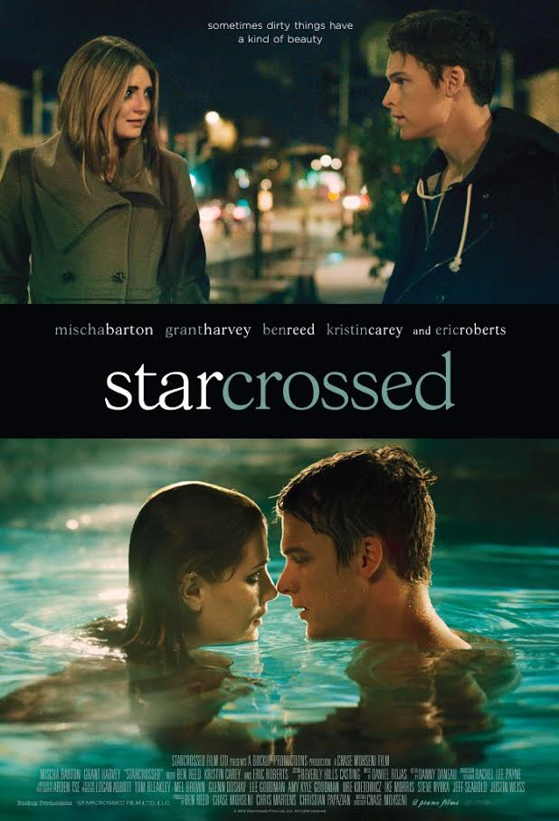
TRT: 82 MINUTES | HDCAM | COLOR | ENGLISH | MATURE | RED
LOGLINE
A down on his luck writer encounters a mysterious woman and over the course of one memorable night rewrites his future.
BRIEF SYNOPSIS
STARCROSSED is the story of four people each unhappy with their lives, whose paths unintentionally cross one fateful night, and are changed forever.
LONG SYNOPSIS
KAT and BEN are both locked in affairs that in their minds have long since run their course, but the one catch is, they’re bought and paid for. Neither one works, except…one night, as each of them roam aimlessly around the city, Ben stops her from running into the street and being hit by a speeding car.
Once they look at each other, it’s magic. She thanks him and heads into the bar across the street. He promptly follows her in to see what he might discover.
They’re respective lovers get ready for a night out as well, only to meet in ANTHONY BISHOP’S office where his wife LUCY BISHOP, pesters him about his business dealings with her wealthy father. He tries to reconnect with her momentarily but she rebuffs him in favor of leaving for the night.
Ben and Kat enjoy a healthy banter which digs deeper and deeper into the bedrock of their souls, but Kat won’t let it go too far. Right as they are about to truly connect, something insane happens…Anthony and Lucy walk in, unplanned, everyone is caught completely unawares.
Anthony quickly tries to resolve the situation by saying that Kat is his business partner’s niece, while Lucy says Ben is a cousin to a family friend. These thinly veiled lies suffice for the moment as Anthony tries to escape to the corner with Lucy. However Kat, ever the instigator, invites herself and Ben to follow them.
As they all sit down a hilariously awkward set of moments ensue as all four of them probe the others for information about how this terrible group back to pass. When pressed too hard Kat escapes to the bathroom. Feeling heavy glares boring down on him, Ben excuses himself and follows her to the bathroom.
When Kat emerges she and Ben have a quiet moment where she diagnoses the kind of person he is, that he’s hiding something. He suggests they leave but she denies him, “I can’t.” then begs him not to leave her alone with the Bishops. He follows her back, too intrigued to let the night end like this.
When they return Kat suggests they all take the party back to the Bishop’s, unable to deny them, all agree, with one condition, Kat rides with Anthony and Ben with Lucy. On ride back, Ben and Kat are both probed more vigorously by their lovers, and even threatened.
Once they arrive at the house, they are settle in, but Lucy demands her husband find the party the perfect drink, but pulls Ben along with him. As he and Ben peruse his garage/alcohol closet Anthony fires question after question at Ben. Trying to discern who is he to his wife, Ben battles back deftly but not without some fear of the physically more imposing Anthony.
Once they return and begin drinking, Kat starts to ask questions about the Bishop’s son, who is away at camp. Quick to avoid any unneeded conflict, Anthony pulls Lucy away for a private meeting and kisses her passionately on the stairs.
In the living room Kat and Ben are alone again and she takes the opportunity to go search the house. He pauses momentarily, then follows her outside. She jumps in the pool and dares him to jump in after her. He wonders where the Anthony and Lucy got off to but finally jumps into the pool to be with Kat. They almost kiss but she pulls away, afraid of what it might lead to.
Once out of the pool and dry, he presses her to what she is really doing here. She tells him she is a whore. She reels when she presses him to admit the same. Until finally he does.
Meanwhile, Anthony and Lucy are upstairs in their bedroom, laying side by side, post-coital. She quietly walks away from him as she presses her for even more intimacy.
Kat runs back into the house, trying to get away from Ben but meets a dead end. He closes the door and she kisses him. They dissolve into love making. Afterwards Ben relays the story of his mother’s death and how it ruined his father’s life, both he would never be like that, so he has actively chosen not to love. But again when he asks for her life story, she scurries into the bathroom and safety.
Lucy tells Anthony they should get back downstairs but he seems perfectly happy there, until she jabs him one too many times and he beats her, forcing her to admit that he is more powerful than her. In an ultimate display of monstrosity, he rains money on her as he leaves her on the ground crying.
Kat emerges from the bathroom but tells Ben she can’t leave, even though he’s called a cab. She leaves him in the bedroom but she soon follows her out but Anthony arrives on the scene and promptly asks Ben for some privacy with Kat.
Anthony then goes on the offensive, terrified that Kat might have betrayed him, feeling that she is the only thing he has left in his life. She won’t tell him anything unless he can give her the thing she’s always wanted, but he tells her it’s not possible.
Ben finds Lucy by the pool, she’s dolled up now, not outwardly the worse for wear. She launches into a predatorial attack on Ben but soon realizes his mind is on Kat. This destroys her, but before it can escalate too much the doorbell rings. Lucy calls Anthony to follow her, his business partner and Kat’s uncle, is there.
Ben finds Kat and presses her again, he wants to know her, until finally she dissolves and admits that her son with Anthony was taken away because of her drug addiction. That’s why she’s here. She wants to see him. When Ben says he can help her, but they should leave together, she tells him she doesn’t want to know him. This breaks his heart, he leaves.
Lucy finds ROMMEL LAZARUS in the dining room. Anthony tries to shut her up but she starts asking about his daughter, KATHERINE or KAT. We soon realize that Kat is actually his daughter.
Ben, tells his cab to turn around, and finds Kat outside, smoking. He convinces her that they are better off together and they head back for the cab. Outside the house, Rommel, who decided to flee the argument, runs into his daughter, Kat. He slugs Anthony, finally realizing what their relationship was. But when he tries to whisk her away, she releases a verbal tirade on him and scurries back into the house.
Ben finds her, she has Anthony’s gun in her hand. He tries to calm her but she’s distraught, thinks life isn’t worth living. As she raises the gun, Ben charges. BAM! It goes off.
We find Ben and Kat in his apartment, after seeing into his mind how he feels about their relationship, and the possibilities in it. Then he finally finishes his book.
The end.
DIRECTORS STATEMENT
There is someone out there who speaks a language only you understand, your secret lover. There are monsters out there who threaten to devour our. Starcrossed is a film about those people, about everyone. We are all lovers and monsters. But we can change, which is one of the best kept secrets in human existence. We have every ability to change within us. To choose it. To be reborn. The story I wanted to tell was one of rebirth, fated in the stars. I hope I did.
ABOUT THE PRODUCTION
PERSONAL JOURNEY
I wrote the play for Starcrossed over a weekend in a fit of rage. It was called Exit Strategy then and set in London. It was a polemic against modern relationships, my belief that they were doomed from the start.
A year later I did my first pass on the script and with the help of my producers we shaped it into something we believed we could make into a film. I’d like to add that this entire time we were in Grad School for Film Production. But we were eager to make the jump into the feature film realm and we were just naive enough to think we could make it happen.
Taking on a project of this size and scope was tantamount to learning how to swim in the Pacific Ocean, fifty miles from shore.
Over the course of six months and with the help of a dedicated team, we were able to cobble together the funds and a indomitable cast that championed my vision. It wasn’t always easy, but what’s that saying, “nothing good comes easy.”? It wasn’t easy…
LOCATIONS
On a budget, location is one of the most difficult things to procure. We were lucky enough to stumble across an old oil baron’s mansion but had to get the signatures of everyone within a five-mile radius of the house to make this happen. This was the best part of the process as I dressed up like a bible salesman and went door to door in the suburb of La Canada Flintridge saying I was doing my thesis project and getting the signatures I needed to film in a house up the street. Every few houses I got the door slammed in my face. But I got the requisite number of houses to sign; it was 10:30pm when I finished. But we were able to shoot.
There was another instance where we rigged this huge camera onto our producer’s car and drove around Toluca Lake at 8pm on a Sunday Night. People kept gawking at us and I had to massage the truth with our talent and crew, saying “of course we have a permit for this.” I knew if they were scared about being caught we would never get a natural performance out of them. Only the lead car knew to watch. I was laying the back with a monitor and headphones, praying that we wouldn’t get discovered; we shot continuously for about thirty five minutes without the slightest hiccup. That was a marvel.
SCHOOL
As I said beforehand, I was supposed to be in my final year of my MFA at Loyola Marymount when I decided to make Starcrossed instead of a massive short I had written. My producer, Chris and I, devised a plan and set out to speak with our thesis advisor about it. We had never met him and didn’t know if he’d be amenable to the plan. We met with him and told him our grand plan. He wasn’t skeptical at all, but said we need to keep this close to the vest so as to not arouse suspicion, since making a feature for your thesis was unprecedented. I need signatures from my other two committee members, so I went to each of them and sold them on the necessity of this film. They agreed and so began a year of massaging the truth. Eventually we graduated with the completed film and no one was the wiser, and if they were, they never said so.
LUCK
We also called in about every favor you could possibly call in when it came to gear. We got an amazing amount of help from the camera house on down to the portable toilets, all with the idea that we would find away to make it up to them if we were lucky enough to make another film, but this entire production would have been nothing without them as well.
VISUAL INSPIRATION
I believe in tone and mode. I believe those are your thesis statement in your film, they can communicate something words cannot on a cellular level. My genius Director of Photography, Arden Tse and I watched a handful of films and looked at a lot of paintings by Carvaggio and Rembrandt. We want the film, which was shot on digital, to have the feeling of those classic 35MM films of the 1970’s, the lush contrast that captivated you on such a visceral level. That led to our obsession with the idea of amber being the main color in our palette with sickly greens and blues making their way into the equation based on the emotional landscape of any given scene. We also played with red as it is to my mind the most expressive color in a filmmakers tool belt.
We also made a couple of rules with the size of the camera, that meant that we never did a close up unless entirely necessary, because we wanted to make sure the wides and mediums spoke truthfully and the close-ups meant something grander.
I have never believed in movement for movement sake, so we were sparse in our movement of the camera, even with Arden pushing me for the more “epic shot” in every moment it made sense. You see where we found moments to add it. I believe the style lends itself to the story in that, each character feels locked up, and as we move through their emotional and physical journey, we see more and more movement.
MUSIC
Daniel fought tooth and nail for this project, I had never worked with a composer before so I was greener than green when it came to selecting someone. But I do know that if someone has the talent and fights for you, that is the person you should be with. We had a minimal budget but he worked with us as if we were a 200 million dollar production. I have to say this was my favorite part of the process because at this point you’re only making the film better, so every day is a joy, because you’re creating a better moment, scene, film.
I remember one day specifically, the scene is a “emotional action scene” as I call them, which my producers always chuckle at, but Daniel had prepared something for me. He played it and he could see on my face I wasn’t feeling it. Instead of losing heart, he picked apart what was going on with me. We stripped the piece down to the part that was really hitting me in the gut. It was a small line he’d written to underscore the main piece, it was magical and terrifying. He cranked the volume on that and start playing the piano under it. We had magic. I can’t imagine the scene without his music as I can imagine any moment in this film without his music. It is the soul of the film.
ABOUT THE FILMMAKERS
CHASE MOHSENI WRITER/DIRECTOR/PRODUCER
Chase Mohseni received a bachelors in screenwriting and a master of fine arts in film production from Loyola Marymount University. Besides film, he is an avid playwright and theatre director. He recently produced the short film, The Dark Comes Quick, which premiered at the Dances with Film Festival and has another project, Zealot, in post-production, gearing up for a fall run.

BEN REED EXECUTIVE PRODUCER/ACTOR
Born in Tulsa, Oklahoma, Reed grew up in Bixby, Oklahoma before attending West Virginia University where he was the starting quarterback. Acting was always the direction he was headed when his football career ended. When the opportunity came for him to attend the American Academy of Dramatic Arts right after college, he seized it and never looked back. Reed's newest film not only has him starring in front of the camera, but also behind as the Executive Producer of STARCROSSED, an independent film which debuted to rave reviews at the San Diego Film Festival. Appearing alongside Reed in STARCROSSED is Mischa Barton and Eric Roberts in the story of a down on his luck writer who encounters a mysterious woman (Barton) and over the course of one memorable night rewrites his future.
CHRIS MARTENS PRODUCER

Chris Martens is a filmmaker living in Los Angeles, CA. Martens was a producer on Starcrossed, which had it’s premiere at the San Diego Film Festival. He directed and produced the short film The Dark Comes Quick, which premiered at Dances With Films and received the highest number of festival audience votes ever for a horror short film. Martens received his MFA in Film and Television from LMU and prior to this, he went through the prestigious Individualized Major Program at Indiana University where he constructed and graduated with a Film Directing and Producing major. Martens is currently producing the independent feature film Zealot and developing a number of other projects

CHRISTIAN PAPAZIAN PRODUCER
Christian Papazian has been a avid film maker since a young age. Writing, directing and acting in films since he was a child. Christian then obtained a bachelors degree from Loyola Marymount University in film and television production. Since then he has joined the Directors Guild of America (DGA) and has been an assistant director on Disney Channel sitcoms "Girl Meets World" and "Mighty Med". He has also produced many independent short and feature films during his off time. One day he aspires to produce and direct studio feature films.
ARDEN TSE DIRECTOR OF PHOTOGRAPHY
Arden was born in China, grew up in England, was educated and trained at Loyola Marymount University: School of Film & Television in Los Angeles. Arden has embraced the world of cinematography with dedication, consistency and endless passion. He is fully aware of the importance of teamwork and having a singular vision in any project. Arden's mantra is to collaborate with the director and producer with a view toward achieving the optimum degree of artistic potential for the respective project and to create through the art of visual storytelling, a profound emotional impact in the audience. Arden was a 2014 ASC Linwood Dunn Heritage Award Undergraduate Nominee finalist. He was also nominated three times for Best Cinematography Award at Film Outside The Frame Festival as well as a win for the Ian Conner Cinematography Award for LMU SFTV’s 2013-2014 Calendar year.
DANNY DENEAU EDITOR
Born in the storybook world of the Cotswolds in Oxfordshire, England, Danny graduated with an MFA in Digital Cinema to write and direct his first feature at the age of twenty-four. Making his livelihood as an editor, his work has premiered at SXSW, been well reviewed by the New York Times and Cinema Editor Magazine, and can currently be seen on HBO. In 2015, Daneau joined the creative production studio KIDS AT PLAY to produce and edit new projects within the company. Daneau currently resides in Los Angeles with his filmmaker wife and enjoys camping, traveling, and spending time with his family in Florida and Ecuador.
DANIEL ROJAS COMPOSER
Daniel Rojas was born and raised in Costa Rica into a musical family. He moved to the US to study at the University of North Texas, where he graduated with a degree in Jazz Studies. In 2008, he co-founded Vesper Sound in Dallas, TX - composing music for commercials and TV shows. He later moved to Los Angeles, where he assisted German film composers Hans Zimmer and Klaus Badelt on nearly 30 feature films and video-games. During this time, he also worked on arrangements of songs by Bryan Adams, Peter Gabriel and the Academy-Award winning duo of Alan Menken and Sir Tim Rice (The Lion King). He currently works as a freelance composer and producer out of his studio 506 Music in LA and is represented by Soundtrack Music Associates in Santa Monica, CA.
ABOUT THE CAST
GRANT HARVEY
Born in a small town in Nevada, called Hawthorne, Grant Harvey grew up running the family pizza parlor, Harvey's Pizza, with his younger Brother and two Parents. He didn't get involved in acting until his early twenties, after he moved to Los Angeles and landed a gig on the highly successful teenage drama, The Secret Life of The American Teenager, playing, coincidentally, the character "GrantVolberg," who worked part time as a pizza delivery boy. Since then, Grant has displayed a vast range of performances, from arcs in comedies such as ABC's The Neighbors to powerful turns in dramas like Showtime's Masters of Sex and, among an array of Guest roles on other TV shows, the highly anticipated film, Billy Boy, due out in 2016.
MISCHA BARTON
Born in London and raised in New York. She went on to work side by side with modern-day screen icons including Julia Roberts and Hugh Grant on Notting Hill (1999), Bruce Willis and Toni Collette on The Sixth Sense (1999) and Sam Rockwell in her Sundance critically-lauded feature film debut Lawn Dogs (1997) produced by Duncan Kenworthy in 1998.Established as one of the most sought after young actresses of her generation Mischa was named "It Girl" by Entertainment Weekly, she was also Hollywood Life's "Breakthrough Actress of the Year", she won several American Teen Choice Awards for the show, and also Cosmopolitan's "Fun Fearless Female Award" for "Knockout Ingenue.

KRISTIN CAREY
Kristin Carey grew up in Santa Rosa, California with the dream of being an Actor.. She attended the prestigious School of Theatre at The University of Southern California where she received her B.F.A. In Theatre/ Film. Kristin has worked in all mediums. She has appeared in over 100 National Commercials, numerous TV Shows such as The West Wing, Criminal Minds, The Newsroom, It's Always Sunny in Philadelphia, Rake, to name a few, and has a recurring role on Scandal.

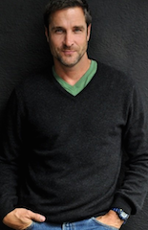
BEN REED
Ruggedly handsome film and television actor Ben Reed starred in the Oscar nominated film AMERICAN SNIPER (including ‘Best Picture’), whose $90 million weekend box office helped cement Reed as a highly sought after Hollywood star. Under the direction of Clint Eastwood, Reed stars as ‘Chris Kyle's’ (Bradley Cooper) father in the film. As Cooper recounts the Navy S.E.A.L hero's amazing and gruesome military career throughout AMERICAN SNIPER, vivid memories of father and son give the audience a glimpse of the values and discipline which inevitably shape Chris Kyle into the man that he has become. Reed drew inspiration for the role from his brother who in real life is an esteemed member of the Army Special Forces
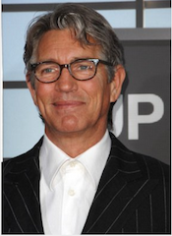
ERIC ROBERTS
Eric Roberts is an Academy Awards nominee for his role in Runaway Train and a three-time Golden Globes nominee for Runaway Train, Star 80 and King of the Gypsies . He also won a Golden Satellite Award for the 2002 season of Less Than Perfect . Eric Roberts was born in Biloxi, Mississippi and grew up in and around Atlanta, Georgia area. In 1989 Eric won the Theatre World Award for his role on Broadway in Burn This. Eric Roberts was recently seen in Christopher Nolan ’s Batman – The Dark Knight , along with one of the most incredible casts ever assembled.

STARCROSSED CREDIT LIST
WRITTEN, DIRECTED AND PRODUCED BY CHASE MOHSENI
PRODUCED BY BEN REED, CHASE MOHSENI, CHRIS MARTENS, CHRISTIAN PAPAZIAN
COSTUME DESIGNER, LILY WALBRIDGE
MUSIC BY DANIEL ROJAS
EDITED BY DANNY DENEAU
PRODUCTION DESIGNER RACHEL LEE PAYNE-DARROW
DIRECTOR OF PHOTOGRAPHY ARDEN TSE

CAST
GRANT HARVEY
MISCHA BARTON
BEN REED
KRISTIN CAREY
ERIC ROBERTS
JONATHAN ROSENTHAL

FESTIVALS & AWARDS
SAN DIEGO FILM FESTIVAL
PRESS
Del Mar Times
Carmel Valley actor and former Country Day student join forces to produce film ‘Starcrossed’
Loglines
A Starcrossed Premiere

