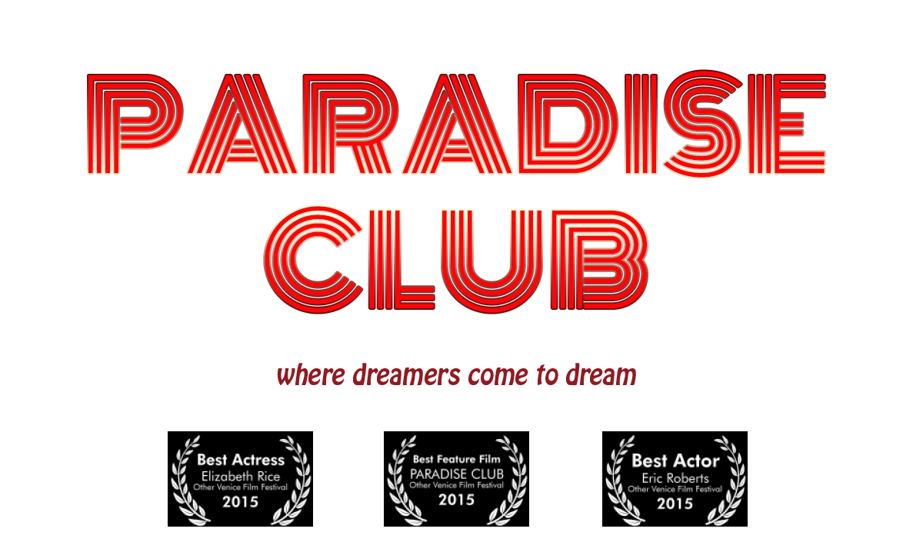

BEST FEATURE FILM – THE OTHER VENICE FILM FESTIVAL 2015
BEST ACTOR – Eric Roberts – THE OTHER VENICE FILM FESTIVAL 2015
BEST ACTRESS – Elizabeth Rice – THE OTHER VENICE FILM FESTIVAL 2015
OFFICIAL SELECTION – THE SAN FRANCISCO INDEPENDENT FILM FESTIVAL 2016

SOCIAL MEDIA & WEBSITE

www.facebook.com/paradiseclubmovie/
http://instagram.com/paradiseclubmovie
https://twitter.com/paradisefeature
http://www.imdb.com/title/tt2540136/
http://paradiseclubmovie.com

ABOUT

“I wanted to be one of the wild ones, the ones who broke free.” These words begin the semi-autobiographical tale of Catherine’s (Elizabeth Rice) journey in 1968 into the heart of the sexual revolution in San Francisco. She dances naked in the Paradise Club. The soul singer stirs up the customers. “Brothers and sisters, these are good times! America’s doin’ fine!” Catherine begins a doomed affair with the club’s owner, Earl (Eric Roberts). She meets her soul mate, Ben, (Evan Williams) but love eludes her. She quickly descends into the club’s dark underworld where she lives by night while America burns with the war in Vietnam, political assassinations and anti-war protests. By the end of 1969, peace and love are dead and Catherine must find her way back into the light.

GALLERY
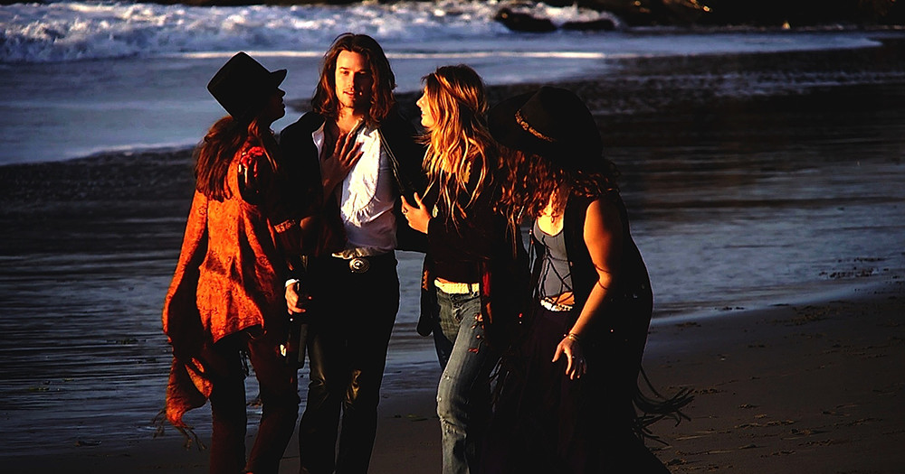
Ben Montgomery swarmed by groupies on Baker Beach, San Francisco the day after his concert at Fillmore West in 1968.

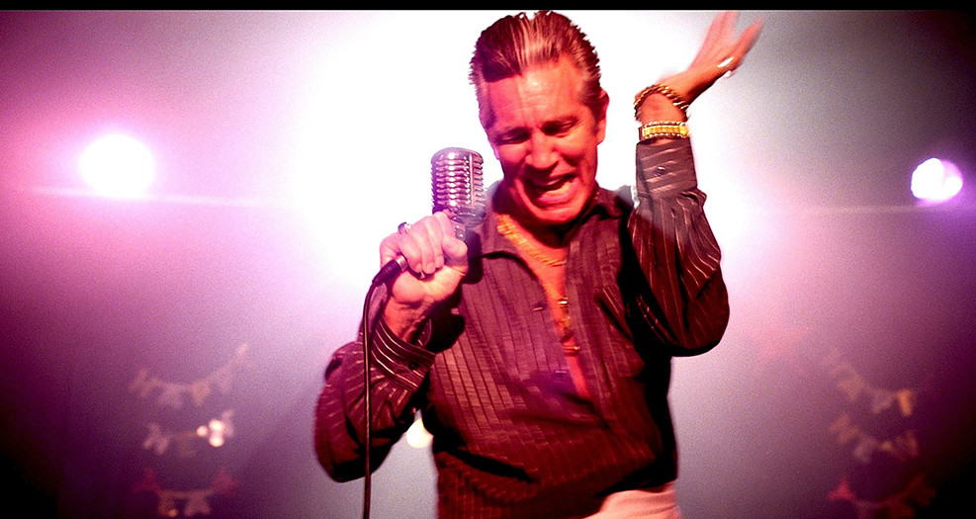
Earl Wild on the Paradise Club stage in San Francisco on New Year’s Eve 1970.
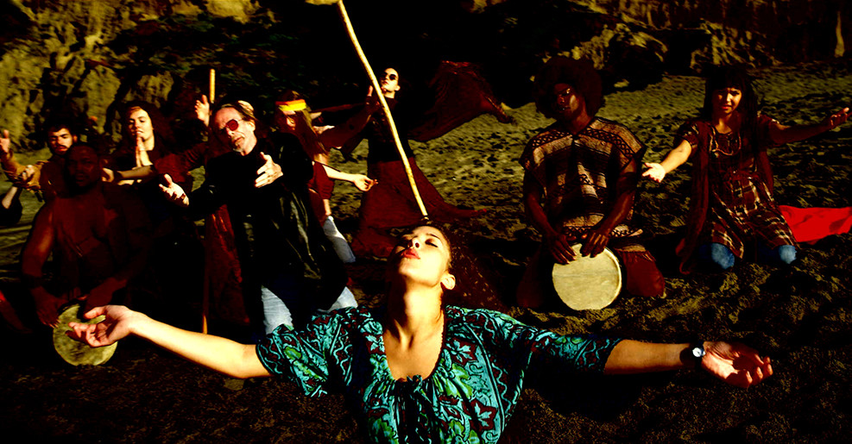 The Tribe greets the setting sun in LSD ecstasy, Baker Beach, San Francisco, 1968

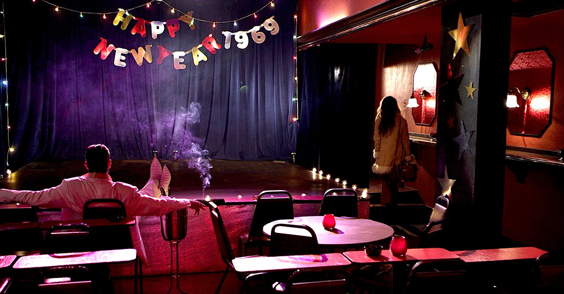
Earl Wild awaits the last night of the Sixties in the Paradise Club, New Years Eve 1969.

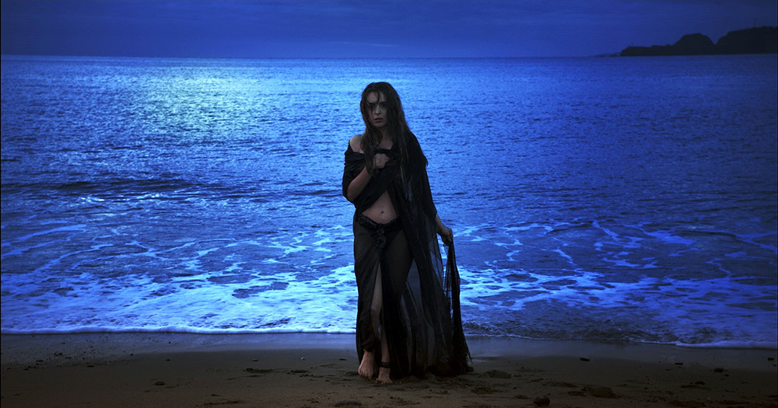
Catherine comes out of the ocean at Baker Beach in a dream sequence in 1969.

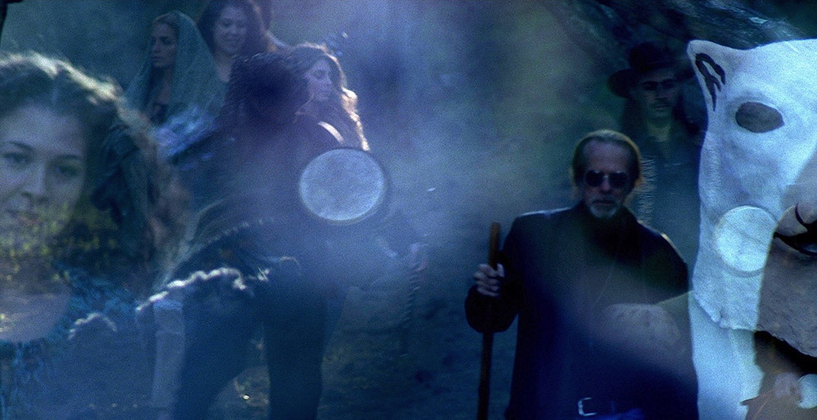
The Tribe descends the hill in the fog on their way to Solstice Ritual on Baker Beach, San Francisco 1968.
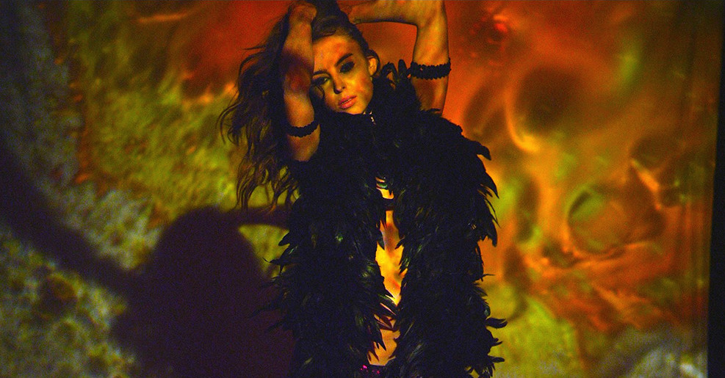 Catherine performs on the Paradise Club stage during a liquid light show, San Francisco 1969

Ben climbs on stage with Catherine during her performance, Paradise Club, San Francisco, 1969.

BIOS

Writer/Director – Carolyn Cavallero

Carolyn Cavallero earned her MFA Degree at University of California, Berkeley during which time she took part in the civil rights and anti-war demonstrations of the late Sixties. Cavallero worked in the Paris atelier of fashion designer Vicky Tiel before returning to San Francisco to start her own label. Her love of photography led her to document the lives of exotic dancers in the clubs of San Francisco. Following this, Cavallero spent the next decade as a successful fashion photographer. In 1990 she left the business to marry Russian film director Sergei Bodrov and moved to Moscow where she wrote and produced the Russian film “I WANTED TO SEE ANGELS”. Moving to Los Angeles in 1992, she and Bodrov established a writing partnership that included such films as “THE QUICKIE” and “BEAR’S KISS” among others. From 2002-2011, Cavallero lived in solitude in the Southern Arizona desert. In 2012 she emerged to write and direct “PARADISE CLUB”.

Producer – Sergei Bodrov

In the United States and abroad, Sergei Bodrov is widely regarded as one of world’s most esteemed international filmmakers. As a director, screenwriter and producer, his powerful films have won him respect and awards across the globe.

Known for capturing incredible cinematic scope, Bodrov’s epic film MONGOL received the 2008 Academy Award nomination for Best Foreign Film. MONGOL also won the coveted National Board of Review for Best Foreign Film, among numerous other accolades.

A consummate actors’ director, Bodrov is revered for his ability to combine large scale production with formidable artistic vision. In 1996, he was also nominated for the Academy Award and Golden Globe for Best Foreign Film for PRISONER OF THE MOUNTAINS, based upon the novella by Leo Tolstoy. This film went on to win the Nika, Russia’s equivalent of the Oscar, for Best Picture and Best Director.

In addition to his Oscar nominations, his films have won awards at The Berlin International Film Festival, Montreal World Film Festival, The Torino Film Festival, and many others. His other directing credits include NOMAD: THE WARRIOR, BEAR’S KISS, THE QUICKIE, and RUNNING FREE.

Bodrov’s most recent directorial effort was the Legendary Pictures & Universal Pictures mega fantasy release, SEVENTH SON, starring Jeff Bridges and Julianne Moore, an international box office success.

Richard J Bosner - Producer

Richard J. Bosner line produced the politically-charged true story FRUITVALE STATION starring Octavia Spencer and Michael B. Jordan which received the Sundance Film Festival U.S. Grand Jury Prize in the Dramatic category and the Sundance Audience Award, U.S. Dramatic, presented by Acura along with 44 nominations/wins during the 2013 Awards Season.

Bosner also produced THE WANNABE starring Patricia Arquette, with Executive Producers, Dean Devlin and Martin Scorsese. In 2015 Richard wrapped two films which he shot back-to-back in the San Francisco Bay Area; THE BOAT BUILDER starring Christopher Lloyd, and CARDINAL X for Executive Producer Cassian Elwes. He was also an executive producer on OTHER PEOPLE starring Molly Shannon & Jesse Plemons which was the opening night film at this years Sundance Film Festival. He is currently in production on SAN BERNADINO BOUND, staring Josh Peck, Tony Revolori & Andy Samberg.

Louis Ferrara – Co-Producer
Louis Ferrara cut his teeth in production, working on such projects as XX/XY for IFC, AT FIRST SIGHT for MGM, and in television, as Production Coordinator on a whopping 132 episodes of FOX’s worldwide juggernaut, THE SIMPSONS and THE SIMPSONS MOVIE.
Always following his passion for filmmaking, Ferrara’s primary education was at New York University but his secondary education, was in the Motion Picture Lit dept at the venerable William Morris Agency, until he transitioned to the innovative, United Talent Agency, where he progressed into the Talent dept. Now, Louis has parlayed that knowledge into his most recent position as Direct of Development and Production at Bodrov Film Production, where he was a collaborator of the esteemed Russian/American director/producer/screenwriter, Sergei Bodrov. Recent credits include Associate Producer on the Legendary Pictures fantasy tentpole, SEVENTH SON, starring Jeff Bridges and Julianne Moore, Co-Producer on the psychedelic art house pic, PARADISE CLUB, and Executive Producer on the inspiring documentary BLACKSMITH.

CAST
Eric Roberts: Nominated Golden Globes Best Actor “King of the Gypsies”, nominated Golden Globes Best Supporting Actor “Runaway Train”, nominated Academy Award Best Supporting Actor “Runaway Train”, nominated Golden Globes Best Supporting Actor “Star 80”. Played the character “Moroni” in “Dark Knight”.

Elizabeth Rice: Recurring role on “Mad Men” playing Roger Sterlingʼs daughter Margaret. Lead actress in “The Faith of Anna Waters” shot in Singapore.

Evan Williams: Currently filming the second season of “Versailles” directed by Jilal Lespert in Paris.

MUSIC

Music Producer Daniel Lanois has won 7 Grammys for producing such legendary musicians as U2, Bob Dylan, Neil Young and more. Playing steel guitar, he joined Rocco De Luca in recording “Nightingale” and “Thief In The Moon” for the movie. De Luca has also written and recorded 3 additional songs for the movie.

The Soundtrack of Paradise Club features such Sixties classics as:
“TODAY” by the Jefferson Airplane
“GET TOGETHER” by The Youngbloods
“THE FOOL” by Quicksilver Messenger Service
“COCAINE” by Dave Van Ronk
“DEATH SOUND BLUES” by Country Joe And the Fish
“GREEN MANALISHI” by Peter Greenʼs Fleetwood Mac
“WHITE BIRD” by Itʼs A Beautiful Day

From the Fifties:
“I ONLY HAVE EYES FOR YOU” by the Flamingoes
“THE SKY IS CRYING” by Elmore James
“TRY A LITTLE TENDERNESS”, “CANʼT TURN YOU LOOSE”, and “CRY, BABY” is performed on screen by Billy Madden and The Thrillers.

SOUND

Sound Designer Peter Brown created the sound for the movie. He is an Emmy Award winner for Sound Design on “Game of Thrones”.
Re-recording Mixer Mark Paterson won the Academy Award for Sound Mix for “Les Miserables”.
EDITING

Greg DʼAuria was first assistant editor on “Django Unchained” and “Kill Bill”.
Howard Smith was editor on “The Abyss”, “Strange Days” and “Point Break”.
Ken Blackwell edited “Conan the Barbarian” and “Ouija”.

DIRECTOR’S NOTES
I AM A SLAVE TO MEMORY. IT ALL HAPPENED IN THE LATE SIXTIES.
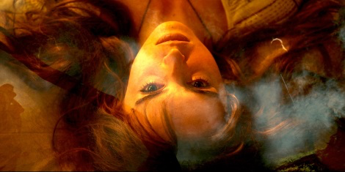

I am a slave to memory.
If I believe the quantum theory of “Many Worlds”, then I dwell in the world of memory as much as I do in the “here and now”, whatever that means. When I was young…I heave a great sigh and my heart races and I feel, for a too-fast nanosecond, that old wild wind nipping at my ass, pushing me forward into…where? Who cared? Just “further” as Kesey said or “Go, just Go, go, go!” That’s Kerouac talking. The main character in my movie (I’ll get to that later) hears those words and says “So I went!” I look back now and I can say, “I went!” There’s a line from the great blues singer, Ma Rainey, “I looked down the line and I wondered. Then I buckled up my shoes and started.” Who knows what awaits down that line but the thing is to put on shoes and get going.
.

About this memory business
It all happened in the late Sixties. In San Francisco. Berkeley too, but that was different. It’s not for nothing that the Bay divides the two cities. One was PC and the other was not! (in those days) You may not know by looking at San Francisco now but from the 1890s to the end of the Sixties it was known as “Sin City”. It was also called the Barbary Coast. Gambling, outlaws and wild women. All gone now of course. The long arm of government could not reach those bars and brothels. There was always music. Honky tonk piano, later jazz sax, still later electric guitar. It was an open city where you could be whatever you wanted. It was your best shot at freedom in America.
.
So there I was in 1967 in San Francisco. Just out of Berkeley with a Master of Art degree in hand. A good artist but not that good. Then the wild wind came storming after me and blew me into the zone of “Go!”

Where to find my place in life, where to be blessed before entering the “real world’, where to express myself, say what I had to say, find the magic, find that freedom? In a topless club, of course.

THE STORY BEHIND “PARADISE CLUB” by CAROLYN CAVALLERO

The story of Paradise Club…
…began in 1968 when I lived in San Francisco during those wild days of
revolution. Joy and pain, sex and death, all lived out, all somehow endured
under the spell of the music.
Paradise Club is the story of this yearning for freedom, this burst of brilliant
light that started to go bad almost as soon as it had dazzled the eyes of so
many hopeful young people. By the end of 1969, the dream was over, the
light went out, and we were left blinded, groping in darkness trying to find
that door marked “paradise”. The door was locked, the key lost somewhere
along the road. But “what a long, strange trip itʼs been”!

I put what I remembered in this movie.
I didnʼt want to slick it up or modernize it, I wanted it to be as it was. The
scenes are filtered throughmy eyes. When I looked at the stage and the
band and the dancers I was dazzled again by the light and I felt the ghosts
of the Sixties live again.
The music is everything. It is the Greek chorus, the lyrics are dialogue. I
had the great pleasure to work with music producer Daniel Lanois and
singer songwriter Rocco De Luca. They created music that haunts the
movie. There are also many songs from the Sixties which urge us on
and on, never letting go, merciless, tightening their grip until finally and
suddenly there is nothing left but silence.

WHERE IT ALL BEGAN: NORTH BEACH

The first club I danced in was the Off Broadway in the North Beach section of San Francisco. More about that later. North Beach had been an Italian neighborhood since the turn of the century so there were plenty of good Italian restaurants not to mention all the fresh crab available at nearby Fishermen’s Wharf.
Allen Ginsberg and the Beat poets came in the late 50’s and hung out in the smoky coffee houses and recited their poetry. That’s where Ginsberg first recited “Howl”.

Two blocks away was the famous City Light Bookstore run by poet Lawrence Ferlinghetti. He published “Howl” and was arrested for printing obscenity. The judge finally ruled the poem not obscene. But the cat was now out of the bag and poetry ruled San Francisco for a while.
The atmosphere of free expression.
It went perfectly with the dark jazz clubs where you could hear all the great musicians. I mention all this because the whole 60’s music scene in San Francisco came out of this atmosphere of free expression. The Grateful Dead took all that esoteric, eccentric, crazy poetry and redefined it with LSD, electric guitar and psychedelic light shows. Right about that time, around 1965, another change was taking place. Right there in North Beach, next door to the Italian restaurants, coffee houses and jazz clubs were these brand new topless clubs.

The Dead actually played in one of them, so did Sly and the Family Stone and Iron Butterfly. Imagine “In A Gadda Da Vida” in a topless club. Carol Doda was the first to go topless and she was immediately arrested. Of course! That’s the good ol’ San Francisco tradition of offending public morality, getting arrested, getting acquitted and then becoming an instant living legend. Happened to the Dead too. Sin City, as San Francisco was called then, was alive and well! So now the scene was ready for the new wave of dancers to take the stage.

AN INTERVIEW WITH CAROLYN CAVALLERO by CLO WILD

Legendary, reclusive muse to artists and writers, Clo Wild, interviews writer/director Carolyn Cavallero about her new film “Paradise Club”.

Clo Wild: Why did you make this movie?
Carolyn Cavallero: I had to make it. I didnʼt have a choice. I realized that if I didnʼt make it I would die…not my body of course, but my soul. I have been haunted, literally haunted, all these years by what happened in the late Sixties. Something magical died in 1970 and I wanted the ghosts to live again. Maybe it was just me wanting to live it again by recreating it on film…video in this case.
Clo Wild: Can you tell something about your life and how it relates to the film?
Carolyn Cavallero: I lived in San Francisco in the late Sixties. I graduated in art from UC Berkeley and what was I going to do? All I knew was that I wanted to stay “outside”. I didnʼt want to join society at all. The underground poetry and art scene attracted me like a moth to the flame so I started dancing in a topless club. And I loved it. It was a magic time of sexual revolution and we women were preaching peace and love on stage. What a cliche that is now but we really believed in it.
Clo Wild: So is this movie autobiographical?
Carolyn Cavallero: In part it is. The emotion of it is and the images are and the music totally! But the characters and the drama are a collage of my story and other stories mixed together and this strange brew ended in fiction.
Clo Wild: How did you react when you saw what you created?
Carolyn Cavallero: I could see as we were shooting that the actors were creating their own universe. That Sixties vibe was contagious! And so I thought, well as long as the magic holds, Iʼm along for the ride. I love journeys where I donʼt know where Iʼm going and thereʼs chaos all around but itʼs buzzing! Itʼs going somewhere that matters and who cares where it ends as long as the energy is riding with you.
Clo Wild: How did you feel…
Carolyn Cavallero: Stop right there! Half the time I was “out of body ecstatic ” watching the dancers and listening to the music and the rest of the time the panic was nipping at my heels for taking on this crazy…adventure? movie?
Clo Wild: So you can call it a movie now?
Carolyn Cavallero: Yes, but it still feels like real life to me. Before I was haunted by the Sixties and now Iʼm haunted by the movie. The past is alive again! What have I done?!
Clo Wild: How was it working with the actors? It was the Sixties and the physical moves were different.
Carolyn Cavallero: We had one day to rehearse the musical numbers with the band and dancers and Eric and Evan which was crazy because we needed at least a week. It was the go-go dance era and the three actresses took about 5 seconds to get it down perfectly. They had done their research! But there was no time to rehearse the solo dance performances in the second part of the movie. So I saw them for the first time when we shot them. I have no words to say how amazed I was. Elizabeth and Nicole expressed everything I wanted to say about them and their story in the dancing. I could have made the movie with no dialogue. I took all of Evanʼs characterʼs dialog out and instead he and Elizabeth communicated telepathically. No words!
For me music is more powerful than words and I can get to the emotional core cleaner that way. Thatʼs just me. Other directors work magic with words.
Eric is an amazingly generous actor. He is very physical and every gesture, every nuance in his face and eyes expresses the inner soul. He would come on the set each morning with a kind word for everyone on the crew and light up the whole room. He was Earl Wild to the core.
Clo Wild: Letʼs talk about politics.
Carolyn Cavallero: Letʼs! What was going on with the political assassinations, the war in Viet Nam and the Manson killings form the subtext of the film…dark water lurking under the stage in the Paradise Club. By the time Altamont rolled around it was all over. Time to turn off the lights and lock the door to Paradise.
Clo Wild: So now youʼre a seasoned director.
Carolyn Cavallero: Not at all! Iʼm more of a filmmaker than a director. I put all the elements together, we met on the set, and I turned it loose. Most of my preconceptions went out the door in the first five minutes and all I could do was encourage the life force to bring in the scene. I just hung on for the ride! When you have good actors they make it look easy!

