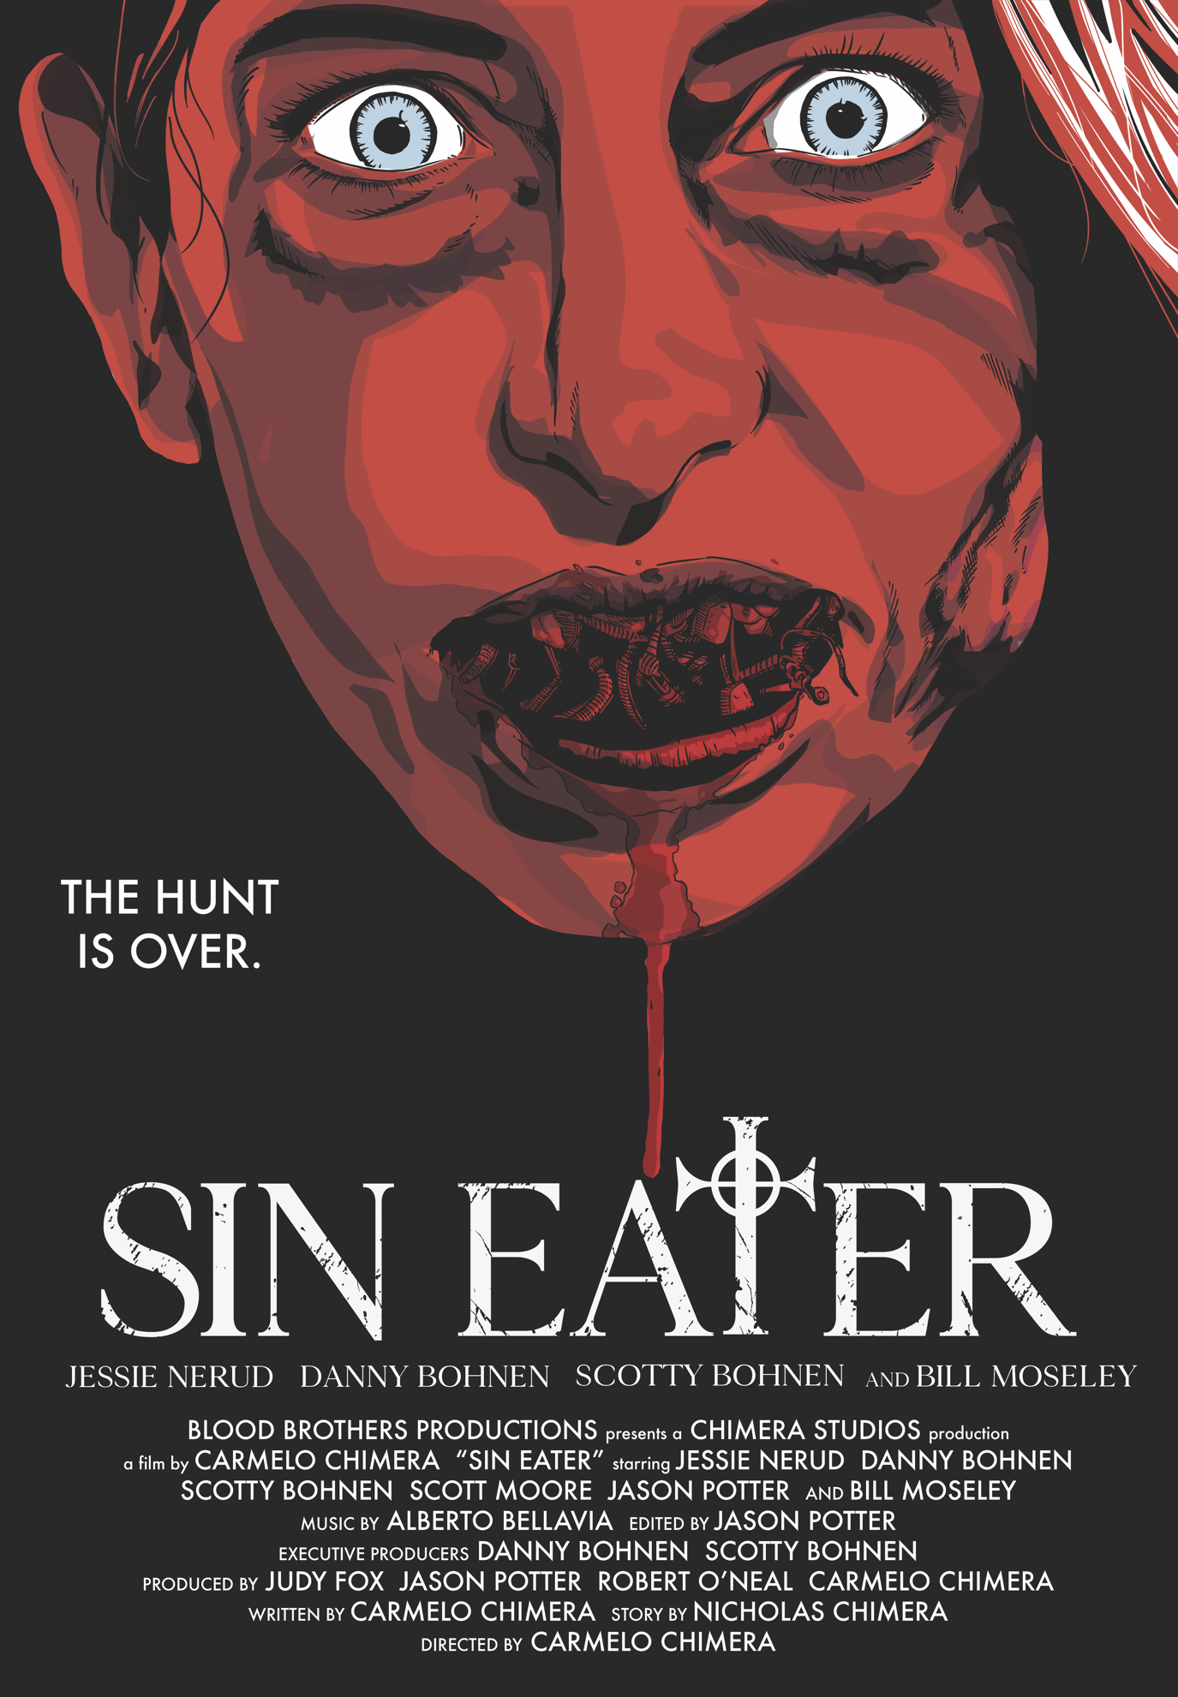
Index

What Is Sin Eater? 3
Taglines 3
Short Synopsis 3
Long Synopsis 4
Biographies 6
Director 6
Carmelo Chimera – Director, Writer, Producer 6
Cast/Crew 7
Jessie Nerud as Christine 7
Bill Moseley as Father Dunne 7
Danny Bohnen as Isaac 8
Scotty Bohnen as Elijah 8
Jason Potter as the Deputy – Director of Photography and Editor 9
Composer 10
Alberto Bellavia 10
Director’s Statement 11
Awards 11

What Is Sin Eater?

Sin Eater is a paranormal horror thriller about a woman surrounded by a small town cult that will sacrifice anything – or any one – to escape their sins.

Taglines

The Hunt Is Over.

Feed Your Sins…Before They Feed On You.

Short Synopsis

In Sin Eater, a gruesome accident leaves a woman with a mysterious past stranded in a small town with its own dark secrets. As she loses her grip on reality and with no one to trust, she’ll have to face her inner demons to survive an ancient evil beyond her imagination.

Long Synopsis

Christine awakens after a car accident in the middle of nowhere, with her face bashed in and the mangled corpse of a hitchhiker dead beside her. With her every earthly possession destroyed and her jaw wired shut, she accepts the kindness of the town sheriff, Isaac, and stays with him while she recuperates.

At first, Christine is grateful to stay with Isaac and his elderly father, Abraham, the Minister of the town’s unique religion. She befriends her kindly nurse Elijah, who has a bitter rivalry with Isaac for who will succeed Abraham as the leader of their Congregation.

Each night tests Christine’s sanity as she experiences increasingly horrific hallucinations, including Isaac’s dead daughter. She has a recurring nightmare of the zealous Father Dunne torturing her as “conversion therapy” to exorcise her of homosexuality - at the behest of her parents.

Her paranoia continues to grow until Isaac tries to force himself on her, prompting Christine to investigate the town’s religion.

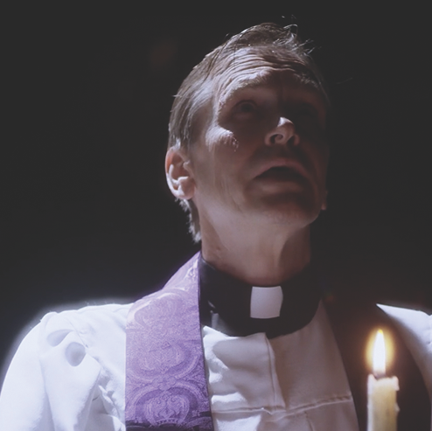
She learns of the cannibalistic sacrifice of the “sin eater” to the demon Azazel, and of the sacred “Ancestor Chair” which chooses the town’s Minister and fills him with the voices of the generations of leaders who came before.

Christine learns that the hitchhiker who caused her accident had escaped the Congregation before they could sacrifice her - and now Christine has been chosen as the replacement. Christine’s revelations come too late, and she is betrayed by Elijah who hands her over to the Congregation for the ritual.

When Christine attempts to escape, she kills Abraham and leaves the Congregation without its leader. When Isaac takes his father’s place in the Ancestor Chair, the chair rejects him, and burns Isaac alive.

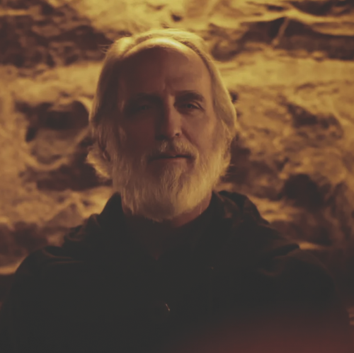
Preferring to die on her own terms rather than be eaten alive, Christine sits in the chair herself. But the Ancestor Chair chooses her as the new Minister.

She takes over the Congregation, and with a horrific display of power, she forces her mouth open through the wires holding her jaw together for so long.

Christine, possessed by the generations of Ministers who have lead before her, wins her lifelong battle against the tyranny of religion by embracing faith and the power it brings her.

She leads the Congregation as they sacrifice the treacherous Elijah in the haunting conclusion.

Biographies

Director

Carmelo Chimera – Director, Writer, Producer

Debut director Carmelo Chimera is a practicing business and transactional attorney and a graduate of the University of Chicago Law School.

At the age of 21, he founded CHIMERA’S COMICS, a retail chain and publishing company, and made international headlines last year when he gave away his business in an essay contest.

He’s the author of the superhero graphic novel MAGNIFICENT and the sci-fi/horror graphic novel anthology CELLAR DOOR as well as the upcoming political conspiracy thriller FAKE NEWS.

In addition to his fiction work, Carmelo is the author of the nonfiction book YOUR KICKSTARTER IS ABOUT TO FAIL, collecting his knowledge on crowdfunding which he has used to raise money for numerous creative projects .

He’s built a following both through his writing and for the top-rated podcast THE CULT CLASSIC HORROR SHOW which he co-hosts with Danny and Scotty Bohnen.

Cast/Crew

Jessie Nerud as Christine

Jessie Nerud made her feature film debut as the titular monster in the found footage horror film SHE WALKS THE WOODS.

Her irresistible charisma and charm made her the perfect choice for the physically and emotionally demanding lead role as CHRISTINE in SIN EATER.

Her emotional range, subtle strength of character, and quiet vulnerability brought Christine to life as a memorable victim-turned-hero scream queen.

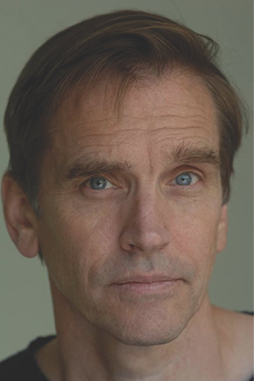
Bill Moseley as Father Dunne

Bill Moseley is a proliﬁc cult classic horror ﬁlm star with hundreds of film and television credits.

Best known as CHOP TOP in TEXAS CHAINSAW MASSACRE 2, as well as for his starring roles in Rob Zombie’s trilogy HOUSE OF A THOUSAND CORPSES, THE DEVIL’S REJECTS and 3 FROM HELL as OTIS DRIFTWOOD, Bill Moseley has starred in RETURN OF THE LIVING DEAD, REPO! THE GENETIC OPERA and most recently wrapped a starring role, opposite Nicholas Cage in Japanese Director Sion Sono’s PRISONERS OF THE GHOSTLAND.

Danny Bohnen as Isaac

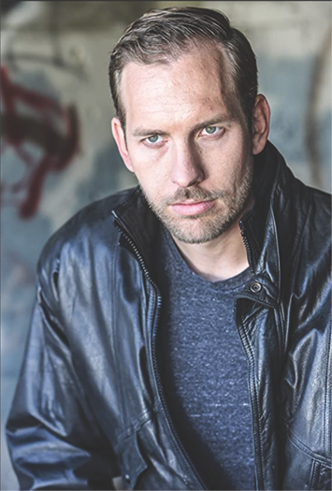
In SIN EATER, Danny Bohnen plays ISAAC, the town’s sheriff and the man responsible for keeping its dark secrets. Danny’s range as an actor brings a likability to the emotionally volatile Isaac. His focus and range twists the role of the villain into an almost anti-hero, which make his arc all the more gripping.

In addition to bringing Isaac to life, Danny is an Executive Producer of the film. His credits include the western THE LAST SON starring MACHINE GUN KELLY and SAM WORTHINGTON.

Scotty Bohnen as Elijah

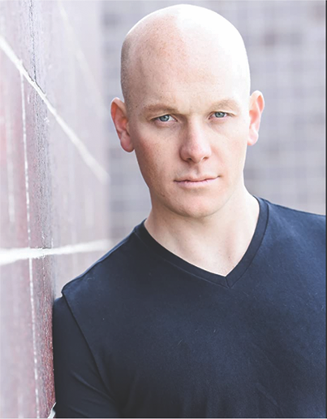
Scotty Bohnen plays ELIJAH, the town nurse who earns Christine’s affection before betraying her to the town’s evil cult.

Scotty’s sincerity and empathy make Elijah a bright point in the film’s darknesss - which makes his ultimate betrayal all the more impactful.

His arc from ally to traitor to abject coward provide an important counterpoint to Christine’s journey from victim to courageous hero to conqueror.

In addition to bringing Isaac to life, Scotty is also an Executive Producer of the film. His credits include the upcoming thriller ONE WAY starring KEVIN BACON.

Jason Potter as the Deputy – Director of Photography and Editor

Jason Potter is a full spectrum artist. He’s best known as an American TV/Film actor who can be seen in shows such as THE SOCIAL DILEMMA (Netflix), AMERICAN CRIME STORY (FX), and THE CLEANING LADY (Fox). Jason enjoys the added challenge of understanding the many other aspects of filmmaking which has led to his works in producing, cinematography, editing, directing and composing. Sometimes several at the same time. He is a self-taught musician and built his own acoustic guitar from scratch. He climbs Colorado’s tallest peaks (30 and counting), and you will always spot him driving around his Jeep with the top down. Jason works everyday to constantly find new ways to enhance his skill sets and extend into learning new ones. His love for the craft runs parallel to his optimism in life. He is the all-American willing to take the risk.

The horror genre used to be a very unfamiliar genre for Jason. It wasn’t until he began diving deep into the production of SHE WALKS THE WOODS (Amazon Prime) that he built a newfound understanding and respect for the genre and has been engrossed since with the anticipated release of the Horror/Thriller narrative SIN EATER.

Composer

Alberto Bellavia

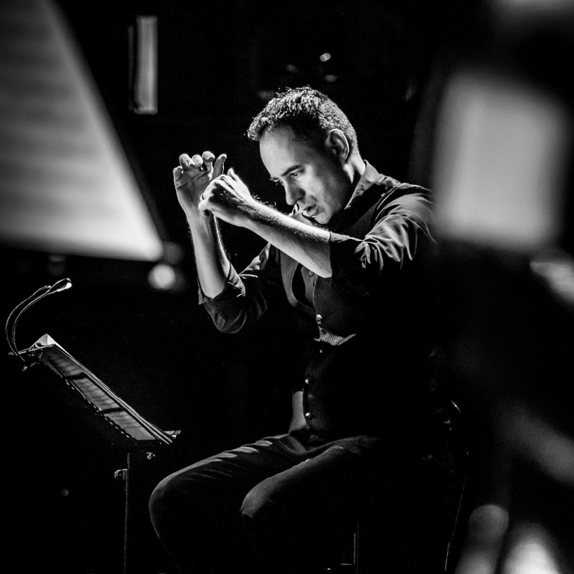
Alberto Bellavia is an internationally award-winning composer. He studied music at the State Conservatory of Music G.F. Ghedini in Cuneo, Italy.

He took the Pianoforte Diploma, the Jazz Music Diploma, the Music Teaching Diploma, the Second Level Laurea for Pianoforte Teaching and the Second Level Laurea for Jazz.

He’s won dozen of awards and continues to compose films and teach music.

Director’s Statement

Since my days as a philosophy student in college, the sin eater ritual fascinated me. Why do people believe their sins are somehow separate from themselves, something that can be transferred? And why do so many different cultures have this belief – Hinduism, Judaism, Christianity, and more all have this idea. And why does the transferrance of food in these different cultures always have to do with eating?

To me, these similarities can only mean one thing: these people are on to something.

Sin Eater is a movie about faith gone wrong. About believers who become zealots. And it’s about how when you silence people long enough, eventually, they’ll make their voices heard.

Inspired by the likes of Kubrick and Friedkin, I hope Sin Eater is a picture that will thrill and excite, but also provoke the audience to reflect on their own beliefs…and their own sins.

Keep moving forward,
Carmelo Chimera

Awards

Best Score, Paris Play Film Festival (2021)

