¿What Luck?

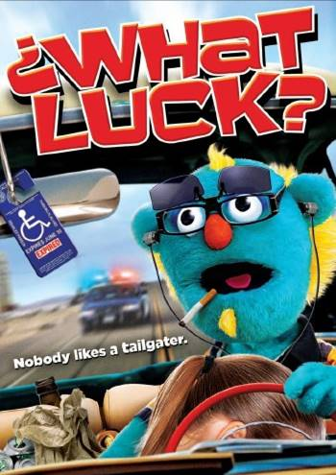

“Just another one of those freaking days…”

Contents

Credits Page 3
Synopsis Page 4
Cast Page 5
Director /Editor Page 8
Directors View Page 9
Director Of Photography Page 10
Writer/Producer Page 11
Composers Page 12
Contact Information Page 13
Screenshots Page 14

Credits

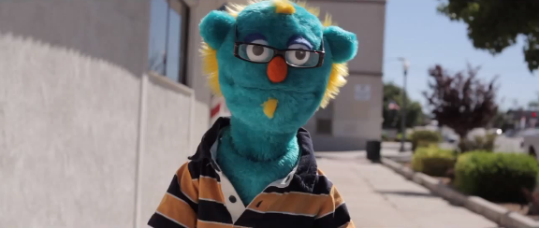

Director/Writer/Producer Jerrold Ridenour

Director of Photography John Matysiak

Editor Jerrold Ridenour

Composers Jerrold Ridenour and Jim McComas

John James Murray

Holly Stephanie Rae

Lance Chad Fishburne

Charlie Troy Guthrie

Tim Jerrold Ridenour

Billy The Bull Kevin Carlson
Synopsis

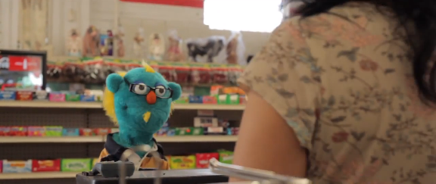

Short Synopsis
When John sets off to work one day in lovely Barstow, the armpit of the earth, he has no idea what’s in store for him. Aside from having the worst day in history, he has the answer to all his problems strapped to his fridge at home; a winning lotto ticket he might not ever get a chance to cash in. Will his girlfriend Holly be there to comfort him, or is she running off with Lance? Worst of all, his best friend Tim, is an asshole.

Genre

Comedy

Tagline

“Just another one of those freaking days.”

Cast

John the puppet as John
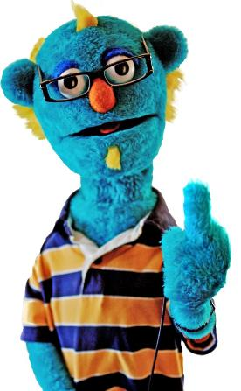

John has been the star of several regional kids shows on cable access television for the better part of the last decade. He has been blacklisted from every high profile puppet show in Hollywood and What Luck? is his last chance to make something of his pathetic career. He’s Balding, moth eaten and smells like a twenty year old gym sock, but that’s not stopping him.

James Murray as John

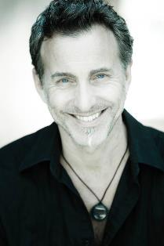

James is a recent GRAMMY Nominee {Best Children’s Album, 2013), an award-winning puppeteer, actor, voice over artist, writer, producer, director, and singer. He has been in the children’s entertainment arena for over 25 years often times wearing multiple hats.

His numerous talents have been utilized by FOX KIDS, MTV, ABC, CNN, Play House Disney, Google, Hallmark, Microsoft, Nickelodeon, MCA Universal, Paramount, Warner Brothers, and The Jim Henson Company - having worked with the likes of the late Jim Henson, Spike Jones, Barry Sonnenfeld, Tim Burton & Francis Ford Coppola.

As a performer, James has voiced and or puppeteered characters on over 30 children’s shows, 15 features and numerous theatre productions, series & commercials.

He voiced the beloved character of Master Splinter in the live action feature, Teen Age Mutant Ninja Turtles III, Back in Time, replacing Kevin Clash. He performed several voices in the Disney Animated Feature: The Brave Little Toaster Goes to Mars… He was repeatedly a featured guest performer on The Jenny McCarthy show for MTV and a series regular on the primetime FOX series Greg the Bunny created by Steve Levitan (Creator of Just Shoot Me and Modern Family) starring Eugene Levy, Sarah Silverman and Seth Green.

Kevin Carlson as Billy The Bull

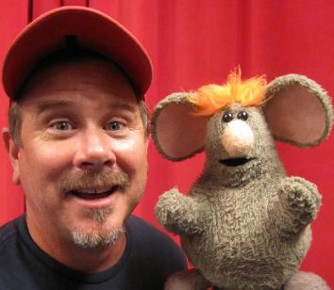

Kevin has been scribbling the title of “Puppeteer” in the OCCUPATION Box for over 25 years. From Live Shows, TV and Feature Films, Kevin literally has had his hand in a lot of productions. Honoring the art form of puppetry in all mediums, Kevin’s early work included touring with the Muppet Show on Tour, where he performed several characters and worked closely with Jim Henson. One of his biggest breaks was being cast in PeeWee’s Playhouse as Conky the Robot, Clocky and Floorey. Kevin also co-created and starred as Timmy The Tooth for MCA/Universal’s family home entertainment where Kevin and team produced 10 half-hour episodes which aired on Nickleodeon.

As a free lance puppeteer, Kevin has worked with some of the best in the business and brings his unique style as a performer to the forefront. Some of Kevin’s credits include: Imagination Movers, the Office, All That, Mr. Potatohead Show, Team America, Dr. Dolittle, Men in Black II, Cats and Dogs, Monkeybone, Batman Returns, Flintstones, Childs Play, Beetlejuice, The New Muppet Movie and others.

Stephanie Rae as Holly

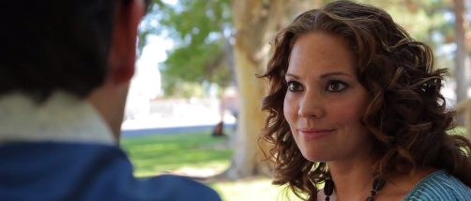

Stephanie Rae is an actress and writer, known for Slinging Mud (2009), High School, I Hate You (2012) and Grace (2006).

Chad Fishburne as Lance

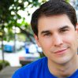

Chad Fishburne is an actor and writer, known for SportSlam (2012), Shellter (2011) and Downpour (2008).

Writer/Director/Producer/Editor Jerrold Ridenour

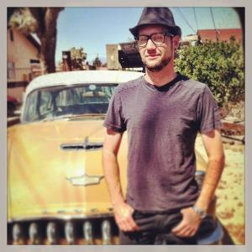

Puppets and Animation have influenced Jerrold his entire life. After a one year animation program and an internship with the Chiodo Bros. he delved headfirst into the zaniest career on the planet, making puppet movies. His short film Señor Huesos is distributed by Heather Henson, daughter of Jim Henson, around the world as part of the Handmade Puppet Dreams showcase. He has contributed to many puppet short films, music videos and pitch pilots and directed six titles for the Bob the Builder franchise. What Luck? marks his first foray into feature filmmaking. He has also recently signed a development deal with Universal for an animated franchise “Max Gigarams” that is being developed for television.

Directors View

The Film
¿What Luck? was inspired by years of dating and financial woes, hearing other friends complain about dating and troubles with money and wrapping a lot of real moments into the life of a very unreal character. A puppet. A puppet that you feel for and root for and hope he will win. It’s a classic story of the underdog.

Brought to life by some of the same talent that has been bringing Jim Henson projects to life in a way that has never been done before. Verite, in a real world.

The Text
The screenplay was crafted as a loose series of events that the actors would improv through until the right moments were captured. Directing acting at the same time was a new challenge for me, but in the end I hope, feels very real.

Style & Cinematography
Unlike any other puppet feature film before, we shot this film in a breakneck five days, Verite style. Long hours, multi-camera coverage, and professionals hitting their marks every time we made a heartfelt tale of one mans struggle, but the man is a puppet. The style lent itself to a handheld, Cinema-Verite style, which when shot with cinema prime lenses, gave us the look of a million dollar movie for less than hundred thousand dollars.

Acting
The acting in my film, I hope feels very natural. We kept it loose it did most scenes in under three takes, usually just one or two, but with two cameras rolling all of the time. This allowed the actors to improve and get comfortable with each scene, and truly allowed them to be in the moment.

Director of Photography John Matysiak

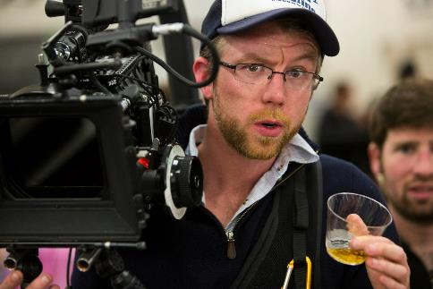

Born of third generation Polish immigrants and raised in Houston, Texas, John Matysiak completed his study of film at Emerson College in Boston, MA. In addition to his study at Emerson, John was selected to study at the Czech National Film School, FAMU, in Prague, where he was instructed and mentored by international cinematographers and directors.
A member of the International Cinematographers Guild, John's credits include television movies of the week, in addition to internationally recognized independent films as well as commercials, promos and branded content for Hyundai, Dodge, Coke Cola, Sony and Yahoo.
His work has been shown in over 50 film festivals around the world including; Festival de Cannes and the Berlin International Film Festival. Recently John was recognized for his achievements in cinematography at the 25th Los Angeles Asian-Pacific Film Festival where he was awarded "Best Cinematography" for his work on the feature films, TWO SHADOWS and MODEL MINORITY.

Composers

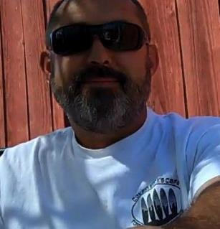

Jim Mccomas is a Mojave Desert resident specializing in Americana and Country flavored music. He has produced several albums, soundtracks and film scores over the last 10 years.

Jerrold Ridenour wrote and performed several of the songs featured in the film as well.
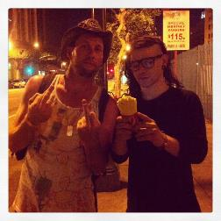

Contact Information

Produced by Jerrold Ridenour
7540 Earhart Ave.
Hesperia, Ca. 92345
email: jerrold.ridenour@gmail.com

Distributed by Indican Pictures
1041 North Formosa Avenue
Formosa Building, Suite 221A
West Hollywood, CA 90046
ph: 323.850.2667
email: contact@indicanpictures.com
www.indicanpictures.com

Screenshots

