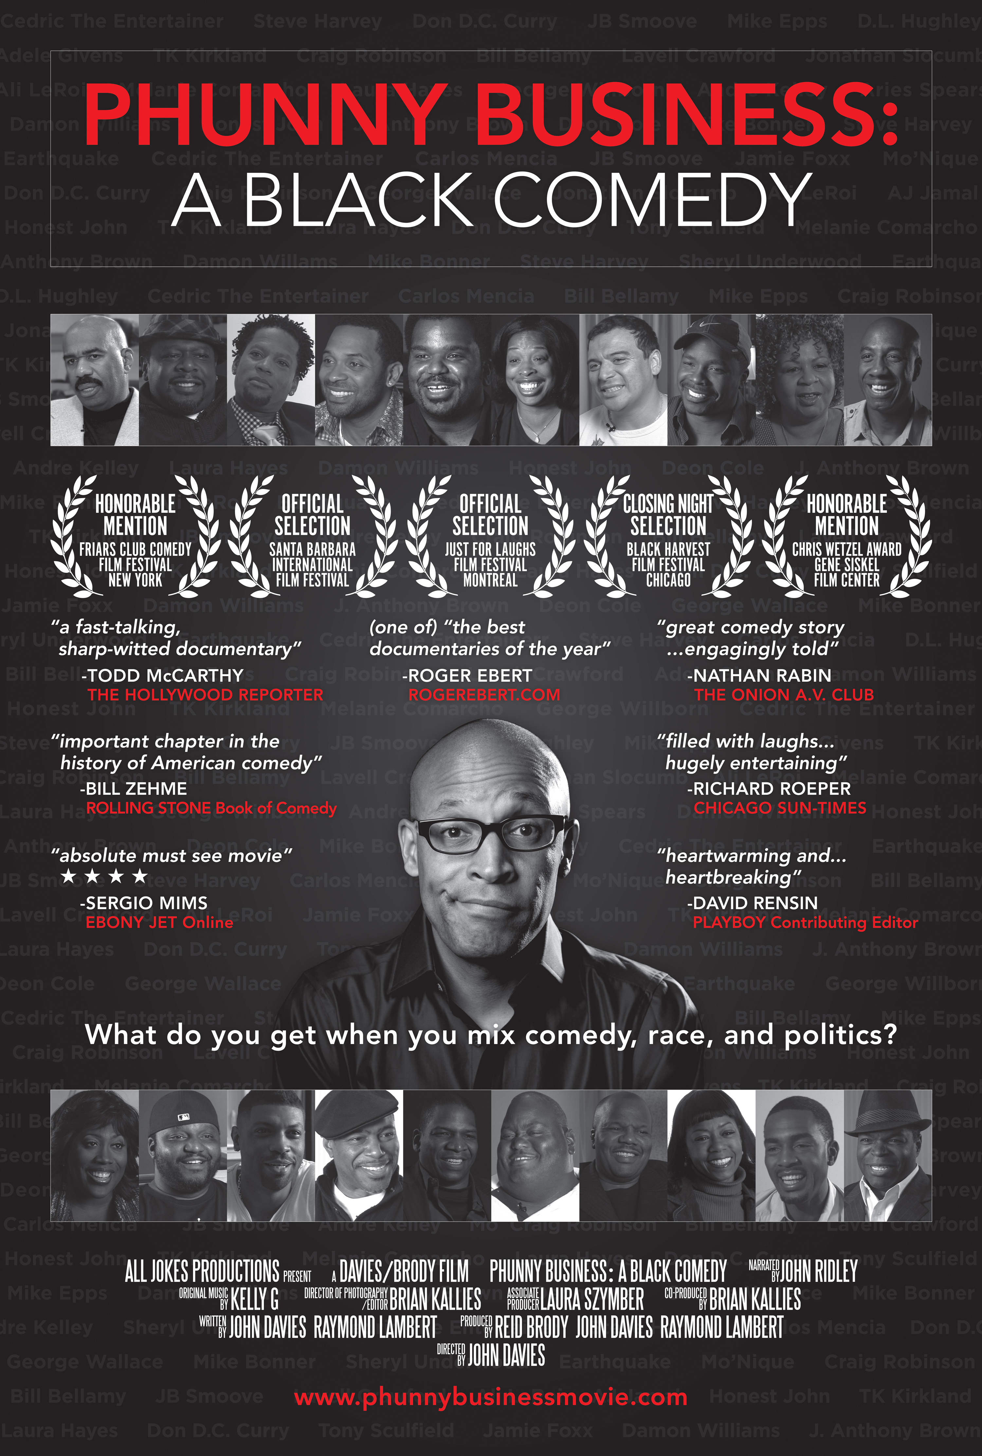

PRESS

“A wonderfully entertaining documentary about the club where it all began for many of today’s top comic talents. The shared proving ground for a generation of great black comic entertainers is giddily illuminated in Phunny Business: A Black Comedy, a fast-talking, sharp-witted documentary about a black-owned Chicago comedy club of the 1990s.”
-TODD MCCARTHY, THE HOLLYWOOD REPORTER

“This is one documentary that comedy fans won’t want to miss.”
-HUFFINGTON POST

“Phunny Business is a breezy, vivid, funny, star-studded and delightful valentine to comedy, entrepreneurship and the All-American impulse to make something out of nothing. The story of comedy club owner/inveterate dreamer Raymond Lambert and his heroic quest to create a safe, productive place for black stand-up comedians to hone their craft and find their voices isn’t just a great Chicago story and a great comedy story: it’s a flat-out great story, lovingly and engagingly told.”
-NATHAN RABIN, Head Writer THE ONION/A.V CLUB

“It’s a very valuable record of a Chicago institution. Skillfully directed and written, it’s takes you on a journey of an id e a , a niche being filled and eager audiences too long overlooked and the visionairies whose dreams came true.”
-JEFFREY LYONS, LYONS DEN RADIO

“PHUNNY BUSINESS is a gem! A funny, insightful, honest knockout winner of a film about the serious business of comedy. A film that’s an absolute must see movie. !”
-SERGIO MIMS, EBONYJET Online

(one of) “the best documentaries of the year”
-ROGER EBERT, ROGEREBERT.COM

“This is an invaluable look back at an all-too-brief but shining and important moment in the history of comedy. A fast-paced and hugely entertaining documentary about the legendary All Jokes Aside comedy club in Chicago. Filled with laughs but also somewhat bittersweet, as we see how this iconic club was allowed to die prematurely.”
-RICHARD ROEPER, CHICAGO SUN-TIMES

“The heartwarming and ultimately heartbreaking hidden history of south side Chicago’s premiere Black comedy club. Inspirational, motivational, hilarious.”
-DAVID RENSIN, Author and contributing editor PLAYBOY

“Here is one of the most thrilling—and, yes, important—chapters in the history of American Comedy that all but escaped attention (how????) until now. Who knew that near the heart of downtown Chicago—less than a handful of miles to the south of revered improv-launch pad Second City—a revolution had arisen and given birth to legends and lessons that would shape the direction of all forthcoming funny business—er, I mean, PHUNNY BUSINESS. This gorgeous film makes it all visceral and indelible in ways you are unlikely to forget. Because we damn well better not forget, not ever again.”
-BILL ZEHME, Author of LOST IN THE FUNHOUSE: THE LIFE AND MIND OF ANDY KAUFMAN, THE ROLLING STONE BOOK OF COMEDY

“Great film, very compelling story.”
-MATT KETTMANN, SANTA BARBARA INDEPENDENT

“Heartfelt and hilarious throughout. It is so well put together and like any good comedy, the timing is spot on.”
-MARK KIRKLAND, Director - THE SIMPSONS

SYNOPSIS

PHUNNY BUSINESS: A BLACK COMEDY chronicles the rise and fall of ALL JOKES ASIDE, which for a decade, was the preeminent Black Comic showcase in America. This mostly unheralded “star factory” impacted American Pop Culture in a huge way, giving early exposure and early paychecks to major talent like Steve Harvey, Dave Chappelle, Chris Rock, Jamie Foxx, MoNique, Bernie Mac, Carlos Mencia, D.L Hughley, Cedric The Entertainer, Adele Givens, Melanie Comarcho, Mike Epps, JB Smoove, Ali LeRoi, Aries Spears, George Willborn, Sheryl Underwood, Laura Hayes, Bill Bellamy, Craig Robinson, Deon Cole, Earthquake and Tommy Davidson, to name just a few. An equally impressive list of celebrities like Michael and Juanita Jordan, Scottie Pippen, most of “Da Bears”, Tommy Hearns, Barry Sanders, Boyz 2 Men, Maxwell, MC Lyte, Vivica A. Fox, Doug Banks and many other luminaries could be found laughing it up in the audience.

All Jokes Aside was the brainchild of 29-year-old Delaware native and Morehouse graduate Raymond Lambert. In the late 1980’s, armed with his new MBA, Lambert was working in the “exciting” world of high finance and being mentored by Chicago’s legendary Chris Gardner. Yeah, that Chris Gardner, the guy WillSmith portrayed in the Hollywood movie THE PURSUIT OF HAPPINESS. The only problem…Lambert was bored and unfulfilled. He wanted to do something entrepreneurial and creative.

One night while visiting friends in Los Angeles, Ray went to THE IMPROV, a famous stand-up comedy club owned by the legendary Budd Friedman. Inspired by that experience, Ray decided he wanted to be less like Chris Gardner and more like Budd Friedman, but with more soul. How tough could it be to run a PHUNNY BUSINESS? Comedians seemed like “nice people” and Ray loved to laugh. Thus began a journey that would put Ray, a showbiz neophyte, in business with some of the biggest names in comedy and eventually, in conflict with a city known for it’s racial politics.

With his decision to switch careers made, Lambert contacted college buddy James Alexander and together they developed a business plan around a void they had identified in the Chicago entertainment market. Simply put, there were no comedy clubs booking minority acts on a regular basis. Their club would make a name for itself showcasing Black talent and entertaining Black audiences in an upscale environment.

On August 9th, 1991, with no experience running a comedy club or any other kind of business, Ray and James borrowed money from James’ mother and opened All Jokes Aside.
For most of a decade, their three hundred-seat club at 1000 S. Wabash in Chicago’s South Loop became the preeminent Black comedy club in the country.

Along the way, Lambert and Alexander would learn hard lessons about the entertainment industry. They would also learn about Chicago, still one of America’s most segregated cities. Because they were new to the “Windy City” and unfamiliar with how it “worked”, Ray and James didn’t realize that choosing to open in a South Loop location, a traditionally Black area, would later marginalize their ability to move North to a more “diverse” location. They had branded themselves a “Black” comedy club and would carry that legacy with them when they attempted to broaden their clubs appeal.

Sadly, after almost a decade, All Jokes Aside officially closed. Like other clubs across the country, it had fallen victim to the end of the “stand-up craze,” but there were other, more disturbing reasons for its demise. Local businessmen and potential new neighbors thwarted their attempt to move the club North to the more “diverse”, upscale, entertainment district. Turning to Chicago politicians for help seemed logical but white politicians were indifferent and black politicians wanted “consideration” or were openly unsympathetic. One infamous Black alderwoman actually professed her loyalty to one of Chicago’s more dominant white comedy institutions. This hostile environment and mounting legal bills spelled the end for All Jokes Aside. “While we were disappointed to see our club close,” said owner Lambert, “we were delighted to see the artists we encouraged go on to impact the entertainment industry and pop culture in such a major way”.

The artists haven’t forgotten “the best little club no one ever heard of “ and have been sitting down in front of our cameras to share their memories and re-live the glory days of All Jokes Aside. Using stills, archival performance footage and interviews, PHUNNY BUSINESS: A BLACK COMEDY chronicles the rise and fall of All Jokes Aside and salutes the legendary showcase for it’s major contribution to comedy history. Will the club ever re-open? You never know, it’s a PHUNNY BUSINESS, but a television series as well as a reunion special are currently being developed to accompany the release of the documentary. Producers for All Jokes Productions LLC. are John Davies – 818 841-4358 jdaviesprod @earthlink.net, Raymond Lambert - 312 479-8070 raymondclambert@ yahoo.com and Reid Brody reidb@filmworkers.com.

PRODUCERS STATEMENT

PHUNNY BUSINESS: A BLACK COMEDY is a bittersweet valentine to All Jokes Aside, a little known, but extremely influential, black-owned Comedy Club. Comedy, race and Chicago politics collided at this cultural gem and we hope our humorous telling of this story will provoke discussion, and in some small way, promote a greater understanding between the races.

CAST
Comedians below appear in the documentary.

Jamie Foxx | Dave Chappelle | Chris Rock
Bernie Mac | Steve Harvey | Carlos Mencia
J. Anthony Brown | Cedric The Entertainer | D.L. Hughley
Mike Epps | Mo’Nique | George Wallace
Aries Spears | Craig Robinson | Rodney Winfield
Bill Bellamy | Tommy Davidson | Ali LeRoi
JB Smoove | Sheryl Underwood | Mike Bonner
George Willborn | Lavell Crawford | Earthquake
Don DC Curry | Adele Givens | Laura Hayes
TK Kirkland | Melanie Comarcho | Damon Williams
AJ Jamal | Deon Cole | Tony Sculfield
Honest John | Jonathan Slocumb | Andre Kelley

NON-COMEDIAN CAST
Notables

Chris Gardner | Author -The Pursuit of Happyness
Bert Hass | Zanies Comedy Club
Jamie Masada | Founder, The Laugh Factory Comedy Clubs
Kelly Leonard | The Second City
Tim Kazurinsky | Screenwriter/Actor
Budd Friedman | Founder, Improv Comedy Clubs
Doug Banks | The Doug Banks Radio Show
Otis Wilson | ’85 Super Bowl Bears
Marv Dyson | Urban Radio Hall of Fame
Ernie Tucker | Former writer, Chicago Sun Times
Allan Johnson | Former writer, Chicago Tribune
Worthy Patterson | Talent Manager
Steven Rogers | Tenured Professor, Kellogg Graduate School of Business
Barbara Bates | Celebrity Fashion Designer
Phil Ponce | Celebrated Chicago Newsman
Burt Natarus | Legendary Chicago Alderman
Obi Nwazota | Award Winning Architect
John Davies | Co-Creator/Executive Producer Run’s House

CREW
NARRATED by: JOHN RIDLEY
John Ridley is an Emmy Award winning commentator and writer for Esquire as well as a current contributor to NPR, CNN, and MSNBC. He is the author of eight published novels. Collectively, his works have been chosen as “Editor’s Picks” or “Best of the Year” by The New York Times, The Wall Street Journal, The Los Angeles Times, Entertainment Weekly, Amazon.com and The Baltimore Sun. His most recent work is the collected graphic novel series The American Way. Ridley’s first novel, Stray Dogs, was made into the Oliver Stone film U-Turn staring Sean Penn and Jennifer Lopez. Other films written and/or produced by Ridley include Three Kings, Undercover Brother, Bobby, and Street Kings. His latest film project is the upcoming George Lucas produced Red Tails which tells the story of the World War II era Tuskegee Airmen.

PRODUCED • WRITTEN • DIRECTED by: JOHN DAVIES
John Davies began his career as a Producer on the PBS movie review series Sneak Previews with Gene Siskel and Roger Ebert. Moving to Los Angeles in the 90’s he Executive Produced the SHOWTIME documentary It’s Black Entertainment, the COURT TV documentary Hip Hop Justice and the ESPN documentary Politics & The Games, a look at the political history of the Olympics. In addition, he produced numerous Network comedy specials for Comic Relief and was Emmy nominated for Producing and Writing A Comedy Salute To Andy Kaufman for NBC. John also Created and Executive Produced series like Second City Presents for the BRAVO network, Movie Club with John Ridley for AMC and the NBC summer comedy series The Rerun Show. More recently he was the Co-Creator and Executive Producer of the hit MTV series Run’s House, winner of the NAACP award for “Outstanding Reality Series” and Executive Produced it’s spin-off series Daddy’s Girls. John is currently developing a scripted series with Happy Madison Productions inspired by PHUNNY BUSINESS: A BLACK COMEDY, his latest documentary.

PRODUCED • WRITTEN by: RAYMOND C. LAMBERT
Raymond Lambert has a broad based business background working with both publicly traded and privately held companies in entertainment, investment banking, and consumer products. The creator of All Jokes Aside™ comedy clubs, he has served as a consultant on comedy and talent to producers at NBC, HBO, Comedy Central, and BET. He recently earned an Associate Producer credit for the feature film Slow Burn and currently serves as President of All Jokes Productions, producers of the documentary film PHUNNY BUSINESS: A BLACK COMEDY; and is in development on a scripted series for television inspired by the documentary. In addition to his business and creative accomplishments, Raymond devotes his charitable energies to the Chicago Public Schools Real Men Read, and the Network for Teaching Entrepreneurship. An avid runner, Raymond has completed the New York City, Chicago, and Boston Marathons. Raymond earned his undergraduate degree in Marketing from Morehouse College, with honors, and his MBA in General Management from The Darden School at the University of Virginia.

PRODUCED by: REID BRODY
Reid Brody is a producer and entertainment executive with many years of experience in all aspects of media. He is also an accomplished writer, director, and songwriter. Mr. Brody is co-founder of 2DS Productions, an entertainment company primarily focused on the creation of low-budget, mainstream movies. He served as executive producer on 2DS’s first movie, Nothing Like the Holidays, which Overture Films released in 2008, and is now readying a slate of movies for production in 2011. Mr. Brody is also founder and president of the successful and highly respected postproduction company, Filmworkers Club, which has facilities in Chicago, Dallas, and Nashville. Filmworkers’ various units include a digital production studio, a motion graphics design firm, and the only motion picture film lab in the Midwest. Mr. Brody resides in Chicago.

CO PRODUCER, DIRECTOR OF PHOTOGRAPHY, EDITED by: BRIAN KALLIES
Brian Kallies is a seasoned editor, videographer and producer performing all three functions on PHUNNY BUSINESS: A BLACK COMEDY. He runs his own Chicago based production company and works with commercial clients all over the country.

ORIGINAL MUSIC by: KELLY G.
Once ranked #2 on The Source magazine’s Power 30 list, Kelly G currently serves as Black Entertainment Television (BET’s) Senior music supervisor. Since 1999 Kelly G has taken BET’s music and programming to levels that have set trends which ultimately jump started and influenced the careers of many multi-platinum artist like Kanye West, Chris Brown, Lil Wayne, Drake, Trey Songs and countless others. For many years he has overseen the music and production of the network’s franchise programs including BET Awards, 106 & Park, BET’s Music Matters, BET Live, Rap City, Uncut and BET Access Granted. In addition, his responsibilities include choosing all the music videos on BET; developing the BET Music Library, dealing with artist and celebrities, and programming to the minds of nearly 80 millions households weekly.

ASSOCIATE PRODUCER: LAURA SZYMBER
Laura Szymber is an award-winning producer of independent film, commercials and corporate video. She owns AXIOM Megamedia, LLC, a full-service production company and is a member of Independent Feature Project (IFP) and Women In Film.

“PHUNNY BUSINESS: A BLACK COMEDY”
FACT SHEET

Origination: | Chicago, Illinois
Concept: | PHUNNY BUSINESS: A BLACK COMEDY is a valentine to ALL JOKES ASIDE, Chicago's first black owned comedy club. In the early 1990’s, this mostly unheralded "star factory" gave early exposure and early paychecks to major talents like Jamie Foxx, Chris Rock, Dave Chappelle, Mo'Nique, Bernie Mac, Steve Harvey, D.L. Hughley, Cedric The Entertainer, Carlos Mencia and many other legends. The story of it's eventual demise is a cautionary tale for all young entrepreneurs.
Featuring: | Steve Harvey  Dave Chappelle  Chris Rock  Jamie Foxx  MoNique  Bernie Mac  Carlos Mencia  D.L Hughley  Cedric The Entertainer  Adele Givens  Melanie Comarcho  Mike Epps  JB Smoove  Ali LeRoi  Aries Spears  George Willborn  Sheryl Underwood  Laura Hayes  Bill Bellamy  Craig Robinson  Deon Cole  Earthquake  Tommy Davidson  and many more.
Written by: | John Davies  Raymond Lambert
Directed by: | John Davies
Production Company: | All Jokes Productions, LLC
Producers: | Reid Brody  John Davies  Raymond Lambert
Co-Producer: | Brian Kallies
Director of Photography: | Brian Kallies
Original Music: | Kelly G.
Editor: | Brian Kallies
Narrated by: | John Ridley
Associate Producer: | Laura Szymber
Awards: | BLACK HARVEST INTERNATIONAL FILM FESTIVAL – Closing Night Selection  FRIAR’S CLUB COMEDY FILM FESTIVAL – Honor-able Mention  CHRISTOPHER WETZEL AWARD – Gene Siskel Film Center  HOLLYWOOD BLACK FILM FESTIVAL – Official Selection  JUST FOR LAUGHS FILM FESTIVAL, MONTREAL – Official Selection  JUST FOR LAUGHS FILM FESTIVAL, CHICAGO – Official Selection  EBERTFEST 2012 – Official Selection  SANTA BARBARA INTERNATIONAL FILM FESTIVAL – Official Selection
Sales & Press Contact: | Indican Pictures  c/o Shaun Hill  323-650-0832  Shaun@indicanpictures.com

